

**Women and Girls’ Equality Panel Annual Report 2022/23**

## Contents

Message from the Chair 2

Introduction to the Panel 3

The previous year: 6

Working Groups 8

ESE 9

VAWG 16

Future focus 20

Contact us 22

## A person wearing a black headscarf and smiling.

Figure : Woman smiling and wearing a black headscarf

## Message from the Chair

### Halyma Begum (Chair of the Women and Girls’ Equality Panel & Senior Inclusion Manager at Business in the Community)

“It’s been another year where the Panel has continued to preserve and campaign for Gender Equality in GMCA. We saw headlines about misogyny in the Police force, the very people who we women put our trust in to protect us. The Panel voiced our concerns and of the women in GM. We built closer relationships working with GMP and contributed to the GBV strategy to ensure the safety of women is a priority.

Not only did the Panel voice the concerns of Women but we also looked at how GM can support young girls in getting the right support to equip them to make the right start as they transition from secondary school into the world of employment. We were fortunate to have Mayor Andy Burnham join us for a Panel meeting where we talked about support for young girls, safety for women and funding for women entrepreneurs, and have had his support to continue to pursue in these areas. I look forward to continuing to progress these actions and continue to tackle Gender equality in GM with the help of the truly committed passionate Women we have in our Panel.”

**Halyma Begum - Chair of the Panel**

## Introduction to the Panel

### The Women and Girls’ Equality Panel was established in December 2020 to address gender inequality in Greater Manchester.

The Panel aims to establish a clear vision for women and girls by utilising its members’ knowledge, expertise, and networks to understand and address the issues and inequalities affecting their lives.

The role of the Panel is to constructively challenge political and system leaders to tackle prejudice and discrimination against women and girls. The Panel works alongside the Greater Manchester Combined Authority (GMCA) and the wider Greater Manchester (GM) system to ensure that equality is actively considered in decision-making to help make the city a better place for women and girls to live, work, study, and do business.

The Panel is convened by the Pankhurst Trust, in partnership with GM4Women2028; a charity focused on promoting equality and diversity for the benefit of the community in Greater Manchester.

The Panel meets on a quarterly basis. It has established two working groups – one looking at Education, Skills, and Employment and the other Violence Against Women and Girls. It also benefits from the support of an Allies’ Network, compromised of women and girls from across Greater Manchester who are willing to contribute their expertise and experiences.

The Panel is made up of a diverse range of individuals, organisations and sectors who are committed to ensuring that the viewpoints of women and girls from a cross-sector of society are represented. To find out more about the Panel and its members, please visit: [Greater Manchester's W&GS’ Equality Panel Information](https://greatermanchester-ca.gov.uk/what-we-do/equalities/women-and-girls-equality-panel/).

## The Previous Year

Over the course of the previous year, the Panel has gained greater insight and understanding across a wide range of issues pertinent to achieving gender equality for women and girls. The Panel and its working groups have achieved some notable successes, generated new ideas and created strong working connections and relationships that continue to positively impact the lives of many.

### The Panel

Halyma Begum continued to serve as the Chair of the Panel, while the chairs of the Education, Skills & Employment (ESE) and Violence Against Women and Girls (VAWG) working groups stepped down at the end of 2022. Emma Persand, Founder of Lemur Health, and Sally Carr, Northwest Director of Street Games, were appointed as the new Co-Chairs of the ESE working group, and Gemma Aitchison, Founder and Director of Yes Matters UK, was appointed as the new Chair of the VAWG working group.

The Panel welcomed eight new members this last year, with the aim of adding new skill sets and energy to the group. The recruitment drive specifically targeted women from certain boroughs of Manchester, women of different age groups, and women of colour to achieve greater diversity within the Panel and better represent the women of Greater Manchester. At the end of 2022 the Panel bid farewell to two members, Francesca Gains and Jean Hurlstone, both of whom were instrumental to the formation and initial work of the ESE working group.

The Panel continued to work with GM4Women2028 this last year. In particular, Panel members ran listening workshops at the Dialogue, Deeds and Determination events held in different boroughs within Greater Manchester to engage local women in determining the Panel’s priorities. Many of the newly recruited members learned about the Women and Girls’ Panel through attending the GM4Women events and hearing about the work the Panel does. Similarly, the Panel gets many expressions of interest throughout the year and channels this towards GM4Women membership and participation in their five working groups on Employment, Safety, Participation, Education and Culture & Active Lives.

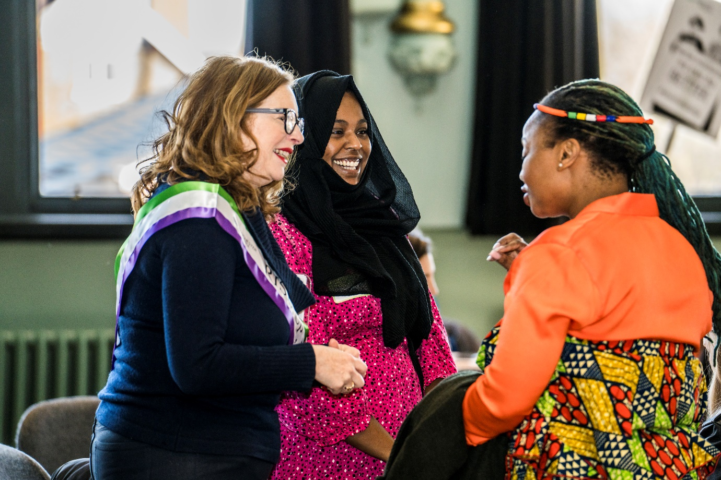

*Alt text: Three women having a conversation.*

The Panel has continued to collaborate with other equality panels across a range of matters, including the representation of women, and particularly women of colour in digital and tech industries and leadership roles and has received valuable input from Elizabeth Cameron, Chair of the Race Equality Panel.

This year the Panel welcomed speakers from several organisations working in the VCSE sector as well as academics, local authority leaders and GMCA officers, with the aim of building our knowledge and understanding across a range of topics and considering how we can work together to influence change and improve outcomes.

The Panel has explored various topics throughout the year, such as how women can get into influential positions in the public and private sector, the high self-employment gender gap, the lack of support for small business scale-up programmes for women, and the confidence barrier that teenage girls face.

The Panel also continued to support the delivery of the GM Gender Based Violence Strategy (GBV Strategy) and strengthened our working relationship with Greater Manchester Police (GMP), allowing for more dialogue and connection to GMP’s VAWG Delivery Plan.

As a Panel we have also been considering how to ensure that women and girls’ equality is adequately considered as part of GMCA’s decision-making process. We will continue to explore whether, moving forward, this could be achieved by being involved in Equality Impact Assessments for all major policy and strategy decisions.

During its first year in 2021, the Panel dedicated its efforts to establishing our purpose and priorities. Over the course of the year, the Panel and its subgroups looked at several topics relating to the ESE and VAWG agendas and developed a series of asks, which we presented to the Mayor of Greater Manchester, Andy Burnham. An important milestone for the Panel was the subsequent meeting with the Mayor in November 2022.

Overall, Andy Burnham expressed his support for the initiatives proposed by the Panel and suggested the need for more regular meetings with himself and (now) Deputy Mayor Kate Green. He advised the presence of GMCA representatives in future meetings, even as listeners, as they can provide different perspectives, take away important insights, and provide explanations if required. The Mayor’s willingness to collaborate and his commitment to address issues related to underrepresented voices in decision-making was well received by the members of the Panel.

##### “We wrote to Mayor Andy Burnham to address three issues. Firstly, we highlighted the need to help young women develop confidence and how it is linked to opening up career choices. Secondly, we pointed out the need to support women's self-employment and address the unrepresentative access women entrepreneurs have to venture capital funds. Lastly, we emphasized the essential need for women to access training in digital and tech skills, and for these programs to ensure access to childcare, allowing women to train and retrain in these vital skills. The Mayor responded positively, acknowledging that our work had influenced the approach taken by the Combined Authority. We are pleased to hear that the mayor will attend meetings regularly and wants to work with our panel to further develop policies that help women and girls live their best lives.”

##### Professor Francesca Gains (University of Manchester) ESE Chair

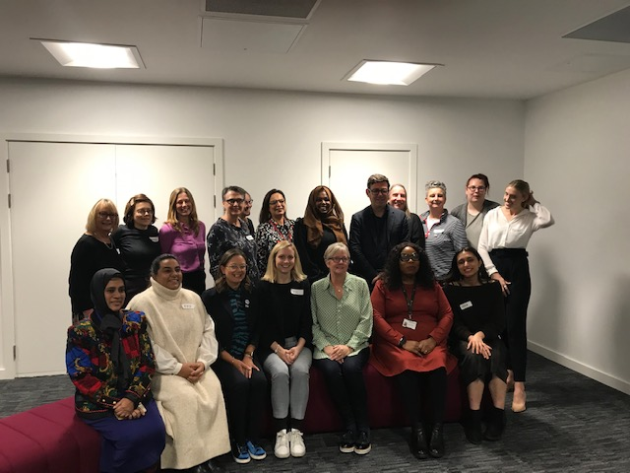

Figure : Panel members with Mayor Andy Burnham at November 2022 meeting

## The Working Groups

### The Panel has two working groups, one focused on Education, Skills and Employment and another on Violence Against Women and Girls. They meet every 4-6 weeks and focus on key areas of interest agreed upon by the Panel. Key findings from the subgroups are routinely fed back into the main Panel meetings. These groups continue to evolve and change with the Panel and take on new areas of focus as the Panel progresses. Below is a summary of the areas covered, the work undertaken to progress these, and the outcomes achieved.

### Education, Skills, and Employment

The Education, Skills and Employment (ESE) working group has had a busy year, continuing to build on its work on childcare, skills pathways, good employment standards, women’s self-employment, and co-operatives, as well as care and commissioning, and exploring the next steps for these issues.

In addition, the ESE group considered several new topics such as reskilling, entrepreneurship, tech and gaming, and flexible working. The group are keen to continue discussions on care and commissioning in more depth and address intersectionality and representation in future sessions.

The main areas of work considered by the ESE working group are set out in greater detail below, along with some key outcomes and examples of how the group’s work has influenced change:

#### The impact of the COVID-19 pandemic on women's employment in the labour market.

An important focus for the ESE group over the past year was examining the impact of the COVID-19 pandemic on women's employment in the labour market. The group heard from several speakers on this subject and analysed information on employment statistics after furlough to identify any changes in women's employment.

Key findings from this work included:

* Despite some positive changes in terms of female employment rates in certain occupations, overall, there is still a significant occupational segregation based on gender. Women remain in part-time work despite flexible and home working initiatives and women were still over-represented in low-paid and precarious roles.
* There are challenges and opportunities in gendered industries such as early years education and childcare, as well as adult social care and care for older people.
* Women face several challenges accessing digital and STEM roles in Greater Manchester, despite the opportunities on offer.
* Exclusions in gaming and tech start early - supporting girls around the age of 5 or 6 is crucial. While there are different routes into the digital industry, the issue of misogyny online, which engages boys but excludes girls, is a significant problem.
* Women face barriers to starting and growing their own business and accessing funding. The current system does not provide fair access to entrepreneurship for all, especially for underrepresented groups such as women and people experiencing racial inequalities.

Several positive outcomes and learning came from these meetings. For example, understanding the various challenges and potential solutions for increasing diversity, equality, and inclusion in the tech and gaming industries, particularly for underrepresented groups such as women and people experiencing racial inequalities. In addition, the group highlighted the importance of supporting girls at a young age to foster positive experiences with tech, as well as the need for role models and inclusive policies and practices in the industry. They also discussed potential solutions such as quotas for skills training and lobbying for devolved childcare funding. The Panel agreed that collaboration and collective action will be necessary to achieve meaningful progress in this area and raised these issues in their letter to Andy Burnham.

#### Acting when the gender gap leaps: Policy for early teen girls’ intervention.

The Panel identified that despite girls consistently outperforming boys academically at school, they often struggle with a significant confidence crisis during their teenage years. In Greater Manchester, only 67% of girls in Year 10 are optimistic about their future, compared to 81% of boys. This lack of confidence can have a lasting impact on girls' opportunities and their ability to make life choices outside of the social norm or pursue promotion.

The Panel heard from Katie Cosgrave from RECLAIM about work to identify and remove barriers that prevent working-class individuals from engaging with organisations. Through the Full-Time Fierce project, they hope to inspire working-class young women and girls to get involved in campaigning and policymaking. In 2022 the Panel also formed a strong relationship with Girls Out Loud, a non-profit enterprise who work with girls in schools to help them find their voice, create emotional resilience, and make better choices. While such community intervention programmes are attempting to address the issues raised, they operate on a small scale. As such, the Panel suggested there was a need for the development of a specific GM-wide strategy for supporting girls during their early teenage years to support them in developing the confidence and positivity they need to become future leaders.

The Panel has strived to make real progress in this area including:

* Working with GMCA to support the development of activities to improve the confidence and career aspirations of teenage girls, as recorded in the annual Bee Well Survey, a programme that measures the wellbeing of young people and delivers meaningful, youth-centred actions.
* Supporting the evaluation of the Meet your Future programme which includes empowering women and girls through mentoring, shadowing, and leadership.
* Working with the Greater Manchester Apprenticeship & Careers Service and Curriculum for Life to support the development of content around confidence levels for teenage girls and women in STEM, as well as digital skills for women and girls.
* Several panel members now volunteer as mentors with Girls Out Loud, helping to inspire girls to be the best they can be. In addition, Girls Out Loud and GMP have attained funding from the Sheriffs Trust for policewomen to become ‘big sisters’ in their program.

Moving forward, we are keen to build our network of organisations supporting girls and young women, to ensure that the Panel hears the voices of both women and girls. In support of this, our July 2023 Dialogue, Deeds and Determination public event has a specific focus on young people and education with representatives from The Girls Network, Stockport Women and Girls Network, and Girls With Pride and Dignity. One of the Panel’s goals is to widen access to policy making for women and girls, especially those experiencing racial inequalities. We will invite girls from the Girls Out Loud and the Full-Time Fierce projects to observe our Panel to support with demystifying local politics and policy work more widely.

#### Breaking down barriers to leadership: Targeted self-employment support.

From our research and discussions with representatives from the Growth Hub and the Enterprising You Programme, we learnt that the gender pay gap remains more significant for self-employed women than for employed women. Female entrepreneurs face numerous difficulties in accessing financing at every growth stage, and the fact that only 1% of venture capital money goes to female-led businesses is alarming. Despite the large and vibrant investment community in Greater Manchester, it is failing to support women adequately.

We also learnt that GMCA has investment funds to support new and scale up existing businesses, but these are not being specifically targeted at this market failure and they need to be. Research by the National Council of Graduate Enterprise reports that 98% of women choosing to participate in their Women's Flying Start programme did so because it was women-only. This may help women who may not be able to participate in mixed groups due to cultural reasons. This investment needs to be available to scale up businesses too; women lead 40% of micro businesses but only 26% of medium-sized ones (Deloitte), and by the scale of venture capital funding representation is in single digits.

To advance equality, the Panel explained to Andy Burnham the need for investment funds to be ringfenced for female-only groups for maximum impact(particularly scale-up funding). Additionally, we suggested that when referencing pay in Greater Manchester, we would like the inequality in self-employed income to be recognised in the same way that the (employed) gender pay gap is.We discussed with Andy Burnham the importance of funding for Enterprising You for self-employment support given the uptake was high amongst women. This funding has now been confirmed which is a great win. Similarly, the Northern Powerhouse Investment Fund has now committed to gender targets and Fund Her North are commissioning a survey on why women are not getting funding for businesses. Our Panel Champion for this issue will continue to meet with relevant GMCA officers to see what more can be done to advance the position of women entrepreneurs in Greater Manchester.

#### Ensuring women participate in the rise of digital: Targeted digital skills training.

Greater Manchester is a world leading digital city region and there will be many new opportunities created in this sector over the coming years. As a panel, we want to ensure that more women and girls are able to access jobs in the digital sector.

The Panel convened a meeting with representatives from GMCA, local politicians and social enterprises to better understand women’s participation in the digital sectors.

Key findings include:

* Over many years, female participation has been proportionally low in STEM and technical subjects at school, as well as after school in careers which support the digital skills transformation. This leaves us with potentially generations of women ill-equipped to join the digital workforce.
* Where training is available, there is a gap in respect to childcare and care options are not considered alongside the offer of skills training. This lack of childcare and care options prevent a lot of women from accessing the training.
* The Panel also learnt about the under representation of women, and particularly women of colour, in digital and tech industries and leadership roles.
* Annette Joseph, the CEO and founder of Diverse and Equal, highlighted the impact of the digital skills gap on the UK economy and suggests that diversity in digital transformation and training people from underrepresented backgrounds can help plug the skills gap, encourage innovation, generate profit, and create opportunities for everyone.

During our meeting with Andy Burnham, the Panel set out a need for targeted digital skills training for women to help with transitioning into new employment or self-employment and that this be allied with childcare and care support so that people wanting to train can access it. Through devolution, GMCA is able to commission skills support across several sectors, including digital, and target the people who need it most. One example of this support was the digital Skills Bootcamps that GMCA ran, however it was acknowledged that childcare provision had not been previously linked to training and this should be considered in the development of future training programmes. Following on from the Trailblazer devolution deal, the Panel will be considering what further opportunities there are to support women and girls access digital skills and adult education.

#### Representation in policy making.

The Panel noted that the 2022 local elections and subsequent leadership elections in some of the ten authorities resulted in fewer women leaders in the Greater Manchester authorities and therefore a lack of senior representation and diversity in the Combined Authority leaders’ group and the Mayor’s executive cabinet.

We raised our concerns about the lack of diversity in the Cabinet with the Mayor, and asked what steps he is taking to ensure greater representation in the policy making team and how he is going to try and get more women around the decision-making table.

The Panel highlighted a number of ways that the Mayor could do this, including ensuring that each local authority appoints and makes use of deputy executive members and ensure they have speaking rights. We also suggested that the Panel could be involved in policy making at an early stage to compensate for where there is otherwise a lack of women’s voices.

While acknowledging that the Mayor has made efforts to include women in shadowing arrangements, the Panel questioned the formalisation of these arrangements and their effectiveness in promoting diversity.

He acknowledged the importance of underrepresented voices in policy-making decisions and mentioned that the structure of the organisation is set down by parliament, implying that some aspects of representation may be dictated by external factors. However, he explained that in cases where there is a male leader in his team, they have been asked to nominate a female deputy substitute, to allow for a broader view at the table. Burnham agreed with the Panel's suggestion about the importance of balancing the cabinet using shadowing arrangements and promised to reinvigorate the system around this.

To give continuity to this issue, as a Panel we are currently supporting GM4Women2028 in their lobbying with the following asks:

* Councils to collect and make publicly available equality and diversity information on their councillors.
* Councils to put formal policies in place to support councillors as parents and carers.
* Party leaders and council administrations to share what they are doing to encourage and support women, and especially women of colour, into political leadership positions.

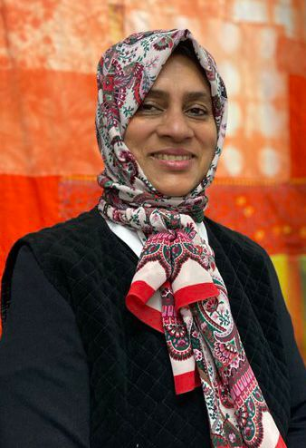

Figure : Panel member Taslima Ahmad

### The Violence against Women and Girls group:

The Violence Against Women and Girls (VAWG) group met frequently over the past year, exploring important topics such as: the Victims Bill, preventing and policing hate crime, Greater Manchester Police's VAWG Delivery Plan, police response to public protection and domestic abuse, the Police Perpetrator Act, and police behaviour and abuse of position of trust.

In addition, an important focus for the VAWG group over the last year has been to strengthen its relationships with GMP, the Gender Based Violence Board (GBV Board), and GMCA, recognising the important roles these organisations play in working to end VAWG.

The VAWG working group was bolstered this year by the addition of two GM4Women coalition members, Dee Sheeran and Omolade Femi-Ajao, who joined as "working" members. They represent the GM4Women Safety group, whose work closely aligns with that of the VAWG group, and they have provided valuable input and support.

The group has made significant progress in building a stronger relationship with Greater Manchester Police (GMP) through the efforts of Chief Superintendent Nicky Porter. Nicky was invited to join the VAWG group at the end of 2021 and later joined the full Panel, fostering an open relationship where both parties can rely on each other for assistance with various tasks and issues.

The VAWG group also wrote a letter to Andy Burnham, with a focus on how to improve outcomes for women and girls in Greater Manchester in relation to the VAWG agenda. Despite progress in the GBV Strategy and the recent Safer Streets initiative, significant gaps remain, and the group has expressed a willingness to work more closely with policymakers to improve the outcomes for women and girls. The Mayor acknowledged the severity of violence against women and girls and highlighted his efforts to address the issue through campaigns and improved safety measures on public transport and suggested, amongst other things, that the VAWG group involve the new Deputy Mayor Kate Green more in the coming year. Subsequently the Deputy Mayor attended a Panel meeting and expressed her support for the Panel’s work in this area, recognising the reach across to her role as Deputy Mayor. The Panel has since supported her on the Greater Manchester response to the consultation on the Police Code of Ethics.

The main areas of work considered by the VAWG working group are set out in greater detail below, along with some key outcomes and examples of how the group’s work has influenced change:

#### Accountability in relation to the Gender Based Violence Strategy

We are fully supportive of the GBV Strategy and have been keen to play a key role in its successful implementation. Concerns were raised this year within the group about our value as an "accountability body" and the challenge function we could provide to the Gender-Based Violence (GBV) Board. We also wanted to be more involved with the design and development of relevant new initiatives as our Panel members have valuable reach and insight into the current realities of those experiencing VAWG.

We asked Andy Burnham to consider how the strategy can make better use of the skills and expertise of the Panel by involving it in the design and development of initiatives to tackle VAWG at the start of the process, in addition to being part of a team ensuring these initiatives are effectively implemented and deliver the change we all want to see.

In response, Carol Judge-Campbell, who leads on the delivery of the GBV strategy for GMCA, was invited to join the working group. There have since been a number of positive developments including the VAWG group being asked to provide feedback on videos for the #IsThisOkay Communication Campaign aimed at educating men and boys and supporting them in calling out sexual harassment, online abuse and stalking, amongst other things, as well as participating in the evaluation of the latest phase of the campaign.

#### Violence against women and girls: Data landscape

The group faced challenges in accessing current data and evidence relating to violence against women girls which limited our ability to identify gaps and participate in the design and development of new initiatives. After discussion about this with Andy Burnham, we have set up a joint Data Working Group between GMCA and the VSCE sector to better understand how VAWG data is currently collated, compiled, shared, and used to inform GMCA Strategy and Policy and consider what data is missing. We are especially keen to develop new data sets that will support early identification of VAWG and track incidents right through to the survivor’s recovery. We are also keen on developing key performance indicators that can demonstrate the success of VAWG initiatives.

#### **Violence Against Women and Girls and Greater Manchester Police**

The group has highlighted the prevalence of violence against women and girls across all age groups, with marginalised groups including sex workers, migrant women, disabled women, LGBT+ women, and women of colour, being at an even greater risk of violence and facing additional barriers in accessing support services. It noted the underreporting of violent crime, a lack of understanding of rape and consent within the public, a culture of victim-blaming, and low conviction rates for sexual assault. The group found that the current system is failing victims of VAWG and that recent high-profile cases have exposed a culture of misogyny and collusion within some institutions, particularly the police force.

Following the VAWG group’s development of a Standards and Expectations list for the GMP to adhere to when it came to dealing with migrant women, GMP started working with two of the VAWG members, Vicky Marsh from Safety4Sisters (an organisation supporting migrant women with no recourse to public funds) and Memory Nyahunzwi from Olive Pathway (an organisation that tackles Domestic Abuse and VAWG within ethnic minority communities) to create a training programme which would help police deal with cases where women victims and survivors have no recourse to public funds. The police had offered to help with some funding while Safety4Sisters & Olive Pathways created a training package for the police which would train senior officers, provide e-learning, and establish feedback groups for communities to engage in. The two organisations would focus on teaching the police about immigration, forced marriage and so-called honour-based violence/ abuse, and cultural competence.

We also heard from Superintendent Jamie Daniels who discussed the Greater Manchester Police's response to domestic abuse and how they are addressing the issue. With a newly created team, Supt Daniels plans to develop a more effective response to domestic abuse, including exploring innovative protective orders and applying to become a pilot force for the new Domestic Abuse Protection Orders.

##### "It has been another busy year for the VAWG working group, with a focus on three key priorities: increasing trust and accountability in public services, engaging men and boys in this agenda, and ensuring that the voices, lived experiences, and realities of VAWG victims are at the forefront of our influencing and driving our ambitions forward. Throughout their lives, women and girls remain at increased risk of violence, with significant data gaps, underreporting by victims, and low conviction rates. Underpinned by the 10-year GM Gender-Based Violence Strategy, we recognize the need for a joined-up approach and radical reform to dismantle systems and societal influences in order to improve outcomes for women and girls."

##### Annie Emery, MASH, VAWG Chair.

## Future Focus

### The Panel has gone from strength to strength over the last 12 months and as it moves into its third year it will continue to play a lead role in reducing gender inequality in Greater Manchester. The Panel will continue to build on its programme of activity, working with partners and stakeholders to deliver real change and continuing to provide intersectional input to GM strategies.

### In 2023 and beyond, the Women and Girls’ Equality Panel is committed to driving equality in women and girls’ health. We have been a key stakeholder so far in providing valuable input into the GM Integrated Care Partnership Strategy and the GM Women's Health Strategy. Our Panel members and Allies Network bring professional and lived experience of the challenges faced by women and girls, in particular the impact of women’s health on employment opportunities, and healthcare services that do not address women and girls’ differentiated needs.

### We will continue to support GM4Women in furthering their goal of reaching gender equality in Manchester by 2028. We will continue to build our Allies Network and gather data and insight on the needs of women and girls in Greater Manchester in partnership with GM4Women2028 through engagement workshops at their Dialogue, Deeds and Determination events and the annual Pankhurst-Fawcett Gender Equality Scorecard.

We will continue to pursue the ‘Asks’ we put to Andy Burnham including improved support for mental health and career services for young girls, promoting digital skills training and exploring existing programs like Enterprising You for self-employment support.

The ESE working group has defined its priorities for the next two years, which include: employment and menopause, entrepreneurship, and sports and leadership.

We will continue to contribute to the development of the Good Employment Charter to make sure it reflects the specific needs of women in employment including childcare, menopause, and sexual health and reproductive challenges.

The VAWG working group has also been developing its priorities which include policing and criminal justice, the creation of whistleblowing guidance for victims of police misconduct, and ongoing support with the delivery of the GBV strategy and the #IsThisOkay Campaign. You can view our workplan on our website.

In 2022 we discussed how to ensure that women and girls’ equality, and safety is adequately considered as part of the decision-making process in GM, for example, by taking part in Equality Impact Assessments where these are carried out on all major policy and strategy decisions. This is a theme we will continue to explore over the next year.

A key aim for 2023 is to increase awareness of the Panel and have greater transparency around the work we do. With this in mind, we are posting regularly on social media, providing public summaries of our meetings, and communicating regularly with our Allies Network through Basecamp where we share relevant events and consultation opportunities. Going forward, we are also keen to explore the potential for releasing position statements on current topics and legislation.

“In 2023, we will be working more closely with the Mayor, Deputy Mayor, and wider partners, developing a robust action plan, and tracking our progress. It's humbling and inspiring to chair a group of such passionate change makers. My thanks go to all members of the working group for their dedication and commitment.”

**Annie Emery, VAWG Chair, MASH**

## Contact us!

Organisations or members of the public wishing to get involved in the Panel’s work can join one of the GM4Women subgroups. The subgroups’ [themes](https://www.gm4women2028.org/thematic-reports/) include Education, Safety, Culture & Active Lives, Participation in Public Life or Employment. You can also join our Allies Network to get Panel and working groups updates, invitations to consultations and information about issues affecting women and girls in Manchester. Just email [womenandgirls@pankhursttrust.org](mailto:womenandgirls@pankhursttrust.org) and ask to sign up to our Basecamp.

You can also keep up to date and get involved with the Women and Girl’s Equality Panel by following [GM4Women 2028](https://www.gm4women2028.org/) on [Twitter](https://twitter.com/GM4Women2028), and Manchester Women’s Aid on [Instagram](https://www.instagram.com/mancwomensaid/), [Facebook](https://www.facebook.com/mancwomensaid/) and [Twitter](https://twitter.com/MancWomensAid).