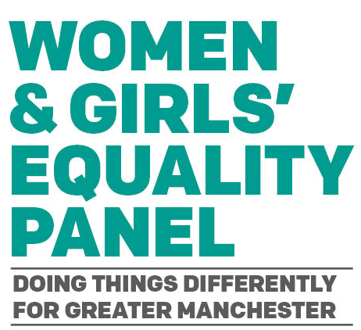
Position Statement on the Urgent Need to Address Women's and Girls' Rights in Gaza:
The GMCA Women and Girls’ Equality Panel stands with all victims of violence, and we are appalled at the targeting of civilians in Gaza and Israel. The escalating Israel-Palestine conflict following the 7th October attack by Hamas and the retaliation by Israel, is disproportionately impacting women and girls, leading to increased gender-based violence, including sexual and psychological abuse. Internally displaced women face heightened risks, including sexual and labour exploitation, human trafficking, and forced marriage, due to the loss of livelihoods, housing, and land.
As a women and girls equality panel, we are confronted with the heartbreaking reality that over 50,000 pregnant women in Gaza cannot access essential health services, food, clean water, or shelter. This situation is exacerbated by a collapsing hospital system, leaving women in Gaza in dire straits. Furthermore, approximately 5,000 women are expected to give birth in the next 30 days, but they do so amidst the absence of critical medical support, leading to tragic miscarriages and stillbirths. Some women are forced to undergo C-sections without anaesthesia, and babies are being cut out of their deceased mothers.
We must recognise that advocating for gender equality cannot be confined to our local contexts. We must extend our commitment to the rights and well-being of women and girls in Gaza, who are enduring unimaginable hardships due to the ongoing conflict. The situation in Gaza is not just a regional concern; it is a global issue that demands our collective action.
We welcome the pause in hostilities to allow for humanitarian aid and the release of Israeli hostages and Palestinian prisoners, but achieving lasting peace requires dialogue and diplomacy. Our position is clear. As a women and girls equality panel, we join Andy Burnham and the leaders of the 10 boroughs in GMCA to demand a lasting ceasefire.

Women’s Peace & Humanitarian Fund, New Funding Appeal to Support Women’s Civil Society, Respond to Escalating Crisis and Humanitarian Needs in Palestine Women’s Peace & Humanitarian Fund
Israel-Palestine war: What it's like to be pregnant in Gaza | Middle East Eye
INTERVIEW: 5,500 women in Gaza set to give birth ‘in race against death’ | | UN News
The Mayor, Deputy Mayor and ten Leaders of Greater Manchester have joined the international calls for a ceasefire by all sides in Gaza - Greater Manchester Combined Authority (greatermanchester-ca.gov.uk)

