Report from the GMCA Greater Manchester Information Strategy Priority Setting Workshops
28th April 2023

Contents
Report from the GMCA Greater Manchester Information Strategy Priority Setting Workshops 0
Executive Summary 3
Context 4
Methodology 5
Participation 6
Creating a rank order 6
Deliverables and their relationship to the six Missions 8
All deliverables 8
Mission 1. 8
Mission 2. 9
Mission 3. 9
Mission 4. 10
Mission 5. 10
Mission 6. 11
Discussions around Deliverables in rank order 12
‘Community engagement’ – Mission 1 & Mission 6 12
‘Better use of data’ – Mission 5 12
‘Enhancing and strengthening governance’ – Mission 1 and Mission 3 13
‘Better information communication’ – Mission 1 13
‘Better information accessibility ‘– Mission 1, Mission 2 & Mission 3 14
‘Countering misinformation and enhancing trust in information’ – Mission 1 14
‘Understanding trust’ – Mission 1 14
‘Inclusive governance’ – Mission 3 15
‘Implementing information standards’ – Mission 1 & Mission 5 15
‘Developing information management standards’ – Mission 4 & Mission 6 15
‘Communicating information rights’ – Mission 1 15
‘Developing information standards’– Mission 1, Mission 3 & Mission 5 16
‘Better information signposting’ – Mission 1 16
‘Opening up more data’ – Mission 1, Mission 2 & Mission 3 16
‘Networking, peer learning and sharing best practice’ – Mission 1, Mission 2, Mission 4, Mission 5 & Mission 6 17
‘Improving information sharing approaches’ – Mission 4 17
‘Understanding emerging information policy’ – Mission 3 17
‘Implementing data ethics’ – Mission 2 17
‘Improving digital infrastructure’ – Mission 3 & Mission 5 18
‘Improving information governance services’ – Mission 6 18
‘Using the right tools when using information’ – Mission 5 18
‘Developing guidance and tools’ – Mission 3 18
‘Communicating information policy’ – Mission 2 & Mission 3 19
‘Using procurement to improve the information ecosystem’ – Mission 1 & Mission 2 19
‘Engaging with related policy teams’ – Mission 3 19
‘Monitoring and measuring success’ – Mission 4, Mission 5 & Mission 6 19
‘Improving approaches to data ethics’ – Mission 2 19
‘Improving information management standards’ – Mission 1, Mission 2 & Mission 4 19
Conclusion 20
Appendices 21
Deliverable summaries 21
Better information accessibility 21
Better information communication 21
Better information signposting 21
Better use of data 21
Communicating information policy 21
Communicating information rights 22
Community engagement 22
Countering misinformation and enhancing trust in information 22
Developing guidance and tools 22
Developing information management standards 22
Developing information standards 23
Engaging with related policy teams 23
Enhancing and strengthening governance 23
Implementing data ethics 23
Implementing information standards 23
Improving approaches to data ethics 24
Improving digital infrastructure 24
Improving information governance services 24
Improving information management standards 24
Improving information sharing approaches 24
Inclusive governance 25
Monitoring and measuring success 25
Networking, peer learning and sharing best practice 25
Opening up more data 25
Understanding emerging information policy 25
Understanding trust 26
Using procurement to improve information ecosystem 26
Using the right tools when using information 26

Executive Summary
After the adoption of the Greater Manchester Information Strategy in January 2022, the commitment was made to conduct an open consultation that would help the Greater Manchester Combined Authority (GMCA) establish the priorities for achieving its vision. As part of this, Open Data Manchester (ODM) designed and delivered five workshops that would help GMCA turns its 28 Deliverables, linked to six core Missions (see: Context), into priorities for action.
Interestingly given the focus of Mission 1 – to foster trust between the people, communities, and businesses of Greater Manchester through greater transparency – though perhaps unsurprisingly, considering the issues at hand, a key concern identified was the issue of trust.
Reassuringly, the top Deliverable chosen would help meet this head on – that of ‘community engagement’ – and indeed, participants suggested that a parallel, general Engagement Strategy could help GMCA ensure that any project builds the perspectives of the community into its work.
The workshop participants emphasised the importance of engaging with the right people in the right communities, involving residents in co-designing processes, and communicating information policies and rights.
They stressed that the strategy also needs to address digital poverty to ensure inclusion of harder-to-reach groups, and continuously evaluate and enhance existing policies to mitigate potential inequalities exacerbated by new processes and technologies.
We know that people may not have the means to engage with general consultation processes or to understand projects being done related to digital or data, a fact that must not be lost on those who deal with data day to day. We therefore suggest that a people-first, rather than technology-first, approach should be seriously considered.
Though community engagement was clearly a concern for the participants, followed by ‘better data use’, much of what happens next must rest on robust, responsive and transparent governance frameworks. Indeed, the third priority identified was the ‘enhancing and strengthening governance’, followed by ‘better information communication’ and ‘better information accessibility’.
It is also necessary to highlight that, even though people identified their highest priorities through this process, it was clear during the subsequent discussions that most of the Deliverables were important to implement. Participants also made clear that many issues and concerns cut across Deliverables and Missions.
This process must be followed up with turning the Deliverables into actions – the ‘how’ and ‘when’ – without forgetting that any documents, policies or guidelines created must be considered part of a living process.

Context
The first-ever Greater Manchester Information Strategy was adopted in January 2022 by the Greater Manchester Information Board, the Greater Manchester Combined Authority (GMCA), and the 10 boroughs of Greater Manchester.
It recognises that developing a better information ecosystem can support the wider Greater Manchester Strategy’s vision of creating a greener, fairer and more prosperous city region.
The Greater Manchester Information Strategy has six ‘Missions’:
- Foster trust between the people, communities, and businesses of Greater Manchester through greater transparency.
- Promote and maintain the responsible and ethical use of information.
- Establish inclusive and proactive governance to drive the strategy.
- Enhance the skills, capabilities, and behaviours for good information management.
- Develop and implement the tools, infrastructure and standards needed to manage and use information properly.
- Create an information governance framework for Greater Manchester that acts together as one.
To achieve these missions, the GMCA committed to an open consultation later that year to help identify the actions, the ‘Deliverables’, needed for these missions to be achieved.
After this, Open Data Manchester (ODM) was asked to run a series of virtual and in-person workshops so that local people, communities and businesses could have their say on which actions should be prioritised. Participants were asked the following questions:
- What actions are necessary for the success of the Information Strategy’s six Missions?
- What actions should be taken first?
- Are there any areas of work we have missed that might be important?

Methodology
Open Data Manchester received the results of the open consultation, published by GMCA in late 2022, including a list of 28 Deliverables that were identified through this process. Each Deliverable was linked to one or more of the six Missions it relates to (see: Appendix for full breakdown).

ODM held five workshops during March 2023, four online and one in-person. These were scheduled at various times of the day, including morning, afternoon and evening, to maximise participation.

Three of the online workshops covered specific Missions and the Deliverables related to them, allowing for deep investigation. The final online workshop and the in-person workshop covered all six Missions.
The initial analysis undertaken by the GMCA was complex, so the adopted approach aimed to create a manageable and accessible workshop experience for those who joined.
Because each of the Deliverables had already been assigned to its respective Mission(s), for the workshop programme, ODM used this as a tool to establish a rank order based on the relative importance given to each Deliverable by participants.

To do this, the Deliverables were allocated random identification numbers, to reduce confirmation bias, and participants were first asked to select which Deliverables were most important to them. The deliverables can be found in the appendices at the end of this report.

They were then asked to place each one on a scale divided into three sections – representing ‘high’, ‘medium’ and ‘low’ priority – with a maximum of five in the top section.

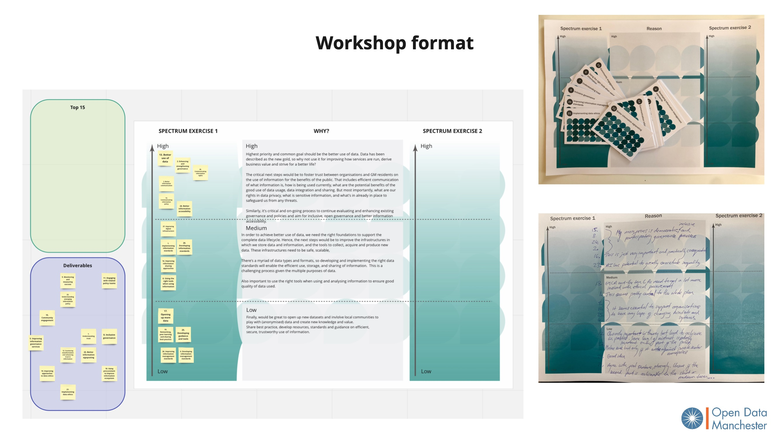
On and off line worksheets and Deliverables cards (Fig 1.)

There was specific complexity identified within the documentation supplied, and to an extent in the resulting process, because some Deliverables were dependant on others being achieved. For example, the Deliverable of ‘opening up more data’ is very likely dependent on ‘improved digital infrastructure’ and ‘improving information governance services’, as well as the ‘implementation of information standards’.
Similarly, a number of Deliverables reflected different stages of strategic maturity within the same domain, such as ‘developing information standards’ and ‘implementing information standards’, meaning the former would necessarily need to be achieved before the latter.
Once participants had decided what their priorities would be, they were asked to write some context to explain their rationale. This exercise was carried out individually, followed by an in-depth group discussion led by a facilitator.

After this, participants had the option of carrying out a second ranking exercise to incorporate any changes that they might want to make as a result of the discussion.

The ranking exercise was specifically designed for the project, with Deliverable cards printed for the in-person workshop (fig 1.), which were replicated online using a Miro board. For those who were unable to use Miro, ODM created a simpler version of the selection process using Google Docs.

Participation
In total, Open Data Manchester ran five workshops, with four being held virtually and one in-person. We had a total of 22 participants from across public, private and academic sectors.
Date | Time | Missions explored | Format | Attendees
13/02/2023 | 1-3pm | 1 | Online | 7
28/02/2023 | 1-3pm | 2,3 | Online | 3
02/03/2023 | 10am-12pm | 4,5,6 | Online | 3
03/03/2023 | 1-3pm | All | In-person | 4
07/03/2023 | 6.30-8.30pm | All | Online | 5

Creating a rank order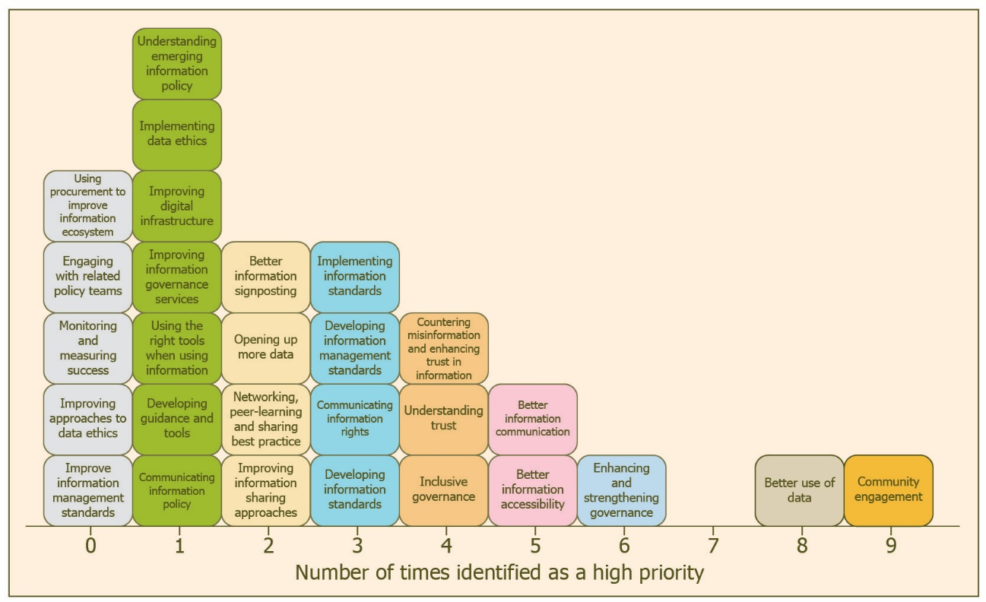Distribution of priorities low to high (Fig 2.)
The rank order was created by counting the number of times a particular Deliverable appeared in the highest priority section of the worksheets. The distribution of these choices is mapped in Fig 2.

The table below shows the total number of times a Deliverable was placed into the ‘high’ level on our ranking scale.
Deliverable identified from consultation | Instances
Community engagement | 9
Better use of data | 8
Enhancing and strengthening governance | 6
Better information communication | 5
Better information accessibility | 5
Countering misinformation and enhancing trust in information | 4
Understanding trust | 4
Inclusive governance | 4
Implementing information standards | 3
Developing information management standards | 3
Communicating information rights | 3
Developing information standards | 3
Better information signposting | 2
Opening up more data | 2
Networking, peer learning and sharing best practice | 2
Improving information sharing approaches | 2
Understanding emerging information policy | 1
Implementing data ethics | 1
Improving digital infrastructure | 1
Improving information governance services | 1
Using the right tools when using information | 1
Developing guidance and tools | 1
Communicating information policy | 1
Using procurement to improve information ecosystem | 0
Engaging with related policy teams | 0
Monitoring and measuring success | 0
Improving approaches to data ethics | 0
Improving information management standards | 0

Though ‘community engagement’ and ‘better use of data’ did not appear among the top Deliverables from the original, open consultation, in the workshops they clearly had the highest importance placed on them.
It is also worth highlighting that, even though people identified their highest priorities here, it was clear during the subsequent discussions that most of the Deliverables were really important to implement.
It became clear that many points made and concerns raised by participants cut across Deliverables and Missions.

Deliverables and their relationship to the six Missions
The following graphics show how the prioritised Deliverables map on to the Information Strategy’s six missions. Deliverables are stacked so that the ones that are deemed to have highest priority are on the top Fig 3.

All deliverables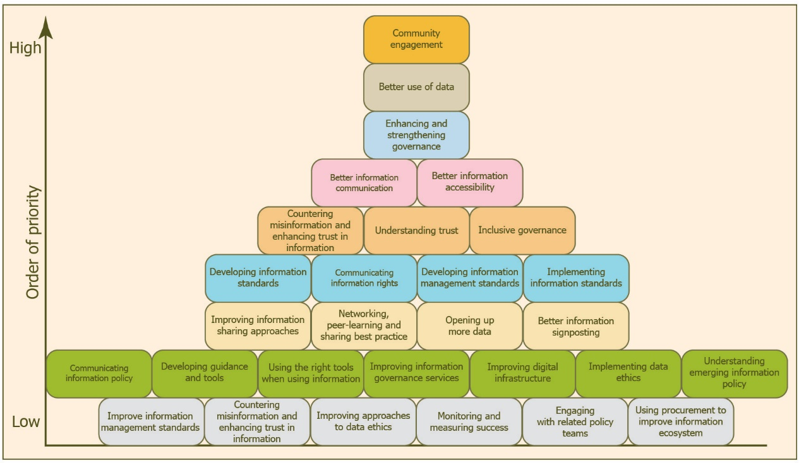All deliverables (Fig 3.)

Mission 1.
Foster trust between the people, communities, and businesses of Greater Manchester through greater transparency Fig 4. Deliverables not covered within the mission are faded.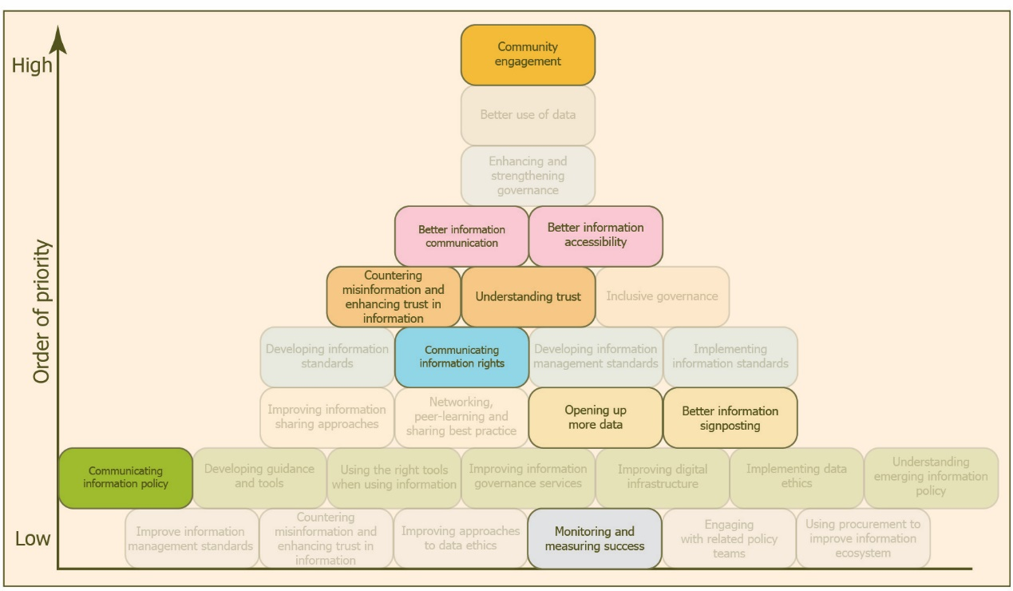
Mission 1. Deliverables (Fig 4.)

Mission 2.
Promote and maintain the responsible and ethical use of information Fig 5.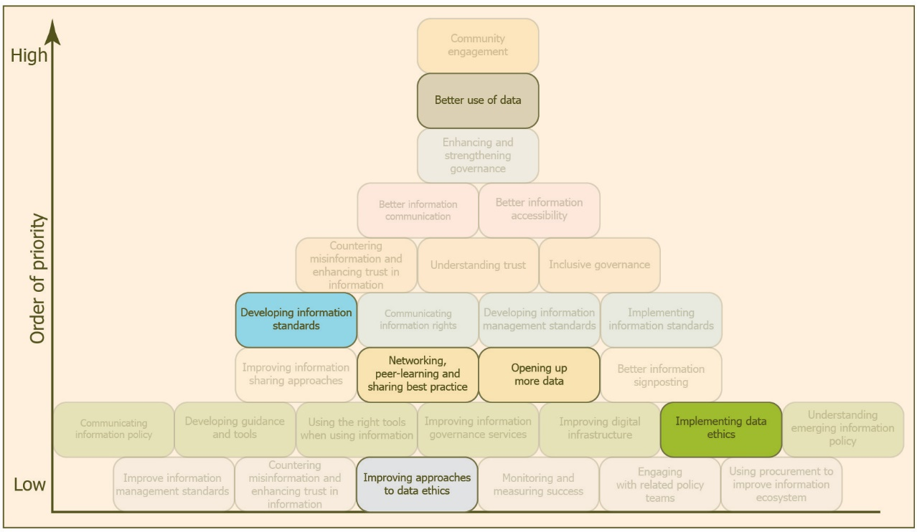
Mission 2. Fig 5.

Mission 3.
Establish inclusive and proactive governance to drive the strategy Fig 6.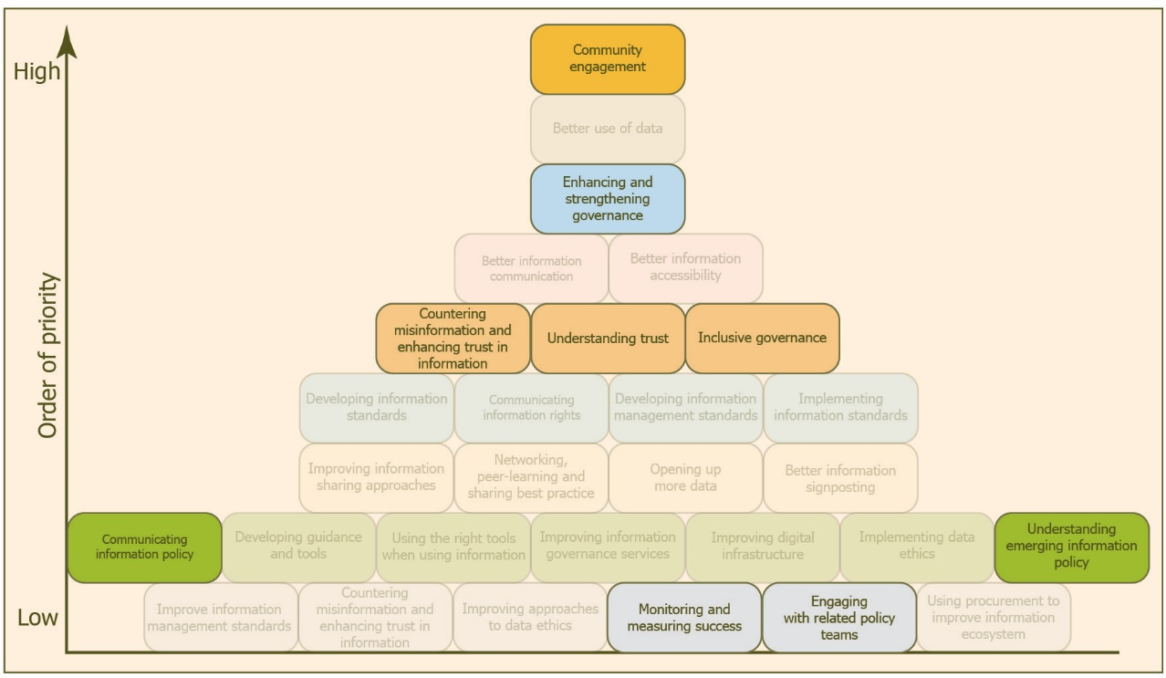
Mission 3. Fig 6.

Mission 4.
Enhance the skills, capabilities, and behaviours for good information management Fig 7.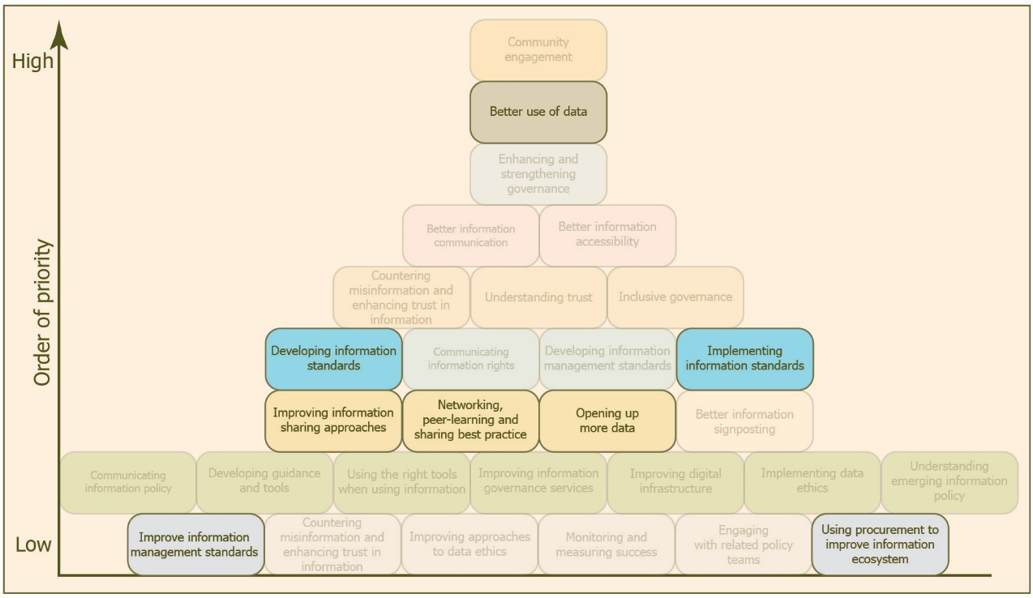
Mission 4. Fig 7.

Mission 5.
Develop and implement the tools, infrastructure and standards needed to manage and use information properly Fig 8.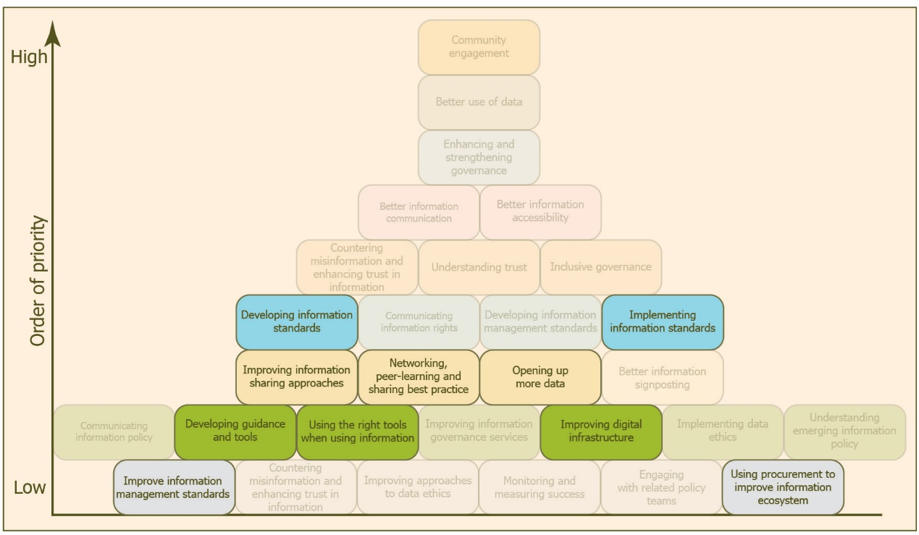
Mission 5. Fig 8.

Mission 6.
Create an information governance framework for Greater Manchester that acts together as one Fig 9.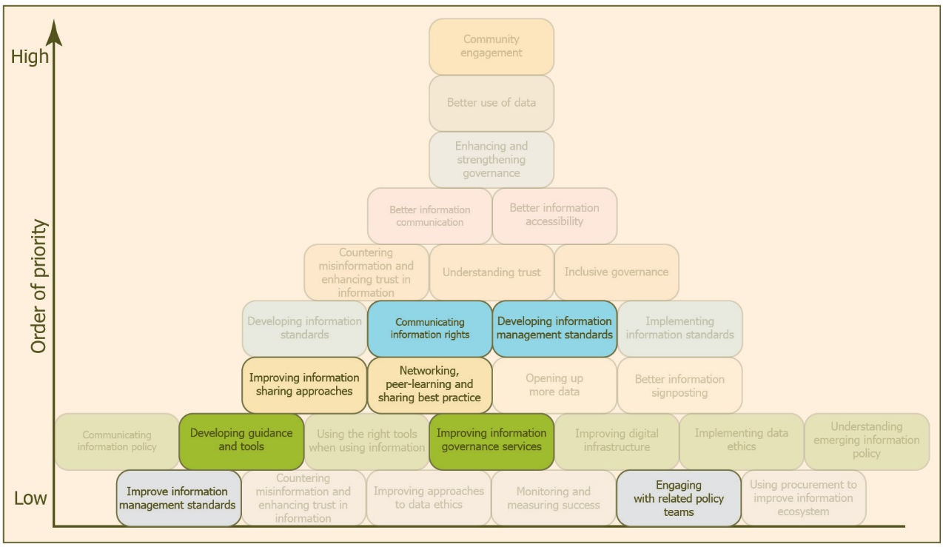
Mission 6. Fig 9.

Discussions around Deliverables in rank order

‘Community engagement’ – Mission 1 & Mission 6
This Deliverable was revealed as the most important for most participants, and the discussions were wide and far reaching.
There seemed to be consensus that all data and information initiatives should start with the community, particularly the people who will be affected by policies or insights created using data or data platforms, rather than a taking a technology-first approach.
The need to build trust was deemed essential, and was mirrored across many of the discussions around the Deliverables, and participants thought that community engagement is likely the bedrock of this.
Participants suggested that community engagement must be a foundational aspect of the Information Strategy and needed to be factored in from the beginning, using transparent processes and methods of engagement. Indeed, they suggested that the community should be involved with the co-design of these processes as their knowledge and lived experience is crucial.
Seeking the widest possible consultation, going out into communities, making effort to engage with the right people, in the right settings, and talking to people about how data can be used and what is being done, were all key for building trust and engagement.
Many participants saw that engagement was an ongoing process and it was important to inform communities about how their data is being used and any findings that result from its use. This could also enable the building of better relationships with service providers and the wider public.
It was also highlighted, and is vital to remember that, even though the Information Strategy is focused on data and digital, not everyone will be able to participate, especially if the mode of engagement is online, therefore it is important to adopt both online and offline approaches.
One participant highlighted that organisations, including the NHS, should try to be more inclusive and engage with lay people in ways that are accessible. Citizen panels were identified as an effective method of engagement.
Highlighting the importance of this Deliverable, it was suggested that there needed to be a Greater Manchester Engagement Strategy outlining the steps for effective consultations and the better dissemination of information more generally.

‘Better use of data’ – Mission 5
Many participants said the need for better use of data is a primary and overarching concern. Echoing the community engagement conversations, the need to be transparent with data use is seen as crucial to building trust and steps must be taken for people to see how their data is used.
Better use of data should also be prioritised as it was considered the key way to derive business value from data collection, identify improvements within existing systems and enable research that could help improve services for Greater Manchester residents.
A number of participants with experience of the public sector suggested there is often a gap between the collection of data and its effective use, and there is a need for robust methodologies that make clear any assumptions made when interpreting the results and informing policy. It was highlighted that data silos exist and these hinder the better use of data.
The discussions touched on the need for better data governance processes that maintain anonymous datasets, and highlight the need to apply learnings from such data collection, creating virtuous cycles that help maximise resources and inform future data collection.

‘Enhancing and strengthening governance’ – Mission 1 and Mission 3
Participants saw that governance needs to be central to the Information Strategy and, with its linked Deliverable of ‘inclusive governance’, this again emphasised the need for community engagement and building trust. This would also involve communicating information rights and letting residents know how information is being handled.
The workshop participants suggested that local public-sector organisations within Greater Manchester should align their governance objectives with the strategy through a governance framework, which could ensure broader accountability across relevant organisations.
It was observed that the building of a robust and accountable framework would help foster trust within and between relevant bodies and residents. It was also seen that a framework could also help bridge the gap between data and policy, through the development and sharing of any research and analysis methodologies.
For governance frameworks and related policies to remain fit for purpose, it was suggested that there needed to be a process of continuous evaluation, especially where new technologies, such as automated decision-making, become more prevalent. Attention here needs to be focused on the potential negative impact of these technologies, not least how they can exacerbate existing inequalities.

‘Better information communication’ – Mission 1
Again, the workshops highlighted that better information communication was essential in helping foster trust between organisations and the public as it would help people understand how data is used for public benefit.
An example was given by a voluntary-sector representative around how there was reluctance from staff to collect certain types of demographic information, reflecting a need to better communicate why certain types of information are collected and how they are used.
This is especially important as certain types of demographic monitoring are essential for ensuring the effectiveness of service delivery and, when properly explained, people do understand this. Proper explanations could help overcome the present lack of good quality demographic monitoring.
As part of communicating how information is used, it was suggested that relevant organisations identify quick wins, especially through case studies. Other efforts should also be made for efficient communication about how data is used, and the potential benefits of good data use, data integration or sharing.
More generally, communicating people’s rights regarding data privacy, sensitive information and safeguarding from any cyber threats or information abuse were seen as critical. The fact that it is not well communicated that people can opt out of research relates to this. This is especially important when bodies are collecting health information.
The Information Strategy needs to ensure it embeds a good understanding of the ways that people access information as more traditional routes, such as through newspapers and libraries, are important for those who may not have online access.

‘Better information accessibility ‘– Mission 1, Mission 2 & Mission 3
Tied to ‘better information communication’, this Deliverable further highlighted the need for more accessible data and information, and greater transparency regarding data processes. This too will help enhance trust.

‘Countering misinformation and enhancing trust in information’ – Mission 1
Within the workshop, it was thought that this Deliverable was extremely important, but challenging to achieve in practice. There was a sense that effort should be made to make Greater Manchester’s information processes trustworthy and efficient by ensuring that residents are able to access data that is factually correct, which is crucial for people to trust in and rely on it.
There was a certain amount of reflection regarding this point, with an acknowledgement that the internet and data can be used in both positive and negative ways, and that education on the good use of data and the internet is important. Additionally, it was noted that some level of mistrust was probably important so that people didn’t leave themselves open to malicious actors.

‘Understanding trust’ – Mission 1
As has been highlighted in previous Deliverables, building trust is crucial for effective use of data. So it is vitally important to understand people's concerns and address them to achieve this.
It was suggested that people may be reluctant to share their information due to concerns about safety or potential consequences. An example was given relating to digital inclusion and questions around internet access at home. It was suggested people may be concerned that if they don’t have internet access, but have children, that social services will be informed.
Similarly, with the ‘countering misinformation and enhancing trust’ Deliverable, it was pointed out that a level of mistrust was important to ensure data privacy and security.

‘Inclusive governance’ – Mission 3
It was found that inclusive governance had to be underpinned by transparency and, even though organisations themselves might not seek to be opaque, difficulty in finding information regarding governance processes might create the impression of something being hidden, which can impact trust.
A case in point was the highlighting of the GMCA’s own information governance processes, which were considered difficult to access, and the related mechanisms around data governance, such as the Greater Manchester Information Board, needed to be more transparent and representative.
As with the ‘community engagement’ and ‘enhancing and strengthening governance’ Deliverables, involving members of the community would help more residents understand what, how and why information is being used. It was stated that the voice of people whose data is being shared is the most important thing.

‘Implementing information standards’ – Mission 1 & Mission 5
Within the workshops, it was explained that from a technical perspective, information standards were foundational as they can improve quality, interoperability and maintenance. Standardised information could also enhance trust and give assurance to the quality of data.

‘Developing information management standards’ – Mission 4 & Mission 6
Although information management standards are related to data governance, it was pointed out during discussion related to this Deliverable that metadata is underused, and the language used to describe data is full of subject-specific knowledge and acronyms.
This lack of metadata and related documentation could mean that if you're a potential data user working outside of their subject area, you might not know what the data is describing, inhibiting the potential for reuse.

‘Communicating information rights’ – Mission 1
Similarly to ‘better information communication’, this Deliverable highlights the need for organisations to communicate information policies and information rights to individuals. It was seen here as important to provide individuals with information on how to control their data, such as opting out of data storage or limiting its use in specific algorithms.
It was stated that the Information Strategy should ensure a wide approach to inform people of their information rights, and the ways they can influence decisions on how their data is stored and processed.
It was also stated that part of this Deliverable should address digital poverty to ensure the strategy is inclusive.

‘Developing information standards’– Mission 1, Mission 3 & Mission 5
Much of what was discussed here echoed the ‘better use of data’ and ‘implementing information standards’ Deliverables, but a further need was expressed – that GMCA should develop information standards that would help identify similarities and differences across the region. Within public health, this could help identify regional variation and targeting for relevant campaigns.
Here is was emphasised that the creation of guidelines for creating and using data could help meet the needs for interoperability and easier maintenance, and thus the trust in and quality assurance of the data expressed as ideals in relation to other Deliverables.

‘Better information signposting’ – Mission 1
Within the workshop, it was acknowledged that there was a lot of data that could be used, but might not be easily found, which can create additional overheads. Given the proliferation of data already in existence, enabling navigation of existing datasets is important. This will create efficiencies and can also create confidence in data usage.
For local people, it is important they know where and how to find information relating to their information rights, along with supporting information to enable them to understand how to apply them.

‘Opening up more data’ – Mission 1, Mission 2 & Mission 3
From the initial consultation from which the 28 Deliverables were derived, responses relating to opening up more data were raised most often than other areas.
Within the workshops, it was acknowledged that opening up more data should be an important focus of the strategy, as it could enhance trust, but this was seen as part of a broader process of transparency.
Participants commented that local authorities and related organisations might be making a minimum amount of data available due to information governance concerns and that this would need to be addressed. Related to this, it was suggested that people need to feel comfortable with data being opened up and that it needs to be done in the right way.
It was seen that accessible, open data can help people understand more about Greater Manchester, but there needs to be some focus on educating people about the world of data and how it is used.
It was highlighted that just releasing data is not enough and it is important to ensure that the community is getting the information they want and need, rather than simply providing data that may not be relevant. This could be said for all data re-users, from individuals to organisations.

‘Networking, peer learning and sharing best practice’ – Mission 1, Mission 2, Mission 4, Mission 5 & Mission 6
Participants felt that many of the challenges that local authorities and public-sector organisations face with data use are not unique, and sharing ideas and best practices among councils would help accelerate learning and cooperation.
This was emphasised through the suggestions of a need for regular skills training and awareness-raising events for practitioners and the creation of a peer-learning network that can highlight best practice through success stories and showcasing the collaboration tools people use. This can have additional effects of making information sharing easier and helping practitioners gain confidence.
The development of skills was also highlighted as important for those who may not be digital users.

‘Improving information sharing approaches’ – Mission 4
Better information sharing was found to have benefits for both residents and service providers. There appeared to be a difficulty of having information spread across different services, especially when there was a need to engage with a particular person. This created inefficiencies and also meant that the person may be targeted on multiple fronts, rather than through a unified system.
A voluntary organisation involved with service delivery stated that the present situation creates an information asymmetry, where information flows to commissioners, but there is no reciprocal flow that would enable them to deliver services more effectively.
It was acknowledged that information sharing also includes the ability to know where or who has information and that the means to access it are understandable.
Although covered by the ‘better information communication’ Deliverable, it was stressed that there was a perception within communities that public-sector organisations already shared information freely, which is not the case.

‘Understanding emerging information policy’ – Mission 3
There wasn’t any substantive discussion that covered this Deliverable, though the need for the Information Strategy to be aware of the impact of AI was mentioned.

‘Implementing data ethics’ – Mission 2
Apart from a comment that data ethics was an essential part of good governance, this particular Deliverable wasn’t discussed.

‘Improving digital infrastructure’ – Mission 3 & Mission 5
Discussions around this Deliverable split into technical infrastructure i.e. software, equipment and connectivity, and human infrastructure i.e. processes, skills and capacities.
Workshop participants identified that data had to be accessible and usable. This means that attention needs to be paid to information standards, and good digital infrastructure is needed at an organisational level to store and process information efficiently. Likewise, not all Greater Manchester residents have access to the internet or mobile phones, which needs to be accommodated within any strategy.
From a human infrastructure perspective, it was uncovered that good information policies, processes, and datasets are important for helping people do their work, and each have different metrics for evaluation. Improved digital infrastructure and easier data sharing were seen as a way of eliminating unnecessary administration. Paying attention to this was also suggested to be a way to improve trust.
As well as some residents not having access to the internet, it was raised here that many people’s first language is not English and this creates a further barrier to participation that must be considered.

‘Improving information governance services’ – Mission 6
There was no substantive discussion regarding this Deliverable, though comments related to governance were raised as part of other Deliverables.

‘Using the right tools when using information’ – Mission 5
The need for peer learning and training has been previously identified within the ‘networking, peer learning and sharing best practice’ Deliverable. Discussions here centred on the need to identify appropriate tools and methodologies. Participants suggested there are many relevant tools available, but some of these were described as ‘blunt’, so there was a need to know the appropriate tool for the task, with appropriate guidance to ensure that it was being used correctly. It was mentioned that the use of more appropriate tools could improve communication with other organisations.
It was also noted that even with the right tools there should be a certain amount of reflection regarding the outputs as these should not always be taken as a given.

‘Developing guidance and tools’ – Mission 3
As with the previous Deliverable, participants explained that while there are tools available, knowing the most appropriate one to use and having the guidance to use it properly were seen as being important.

‘Communicating information policy’ – Mission 2 & Mission 3
Although there was some discussion about information policy and not reinventing the wheel, no substantive insight was drawn here.

‘Using procurement to improve the information ecosystem’ – Mission 1 & Mission 2
It was found that procurement could be a lever to enable better data sharing through the commissioning of systems that enabled better data exchange and interoperability. It was also noted that Greater Manchester needed to be better at ethical procurement.

‘Engaging with related policy teams’ – Mission 3
No substantive comments were made about this Deliverable.

‘Monitoring and measuring success’ – Mission 4, Mission 5 & Mission 6
Although participants had commented about how measuring policies, processes and interventions is important, there were no substantive remarks about this Deliverable.

‘Improving approaches to data ethics’ – Mission 2
The discussion here highlighted the importance of having an ethics framework, and guidance and tools for ethical data use, as another essential aspect of building trust. It was also emphasised that information-governance services and projects should lead with their approaches to data ethics.

‘Improving information management standards’ – Mission 1, Mission 2 & Mission 4
There was no substantive discussion that hadn’t already been covered within the previous information standards Deliverables.

Conclusion
Given the complexities within the documentation supplied and some of the issues outlined in the methodology regarding the relationship between the Missions and the Deliverables, and between the Deliverables themselves, the workshops were designed with simplicity in mind.
Participants shared their experiences as people living in Greater Manchester, and offered any expertise in data use, to help produce a rank order that should provide clarity around priorities.
There are clearly overlaps among the Deliverables, perhaps indicating an opportunity for further review and condensing, as well as revealing some logical order for next steps.
But the key thing we heard from participants was that the Greater Manchester Information Strategy has to deliver for, and really be experienced as delivering, by the residents of Greater Manchester.
The need to build trust, whether through transparent governance processes or real community engagement, is crucial to this process.
There was particular focus was on the following actions:
- Prioritising community engagement and building trust, including engaging with the right people in the right communities, involving residents in designing processes, and communicating information policies and rights.
- Promoting the better use of data, which is dependent on more foundational Deliverables, such as data standards, governance, ethics and better access to data, either through better information sharing or open data.
- Developing an inclusive governance framework that is continuously evaluating and enhancing existing policies, focusing on the potential for new processes and technologies such as AI to exacerbate existing inequalities, and addressing digital poverty to make sure the strategy is inclusive for harder-to-reach groups.
- Ensuring responsible use of data through building a strong, robust, accountable governance framework to foster trust within and between organisations and individuals, clarify information rights, and make clear the processes and safeguards around the handling of sensitive information.
- Improving information communication by providing individuals with information on how to control their data, ensuring they understand their rights regarding the data that is held about them, and addressing the lack of good data on inequality due to resistance to sharing information.
- Supporting people to understand data about them and their communities, and to promote sharing, peer support, guidance and learning resources so that data users within public sector organisations are confident that they are using the right tools in the right way.

Appendices

Deliverable summaries

Better information accessibility
Accessibility is more than just openness. Accessible information means that all people are able to access and use information. Making information more accessible means taking actions that make it open to people who may require different languages, different formats, or clearer explanations.

Better information communication
When information is released or shared, that should be communicated clearly and comprehensively to all. This means using simpler, clearer language; avoiding ‘buzzwords’ or jargon; and being less vague when we talk about data and information.

Better information signposting
Part of making information more accessible is thinking about where it is placed. If people cannot easily find the information they seek, this can lead to distrust and a feeling that information is being ‘hidden’. Being clearer about what information is shared, and where people can access that, can help to reduce distrust. Signposting, or having consistent locations for the public to access information about an organisation, will help to improve trust and transparency.

Better use of data
Many organisations have access to a wide array of information. But often, it is not used to its fullest potential as it is kept in silos. Better use of data is therefore about better use of data within organisations – for example, when talking about schools, using the unique school reference number produced by the Department for Education, alongside the name of the school, so that people know which particular school is being referenced. But it is also about using tools correctly to make this more widely available – for example, using open standards for sharing non-personal information.

Communicating information policy
Information policy is a complex and wide ranging area, covering aspects of regulation and law relating to personal or commercially sensitive information; the use of a variety of digital tools to collect, process, manage, store, and share information; policies on open data and open standards; and data ethics and responsible use of information. To help improve trust in organisations and organisations’ use of data, we need to be better at communicating what information policy covers; Greater Manchester’s position in these areas; and the different roles that organisations play in the implementation of information policy.

Communicating information rights
Not everyone has perfect knowledge about their information rights. There are misconceptions about what information can be shared, and what rights individuals have and do not have when organisations access, use, or share their information. For example, people have the right for their information to be deleted, but not in the process of an active criminal investigation. Campaigns and communications about people’s rights – especially when people’s information is being collected – will help to improve trust in the management and use of people’s personal information.

Community engagement
An important aspect of the Information Strategy is being more inclusive – engaging more audiences, listening to more voices from a variety of backgrounds, and taking their views on board. Feedback suggests that generally smaller organisations, community groups and third sector organisations do not feel like they have a voice. This deliverable would focus on engaging with a wider community, and ensuring more of these voices are heard, and listened to.

Countering misinformation and enhancing trust in information
Trust is a complex issue. One aspect of it is trust in information – in data used to support arguments, or trust that information held is correct. Being more open about decisions, and the trustworthiness of information, can be crucial in helping to reduce distrust and to counter misinformation.

Developing guidance and tools
Consultation feedback suggested that while there is a lot of information on the rules and regulations organisations should follow, there was a lack of detail on how specifically to implement these rules internally – for example, through templates, tools and guidance. These tools and guidance could cover an array of subjects, including applying information governance principles, guidance on applying data schemas, or putting in place tools that help organisations work better (for example, a digital DPIA tool).

Developing information management standards
Information management standards would be set levels of service that organisations might be expected to meet when managing information assets. For example, this could include developing a skills gap analysis to understand what skills might be needed within an organisation.

Developing information standards
Information standards focus on what information is collected and recorded about certain subjects. Having consistent standards means that each organisation can collect and compare the same information, and it means that people can be confident knowing the same information is comparable. For example, the numbers of planning applications received in one district is comparable with the number received in another; or that information about expenditure at one local authority is comparable with expenditure at another.

Engaging with related policy teams
Everyone manages, shares, and uses information in different ways. Information policy therefore covers multiple thematic policy areas – from digital infrastructure and tools to legal compliance, to how information is used to inform policy. This deliverable would seek to ensure that information policy is linked with other policy areas in Greater Manchester.

Enhancing and strengthening governance
It is important that there is oversight of the development and implementation of information policy. This includes ensuring that there is broad agreement on areas of information policy, such as the development of guides and tools, engagement and support, and Greater Manchester-wide approaches to information management. In order to best do this, governance and oversight groups need to have the strength and broad membership to bring a range of perspectives to delivery of the Information Strategy.

Implementing data ethics
Acting responsibly and ethically with information can be supported by introducing guidance, tools, processes and procedures that put ethical data use at the forefront of any project. This deliverable aims to put in place these elements, to ensure people know that the use of information in Greater Manchester can be trusted.

Implementing information standards
This deliverable is about putting in place data schemas and standards so that information is consistent, comparable, and useable. These standards may have been developed in Greater Manchester, or may be national or international standards – for example, a standard for open data to be released in a format that allows anyone to use it; or a standard for the way demographic data is collected.

Improving approaches to data ethics
When attempting to put in place approaches to data ethics, there may not be any existing guidance or support. This deliverable looks to encourage more organisations to consider the importance of data ethics, and what they can do to act more responsibly and ethically when collecting, managing, sharing, or using information. It may be more of a first step, such as agreeing to abide by a range of principles.

Improving digital infrastructure
The tools and infrastructure we utilise affects how we manage, share and use information. For example, each organisation may use a different provider when sharing large files or documents. This adds unnecessary complexity, when the aim – especially among the public sector – is to work together for the benefit of the people, communities and businesses of Greater Manchester. Improving the systems and infrastructure to be simpler, easier to use, and to better safeguard individuals’ information is important for us all to work better together.

Improving information governance services
Each organisation has different approaches, investment in, and capacity to deliver information governance services. This deliverable aims to support IG teams to put in place the best practice and the right processes across the public, private, and third sector.

Improving information management standards
For people to trust organisations with their data, they need to trust that their approaches to managing information meet certain standards. This deliverable looks at what processes and procedures could be adopted across Greater Manchester to improve the level of information management across the city region.

Improving information sharing approaches
Different organisations use different tools and different approaches to share documents and information. This creates needless complexity, and a requirement for organisations to sign up to multiple tools and services, making it more difficult to manage information sharing in each organisation. This deliverable focuses on what can be done collectively to improve the way information is shared, while protecting the rights of individuals and organisations whose information may be shared.

Inclusive governance
This is a part of one of the Missions of the Information Strategy – to create a proactive and inclusive governance structure. For governance and oversight to be trusted, it needs to be representative of the communities and people it serves. This deliverable aims to expand the organisations and communities represented in reviewing and implementing information policies and approaches in Greater Manchester. It may involve inviting in more voices, opening governance meetings to the public, or ensuring that there are inclusive practices in sharing governance decisions.

Monitoring and measuring success
To understand our impact with the Strategy, it is necessary to monitor and measure the impacts of the work being conducted. This deliverable will look at what indicators truly show that we are achieving the Missions of the Information Strategy, that in doing so we are aligning with its Principles, and that overall we are creating a better information ecosystem.

Networking, peer learning and sharing best practice
Each organisation is at a different stage of its information management journey. It is important that we learn from one another’s mistakes, and share best practice as widely as possible. This deliverable aims to support different organisations on their journey, by linking up organisations through networking, events, sharing best practice, and more in-depth collaboration such as mentoring or shadowing.

Opening up more data
To be a transparent, organisations need to go beyond their statutory requirements to make information open. They must consider what information they might have access to that could also help the people, communities, and organisations of Greater Manchester, and whether making that information open would benefit society. This deliverable looks at the recommendations for making more data and information open to the public about Greater Manchester, and the organisations that work here.

Understanding emerging information policy
Information policy is a vast and complex area. With new technological and regulatory changes happening daily, it is important that Greater Manchester is not left behind, and that we respond to the challenges – and opportunities – emerging from these changes. This deliverable aims to better understand emerging areas of policy, such as the use of machine learning, automated decision making, and artificial intelligence. It seeks to understand the impacts - both positive and negative – to better inform policy decisions at a city regional level.

Understanding trust
While it is understood that some organisations are trusted more than others, it is not understood to what extent, or why. Developing a deeper understanding of which organisations are trusted – and why – can help other organisations put into place best practices to better engage with different communities, and build long-lasting, trusted relationships. This will help organisations better support the communities they serve.

Using procurement to improve information ecosystem
Procurement is a powerful tool in encouraging positive or desired behaviours. From recyclable packaging to improving food quality, it has been used to ensure that procured goods and services meet local, national, or international standards. Procurement can therefore be a great tool in encouraging good behaviours and processes when considering information management, sharing, and use. This deliverable looks at how procurement practices can best support improved, and trusted, delivery of services.

Using the right tools when using information
A range of tools are available to analyse and use information. Some help to make decisions, others provide analysis and support. Choosing the right tools, and encouraging the use of those tools that promote the best practices, while safeguarding the rights of people and communities, can help to develop good standards and trusted uses of information.

