Addressing inequality can be everyone’s business and now is the time to take action. Social value is a key element of our mission to build back better and fairer, carrying out normal business in a way that creates lasting benefits for the people of Greater Manchester, the local economy and the environment.
Greater Manchester Social Value Framework Taking Action Checklist
This leaflet helps you plan how you can maximise social value in your business, your community group, your organisation, and take part in making Greater Manchester a better place.
As we rebuild our economy and society in Greater Manchester following the crisis caused by Covid-19, we want to use social value to tackle the inequalities around us and make the things that we do, good, fair and sustainable. We will encourage every organisation in Greater Manchester to carry out its primary activity, managing the resources that it controls and drawing in investment, in such a way that it encourages them to create lasting benefits for the people of GM, improve the local economy, whilst positively contributing (or at least minimising damage) to the environment.
Addressing inequality can be everyone’s business. Now is the time to take action. Achieving positive change through social value should be part of all ‘business’, so we have created a Framework that can be used across all sectors to help maximise your positive impact for Greater Manchester, its environment and its citizens.
The Greater Manchester Social Value Framework is structured around 6 priority goals:
- Provide the best employment that you can
- Keep the air clean in Greater Manchester
- Create the Employment and Skills Opportunities That We Need to Build Back Better
- Be Part of a Strong Local Community
- Make Your Organisation Greener
- Develop a Local, GM-based and Resilient Supply Chain
WHERE TO START….
Leadership is crucial to embedding social value, and perhaps the best place to start thinking about creating more social value is with the people in your organisation and the things that they are already doing.
Bring a group of interested people together - staff, directors, trustees, service users, customers, members… and use the Taking Action Checklist on the next 6 pages to discuss these questions:
- What are we already doing towards this goal?
- What else could we do?
- How feasible is it to do that – are there any barriers / issues and what’s the ‘business case’?
- What are we going to commit to do?
Provide the Best Employment That You Can

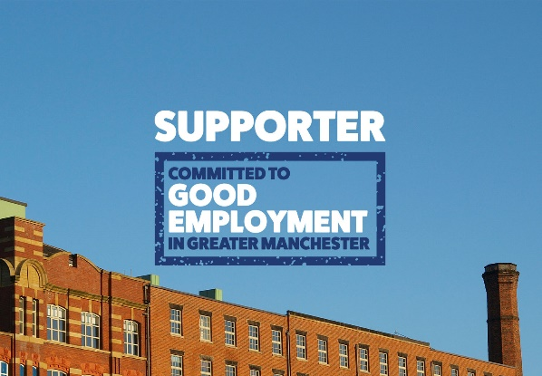 |  | Greater Manchester should be a place where people can fulfil their ambitions, this means making it a place where people want to live and work. While employment growth has been strong in recent years, too many residents are in low paid and insecure roles with little opportunity to progress. Evidence shows that businesses that support and invest in their employees are more profitable, add more value and are better respected. Excellent employment practice also helps Greater Manchester to succeed.
 |  |  |  |  | Are Already Doing |  | Could Start Doing Now | Would Like to do in the Future
Get Involved in the Greater Manchester Good Employment Charter

Become a Real Living Wage Employer

Signpost to Local Housing and Finance Advice

Employee and Volunteer Wellbeing

Support Employees’ Personal Issues

Increase Workplace Diversity

Where to get help:  - Greater Manchester Good Employment Charter  - Living Wage Foundation  - Employ GM  - Citizens Advice GM  - GM Moving Employers’ Toolkit  - 5 Ways to Wellbeing |  |  |  |  | - Mental Health at Work Toolkit  - BBC Happy Tiny People  - GM Health Hub Stop Smoking Support  - I Can GM Stop Smoking Support  - Employers Network for Equality & Inclusion  - Thriving at Work
NOTES:

Keep the Clean Air in Greater Manchester

 |  |  | Greater Manchester is developing a Clean Air Plan to tackle harmful and illegally high levels of roadside air pollution across the city-region. Everyone is at risk. Air pollution harms our health at every stage of life and is even linked to early deaths. There are plenty of ways you and your organization can help reduce air pollution.
 |  |  |  |  | Are Already Doing |  | Could Start Doing Now | Would Like to do in the Future
Put in Place Green Business Travel Options for all Employees and Volunteers
Implement Cycle to Work and Salary Sacrifice for Ultra Low Emission Vehicles Schemes for your Staff

Install Cycle Racks at your Workplace, Electric Vehicle Charging Points and Transition your Fleet to ULEV

Encourage Home Working and Digital Solutions – use Online Communication, Webinars and Video Conferencing

Get Involved in Physical Exercise Programmes with GM Moving

Where to get help:  - Cycle to Work  - Salary Sacrifice |  |  |  |  | - GM Moving  - Clean Air GM  - Schools Toolkit
NOTES:

Create the Employment and Skills Opportunities That We Need to Build Back Better

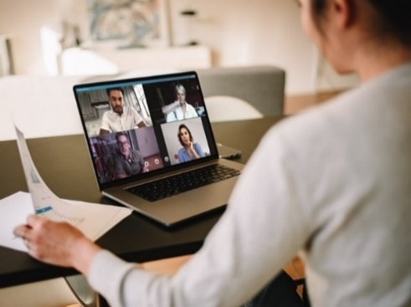 |  |  | As we learn to live and work in a post-COVID economy, we need to ensure that an appropriately skilled workforce is available locally to meet immediate and emerging needs. We must also ensure that the talent pipeline is in place to future-proof jobs, businesses and workers with the agility and resilience needed in a shifting labour market. We want organisations across the city to deliver social value to inspire everyone about their future career prospects and help them to understand the opportunities available to them across all industries.
 |  |  |  |  | Are Already Doing |  | Could Start Doing Now | Would Like to do in the Future
Support your employees / members / volunteers to become a mentor to a young person through Bridge GM and develop links with the wider Bridge community to support young people.

Use the GM Apprenticeship Hub to build your apprenticeship programme.

Support re-skilling in sectors heavily impacted by Covid-19

Reach out and share the skills that you have in your organisation into the wider business sector and with VCSE organisations.

Offer apprenticeship, experience / internship and other opportunities for young people and schools through GM Apprenticeship and Careers Service

Provide careers support/ work experience/ mentoring to build digital skills and promote digital inclusion

Where to get help:  - Bridge GM  - GM Apprenticeship Hub |  |  |  |  | - Enterprising You  - GM Apprenticeship and Careers Service
NOTES:

Be Part of a Strong Local Community

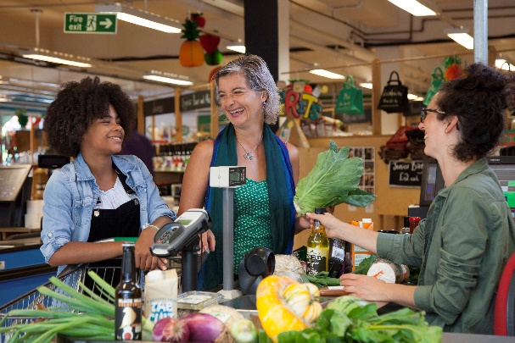 |  |  | One of the biggest benefits of Social Value comes from the wider financial and nonfinancial value that your organisation can create in terms of the wellbeing of individuals and communities. During the pandemic we have seen a rise in community volunteering – people wanting to help out and help people. This proactive support could be harnessed by business to achieve a huge and positive benefit for local people and local communities, your employees, their families and friends. Getting involved in local projects is a great way to be part of a community, building its strength and resilience; and ensure that no one from any background gets left behind.
 |  |  |  |  | Are Already Doing |  | Could Start Doing Now | Would Like to do in the Future
Encourage your employees and members to take part in organised volunteering through your local volunteering centre or provide trustees for local charities and voluntary organisations.

Develop organisational partnerships with your local VCSE sector.

Offer professional support with Business in the Community National Business Response Network.

Support the GM Age-friendly Neighbourhoods Challenge.

Enable employees, members and volunteers to take part in volunteering and improve the local environment with Nature GM or activities which reduce social isolation.

Help tackle food poverty by getting involved with Fare Share GM, join Good Food Greater Manchester or support your local Food Bank.

Agree to support a local corporate charity and encourage the team to pool fund raising to make a difference?
Where to get help:  - Volunteer GM  - Reach Volunteering  - 10GM - VCSE Sector  - Business in the Community  - GM Age-friendly Neighbourhoods Challenge  - Our Pass  - Nature GM |  |  |  |  | - Fare Share GM  - Good Food Greater Manchester  - Food Bank or Pantry  - United We Stream  - Community Arts North West  - A Bed Every Night  - GM Homelessness Action Network
NOTES:

Make Your Organisation Greener

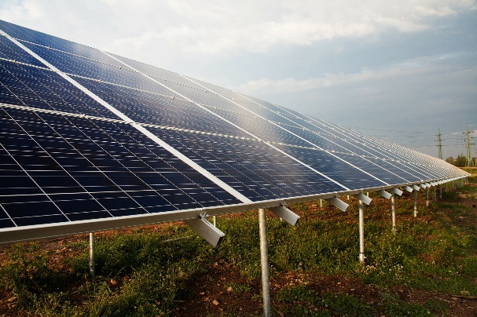 |  |  | Our environment in Greater Manchester underpins all aspects of our daily lives. We face urgent and significant environmental challenges in Greater Manchester. They require us all to take action now. Together we can work to address the major environmental challenges to our city region:  - Mitigating Climate Change  - Air Quality  - Production and Consumption of Resources  - Natural Environment  - Resilience and Adaptation to the Impacts of Climate Change
 |  |  |  |  | Are Already Doing |  | Could Start Doing Now | Would Like to do in the Future
Put in place an operational plan for your organisation to be carbon neutral by 2038 with the support of Green Growth GM.

Organise carbon literacy training for all employees

Maximise energy efficiency and local low carbon energy generation in your work

Build climate change resilience measures into your risk management and investment plans.

Help enable a Plastic Free GM.

Create less waste, with support from Recycle for Greater Manchester or the Business Growth Hub

Manage any green spaces at your workplace for wildlife and promote environmental volunteering days for your employees.

Where to get help:  - Natural Capital Investment Plan  - Green Growth  - Carbon Literacy Project  - Carbon Coop |  |  |  | - Plastic free GM  - Recycle GM  - Business Growth Hub
NOTES:

Develop a Local, GM-based and Resilient Supply Chain

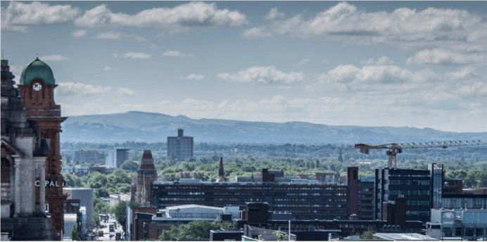 |  |  | Social value presents a chance for any organisation to use resources in a more impactful way, and think more clearly about how wider social, environmental and economic benefits can be achieved through the day to day activities of our work. As well as improving wellbeing directly through your own actions, your organisation can act indirectly through its supply chain, influencing others, as well as through collaborative work with partners. Buying locally, ethically and sustainably will improve our chances of recovering from the current COVID-driven recession. Your purchasing decisions can influence the success of your suppliers’ businesses and impact on the lives of their employees. This can also make good ‘business sense’ - social value will provide greater value for money and can help to mitigate the impact of negative external factors – if we all work together.
 |  |  |  |  | Are Already Doing |  | Could Start Doing Now | Would Like to do in the Future
Use your procurement practices to maximise social value – buy local, sustainable and ethical goods and services.

Open up your buildings and green spaces for VCSE use.

As far as is feasible, purchase goods, services and works from GM-based organisations.

Consider how to innovate your business to deliver more sustainable goods and services.

Adhere to the Fair Tax Mark standards.

Explore whether it is right for you to enter ‘social contracts’ with your suppliers and partners.

Think about your banking.

Purchase from organisations known to provide that added ‘social impact’.

Where to get help:  - GM Social Value Network  - Business Growth Hub |  |  |  | - Fair Tax Mark  - Sound Pound  - Co-operatives UK  - GM Social Enterprise Network
NOTES:

OUR PRIORITIES FOR ACTION
Organisation:
Date:

 | Action |  |  |  |  | Who will be responsible to make this happen?
1.
2.
3.
4.
5.
NOTE #1: this shouldn’t be about doing all or nothing, every small change has value so as much or as little as you can is great.

Two further actions that you could take:
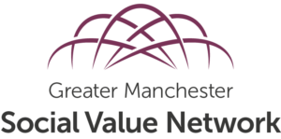
Get involved in the Greater Manchester Social Value Network, which:
Collects information, evidence and examples of social value from across Greater Manchester
Supports organisations across all sectors to deliver more effective social value policy, practice and outcomes
Uses the skills knowledge and experience of the group to influence the behaviour of the range of individuals and organisations with a stake in social value

Celebrate what you are doing – and tell others about it!

Social Value can make Greater Manchester a better place - Greater Manchester Combined Authority (greatermanchester-ca.gov.uk)

