Putting Greater Manchester’s waste to good use
SUEZ social value update June 2022

Welcome to our new, monthly, social value update!
SUEZ Recycling and Recovery UK manage the waste sites on behalf of the Greater Manchester Combined Authority (GMCA), managing 1.1 million tonnes of waste arising from nearly 2.3 million residents.
In Greater Manchester, we have 54 social value commitments centred around 9 social outcomes and we’ll be keeping you updated on progress each month. Our goal is to help create a circular economy in which nearly all waste materials are reused, recycled, or recovered for their energy.

Social value
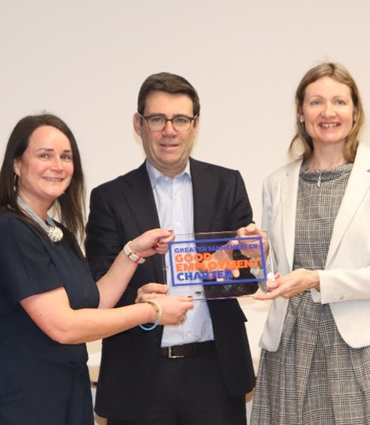
Social value is all about securing wider social, economic and environmental benefits from the work that we do. This is a core part of the SUEZ business. To achieve maximum impacts, we have tailored our social value approach to Greater Manchester’s specific vision – to create a greener, fairer, more prosperous city region.
So, when SUEZ partnered with Greater Manchester Combined Authority (GMCA) to manage waste and resources services in 9 local districts, we committed to 54 social value actions centred around:
- employing local people and treating them fairly
- being a responsible business and working with other local businesses
- working with the third sector
- enabling communities to support themselves, and
- protecting the local environment.
Three years on, we have made significant achievements.

These include:
- becoming a ‘member’ of the Greater Manchester Good Employment Charter - recognising our practices as a responsible employer
- employing apprentices in a range of roles including recycling operatives, welders and HGV technicians, and
- introducing new volunteer activities, which continued throughout the Covid-19 pandemic, including litter picks and tree planting.

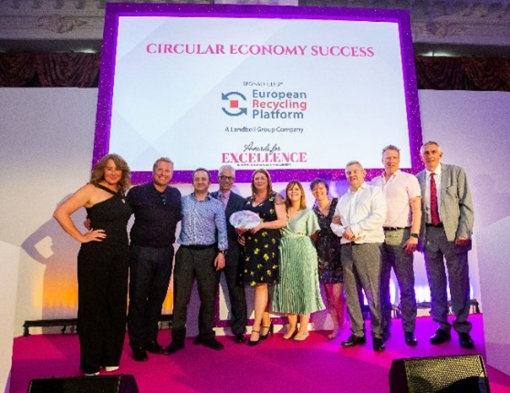
Re-use
Our proudest achievement to date has been our work around re-use.
We committed to opening re-use shops and a re-use hub to divert items from waste into re-use.
In 2021, we opened three Renew shops – in Trafford, Salford and Oldham - and a Renew Hub in Trafford Park
Since we began:
- more than 500 tonnes of thrown-away items have been taken to the Hub to be sorted for sale or repair.
- 360 tonnes of pre-loved items have been sold in our three Renew shops, giving these items a new lease of life and providing good-quality items at a low cost for residents.
- over 65 tonnes have also been donated direct from the Hub to various charities across Greater Manchester who offer furniture packs at little to no cost to those most in need.
All money raised from the Renew shops goes back to Greater Manchester communities. Every year, £100,000 is given to the Greater Manchester Mayor’s Charity and £220,000 is given to the Recycle for Greater Manchester Community Fund.
In its first year, the fund supported 21 community organisations across Greater Manchester focused on re-use or recycling projects in their local areas. The most recent round of funding had more than 60 applications. Details of which of these will receive funding will be announced shortly.

Monthly activity - May

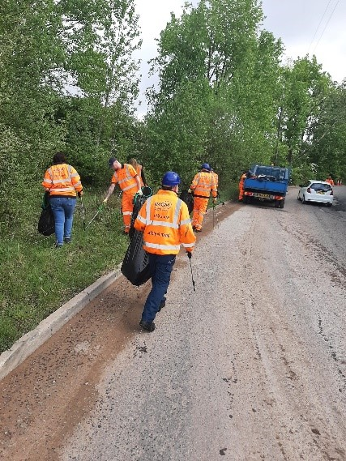
Litter pick
Operational staff from Adswood Road recycling centre in Cheadle Hulme carried out a litter pick with land management contractor Booths Ventures and Stockport Council. We collected 1.76kg of waste from the access road.

Biodiversity

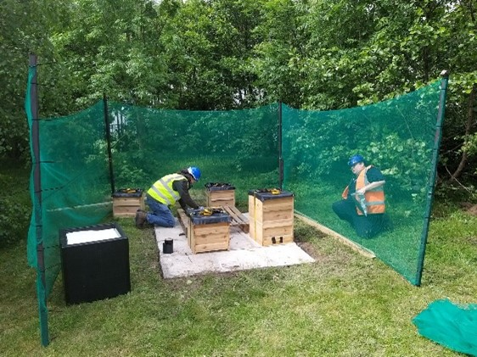
We commissioned the installation of our first apiary in Greater Manchester at our Nash Road site in Trafford Park. The apiary, delivered in partnership with the Manchester Honey Company and The Bee Farmers Association, consists of 4 hives, with around 100,000 bees!
A large proportion of the plants that we rely on for food depend on pollination, so we’re really proud to have developed this site!

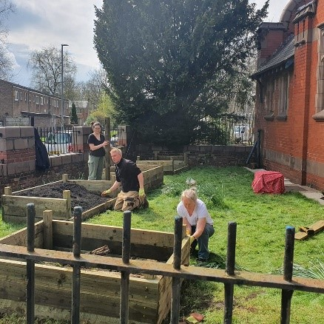
Compost
We have worked with our partners to create organic peat-free compost - certified to PAS 100 standard as 100% recycled green compost - from Greater Manchester’s food and garden waste. In May we received 19 applications from community organisations for the free 1 tonne of compost. We have now provided this to a total of 147 organisations since the scheme’s launch in February.

