Putting Greater Manchester’s waste to good use
SUEZ social value update August 2022
SUEZ Recycling and Recovery UK manage the waste sites on behalf of the Greater Manchester Combined Authority (GMCA), managing 1.1 million tonnes of waste arising from nearly 2.3 million residents.
In Greater Manchester, we have 54 social value commitments centred around 9 social outcomes and we’ll be keeping you updated on progress each month. Our goal is to help create a circular economy in which nearly all waste materials are reused, recycled, or recovered for their energy.

Re-use
You may have seen the Renew Hub featured on BBC Breakfast recently! The piece gathered lots of attention and we’re hopeful to do more with media shortly to spread the word about what we’re doing in Greater Manchester to support residents through the cost of living crisis and move towards a circular economy.
Our latest video on the project can be found at https://recycleforgreatermanchester.com/renew/
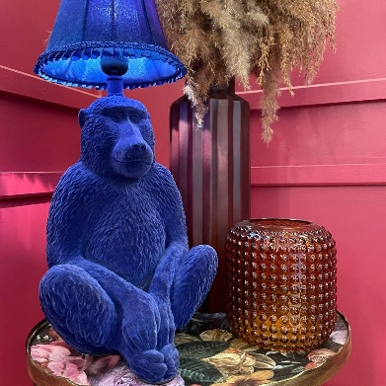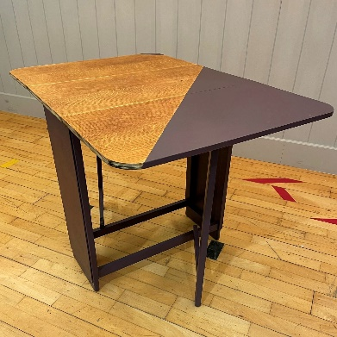
We mentioned in the previous newsletter that we launched online sales via our ebay page in July. https://www.ebay.co.uk/str/renewgreatermanchester
The money raised works in the same way that the shops do, with £100,000 going to the Greater Manchester Mayor’s Charity every year and a minimum of £220,000 to the Recycle for Greater Manchester Community Fund.

So far, we’ve sold 75 items, have 688 followers on our page, and have 100% positive feedback.The page focuses on more unique items and upcyled items, as well as electricals and bikes. We have also recently added project pieces suitable for upcycling at home.
In addition to sales, the Hub also supports a number of charities with weekly donations of reusable items for their own networks. We already work with Mustard Tree (Ancoats and Salford), Emmaus (South Manchester), Bolton Community Transport (Bolton) and Wesley Community Furniture (Manchester). In July we also began working with Tree of Life (Wythenshawe) who will be collecting weekly donations of furniture from the Renew Hub.

Volunteering
This year SUEZ are encouraging all colleagues to take a ‘Day a Year to Volunteer’. Aside from supporting local projects, SUEZ will donate £5 to Macmillan for every person who volunteers. The team across Greater Manchester have so far spent time volunteering with Mountain Rescue, Manchester Dogs Home, and transforming the outdoor space of a primary school in Bolton which was hit by flooding last year.
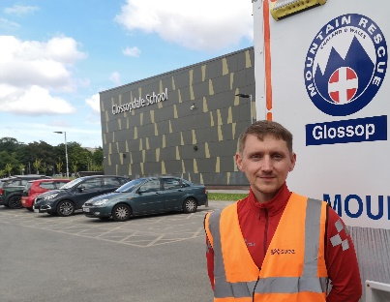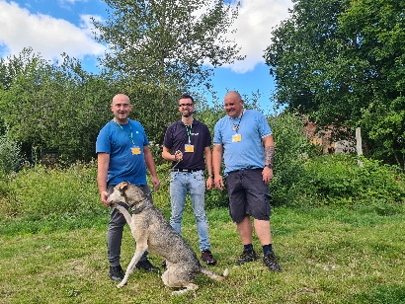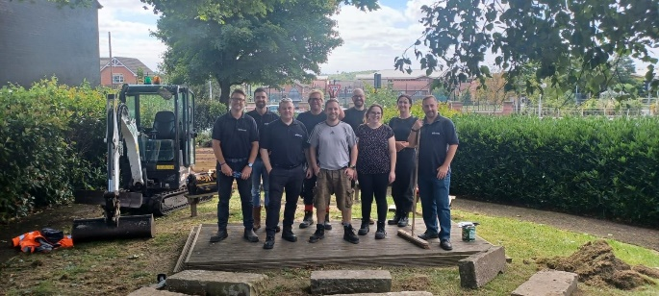

Apprenticeships
In July, three apprentice maintenance technicians and one business administration apprentice joined the Greater Manchester team. We are still recruiting for another business administration apprentice to be based at Higher Swan Lane in Bolton.

Recycle for Greater Manchester community fund
The Recycle for Greater Manchester Community Fund is a joint SUEZ and R4GM initiative to support Greater Manchester community and voluntary sector groups. The fund helps to deliver projects aimed at reducing household waste, increasing recycling and encouraging reuse, and is funded through the sales from Renew.
The successful projects for 2022 have now been finalised with a full list at https://recycleforgreatermanchester.com/community-fund/
There are 26 projects in total securing between £3,500 and £20,000 each. Several projects are based on reducing food waste and providing free healthy food to those in need, such as the Manchester Urban Diggers project. Humans MCR are also using the funds to break the cycle of food poverty by providing clients with the tools and resources to sustain themselves without relying on emergency foodbanks as a regular measure.
The Community Buds project in Bury is creating a community garden using people's waste, they intend to bring members of the community out of isolation and help them to overcome mental health barriers.
In Trafford, the Little Green Sock project has also won funding to increase storage at their clothing and baby bank to help reach more families in poverty and provide access to pre-loved baby clothing and accessories.
Other projects also address wider community issues including mental health, food poverty and sustainability, creating extra social benefits for the communities they work within. In this way, the fund not only contributes towards environmental improvements, but to residents of Greater Manchester as a whole, creating new opportunities and supporting individuals to have a better quality of life.

Social value
Social value is all about securing wider social, economic and environmental benefits from the work that we do. This is a core part of the SUEZ business. To achieve maximum impacts, we have tailored our social value approach to Greater Manchester’s specific vision – to create a greener, fairer, more prosperous city region.
We are committed to 54 social value actions centred around:
- employing local people and treating them fairly
- being a responsible business and working with other local businesses
- working with the third sector
- enabling communities to support themselves, and
- protecting the local environment

