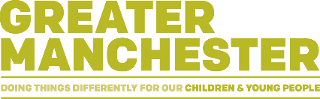
Building Blocks to Words: I am a responsive practitioner

Children learn best when we tune into their interests and listen to what they are communicating. For example, letting the child choose the activity, watching what they are doing, and talking about what they are doing. Use this sheet to help reflect on your interactions.

- Capture the child’s name, age and date today
- Did the child, practitioner or both choose the activity?
- Did the child, practitioner or both start the activity?
- What happened first?
- What did the child do next?
- Did you follow the child’ lead (yes, no, sometimes)?
- What did you do well?
- What will you do differently next time?

Example 1 of a completed practitioner reflection sheet – Playing with blocks

- Child’s name is Tommy, he is 11 months old and todays date is 23/01/22
- I as the practitioner chose the activity
- I as the practitioner started the activity
- Started with building a tower; gave child a block. The child banged the blocks together
- I responded by putting blocks on top of each other saying ‘block’
- Next, the child kept banging the blocks
- I did not follow the child’s lead
- I chose an activity the child enjoyed, let the child play with the blocks in their own way. I thought I did this well.
- Next time I would follow the child’ lead by copy banging blocks and say ‘bang’ and also offer the child a choice of activity.

Example 2 of a completed practitioner reflection sheet – Reading a book together
- We both chose the activity
- I as the practitioner started the activity
- Started with offering the child a choice of books, waited for the child to choose. The child grabbed at the book.
- I responded by holding the book out of the baby’s reach and read the story
- Next, the child cried and reached for the book again
- I sometimes followed the child’s lead
- I let the child choose the book. I thought I did this well.
- Next time I would follow a child’ lead by letting baby hold the book and talking about pictures

