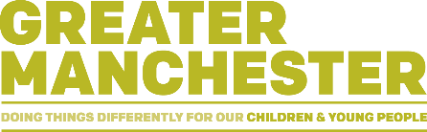
Babies First Gestures

Did you know babies' gestures are a key sign of how their language skills will develop?

What do we mean by gestures?
Before babies learn to talk, they typically use gestures as a way of communicating. This might look like:
- Reaching out
- Holding out objects to show and share
- Pointing

Hold out gestures
'Hold out' gestures are when your baby holds an object out to show or share with you. Babies use holdout gestures before they start pointing, but this gesture is often missed by adults. We can help baby’s language development by responding immediately (within 2 seconds) by talking about what the baby is looking at/doing/thinking about.

Benefits of responding to babies gestures
- Babies who use lots of early hold out gestures go on to use lots of pointing later on... and pointing predicts later language skills!
- Babies who use more gestures have bigger vocabularies later on.
- Good talking and communication skills help your child to become a happy, healthy and confident communicator in the future.

Top Tips
- Watch what your child is interested in.
- Match what you say to what your child is looking at, playing with, holding or pointing to.
- This really helps encourage your child to learn new words.
- For example, if your child holds out a spoon, you can say "spoon", if they hold out a ball, you can say "ball".

