Putting Greater Manchester’s waste to good use
SUEZ social value update November 2022
SUEZ Recycling and Recovery UK manage the waste sites on behalf of the Greater Manchester Combined Authority (GMCA), managing 1.1 million tonnes of waste arising from nearly 2.3 million residents.
In Greater Manchester, we have 54 social value commitments centred around 9 social outcomes and we’ll be keeping you updated on progress each month. Our goal is to help create a circular economy in which nearly all waste materials are reused, recycled, or recovered for their energy.

Re-use
During November, the Hub hosted several events from the wider industry including a CIWM North East conference and an internal conference for officers from the Environment Agency.
We also partnered with several organisations to donate preloved, serviced bikes in the lead up to Christmas.
This includes Transport for Greater Manchester’s Christmas campaign to provide ‘bikes for life’ in a bid to make active travel more accessible to residents in the cost of living crisis. It also includes the donation of more than 50 bikes, trikes and scooters for HITS Radio’s Cash for Kids Christmas campaign supporting children in poverty in Greater Manchester.
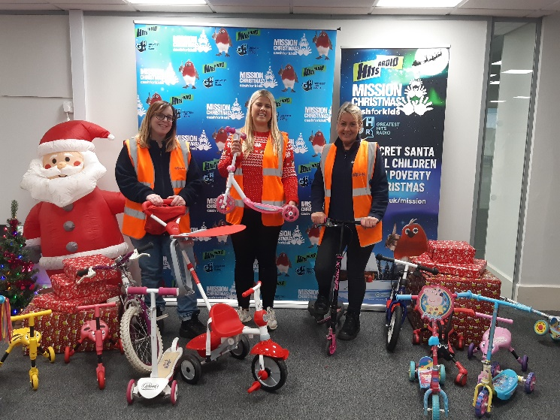

SUEZ also launched ‘A guide to re-use’ to support other local authorities in integrating reuse into their recycling centres across the country. The guide shares expertise from various reuse operations including the flagship project at the Renew Hub.

SUEZ ranked in Best Companies’ list for 2022
For the third time, SUEZ has been recognised in Best Companies’ list of the UK’s top 25 best big companies to work for. This was the first year that Greater Manchester colleagues were able to take part in the survey and we’re delighted to be recognised for valuing employee wellness, health and safety, and continuous learning opportunities.

SME support
SUEZ attended a Bolton Business Fair to network with local small and medium companies around working with SUEZ and to discuss procurement requirements. SUEZ also presented at a Salford and Trafford construction event to highlight upcoming opportunities to work with SUEZ.

Social value
Social value is all about securing wider social, economic and environmental benefits from the work that we do. This is a core part of the SUEZ business. To achieve maximum impacts, we have tailored our social value approach to Greater Manchester’s specific vision – to create a greener, fairer, more prosperous city region.
We are committed to 54 social value actions centred around:
- employing local people and treating them fairly
- being a responsible business and working with other local businesses
- working with the third sector
- enabling communities to support themselves, and
- protecting the local environment

