International Day of Older Persons 2023 – social media toolkit
- Communications messaging and assets for International Day of Older Persons for use from 1 October-31 October.
UN International Day of Older Persons takes place annually on 1 October and provides an opportunity for communities around the world to come together, support older people and raise awareness about the challenges ageing populations face.
This year we are celebrating the importance of neighbourhoods in ageing well. Research has found that individuals aged 75 and over spend at least 80 per cent of their time in their homes or the surrounding area. This is just one of the reasons why neighbourhoods are key to ageing well.
In Greater Manchester, we are committed to listening to and valuing the voice of lived experience and this is best demonstrated by our commitment to the Ageing in Place Pathfinder (AIPP) – a programme that is establishing resident-led partnerships in nine neighbourhoods across our city-region.​ These partnerships are working together with local residents on co-produced action plans to improve residents’ quality of life as they grow older.​
The social media plan below includes short films from the Pathfinder neighbourhoods. The videos document people in mid and later life in their neighbourhoods engaging in activities, classes and groups that they enjoy. Three further videos are expected, one from Ridge Hill, Old Trafford and Greater Manchester Older People’s Network, and will be shared in due course.
Key messages
- Older people’s voices and contributions need to be valued so that neighbourhoods in Greater Manchester are good places for everyone to grow older.

- We need to make sure our homes and communities are age-friendly as people aged 75 and over spend at least 80 per cent of their time in their home or the surrounding area. Our neighbourhoods are key to ageing well.

- Our population is ageing rapidly, we all need to act to ensure places are accessible and welcoming to everyone as we age.

Audiences
- People in mid and later life across Greater Manchester
- Those who work with or volunteer with people in mid and later life
- People working on ‘Places’ – developers, planners, architects, government officers etc.
- People working on ageing outside of Greater Manchester, nationally and internationally

Channels
- X/Twitter - @greatermcr, @gmageinghub, @mayorofgm
- Facebook - @greatermcr, @mayorofgm
- Instagram - @greatermcr, @mayorofgm
- LinkedIn – Greater Manchester Combined Authority
Social media copy
International Day of Older Persons will be used as a launch date for a wide range of content that highlights the importance of place and neighbourhood to ageing well. Regular content will then be shared across various social media accounts throughout the month of October.
You will find suggested social content, YouTube links and video titles in the table below. Each video is going live on the specified day at 9 AM on the GMCA YouTube channel. Please do not share the YouTube links before 9 AM on their specified days as they will not work. You can also download the videos and all of the other assets via this WeTransfer link.
You will see the phrase ‘[insert press release website link]’ on a number of the suggested social posts. The press release website link will not be generated until the morning of Monday, 2 October. You will be able to find the press release link here and it will be titled ‘Greater Manchester putting neighbourhood and older people’s voices at the heart of age-friendly projects’.
Please use the following hashtag on your social posts: #KnowOurPlace
If you are using your own social media content, please tag us so we can support you by sharing your messaging across our channels.
Accessibility
Please make sure all images posted on social media make use of the ‘alt text’ function. Any words that appear in a graphic should be duplicated in the ‘alt text’. This will allow those using screen readers to access the content. The imagery in the graphic should also be described. You will find suggested alt text in the table below.
Useful links
- Join the Age-Friendly Movement - www.greatermanchester-ca.gov.uk/what-we-do/ageing/keep-in-touch/
- Become an Age-Friendly Employer: www.greatermanchester-ca.gov.uk/what-we-do/work-and-skills/age-friendly-employer-toolkit/ and sign up to the Age-Friendly Employer Pledge: ageing-better.org.uk/age-friendly-employer-pledge
- Join the Greater Manchester Older People’s Network: www.gmopn.org.uk/

Asset and alt text | Social copy |  | Date
Twitter

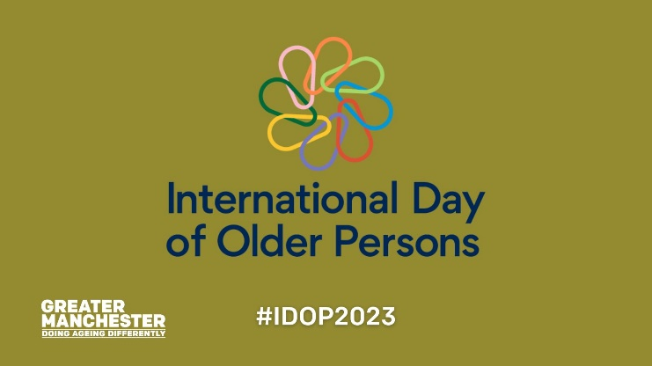  Alt text: Green background with multicoloured International Day of Older Persons logo, white Greater Manchester Doing Ageing differently logo. Graphic text reads, ‘#IDOP2023’. | Today is International Day of Older Persons and this year we are celebrating the importance of place in ageing well.  Throughout October, we’ll be sharing the stories of older residents across Greater Manchester in places that support them in later life.  #KnowOurPlace |  | 1 Oct AM
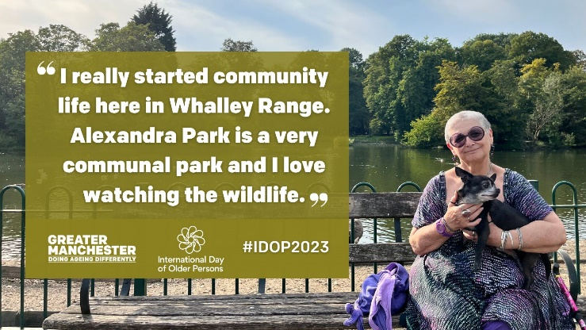  Alt text: A person sitting in front of a lake on a park bench holding a dog. Graphic text reads, ‘”I really started community life here in Whalley Range. Alexandra Park is a very communal park and I love watching the wildlife.”’ | Freddi has been a regular at Alexandra Park ever since moving to Whalley Range 12 years ago.  A big part of the local age-friendly community, Freddi is passionate about green spaces and loves having a park on her doorstep.  https://greatermanchester-ca.gov.uk/what-we-do/ageing/international-day-of-older-persons-2023/  #KnowOurPlace |  | 1 Oct PM
(Thumbnail hyperlink to PR) | In Greater Manchester, we’re putting place and the voice of lived experience at the heart of our age-friendly projects.  We want our city-region to be a place where older people feel valued and welcome.  Find out more 👉 [insert press release website link]  #KnowOurPlace |  | 2 Oct AM
Lynne AIPP Abbey Hey MP4 file  or  https://youtu.be/B2AXsIia0FI | (Tweet 1)  🗣 "The craft group is absolutely amazing."  📍 Lynne has lived in Abbey Hey, Gorton for 15 years.  The local community centre is a big part of her social life and has helped her through Covid and with her digital skills.  #KnowOurPlace | (Comment/thread tweet)  The Ageing in Place Pathfinder programme works with people in mid and later life and a range of stakeholders in the neighbourhood of Abbey Hey to improve local residents’ quality of life.  Find out more 👉 greatermanchester-ca.gov.uk/what-we-do/ageing/the-ageing-in-place-pathfinder/ | 2 Oct PM
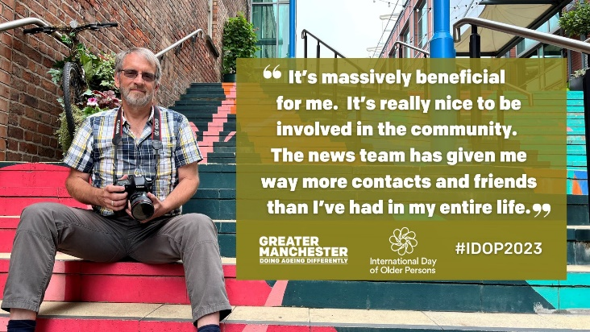  Alt text: Person with a beard sitting on multicoloured steps holding a camera. Graphic text reads, ‘”It’s massively beneficial for me. It’s really nice to be involved in the community. The news team has given me way more contacts and friends than I’ve had in my entire life.”’ | David is a volunteer photographer for @MyGenerationGM – an older people’s-led news team who meet at Deansgate Mews.  Such volunteer work has been “massively beneficial” for David in his retirement and he is now “more engaged” with people than ever before.  https://greatermanchester-ca.gov.uk/what-we-do/ageing/international-day-of-older-persons-2023/  #KnowOurPlace |  | 3 Oct AM
Dave AIPP Worsley Mesnes MP4 file  or  https://youtu.be/ysL2QTlHZzM | (Tweet 1)  “You are always made to feel welcome and people feel comfortable.”  Dave has lived in Worsley Mesnes, Wigan with his wife for 52 years.  He loves the community and the wide range of amenities in his neighbourhood.  #KnowOurPlace | (Comment/thread tweet)  The Ageing in Place Pathfinder programme is working to ensure older people's voices are heard and valued in the places they live.  Find out what is being done in neighbourhoods across the city-region to benefit older residents 👉 greatermanchester-ca.gov.uk/what-we-do/ageing/the-ageing-in-place-pathfinder/ | 4 Oct PM
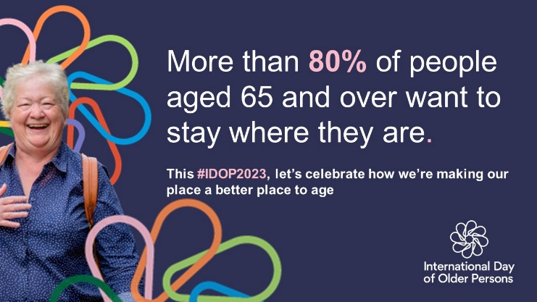  Alt text: Person wearing shirt and rucksack smiling on a blue background. Graphic text reads, ‘More than 80% of people aged 65 and over want to stay where they are. This #IDOP2023, let’s celebrate how we’re making our place a batter place to age.’ | Research suggests as we age neighbourhood becomes more important to us.  In Greater Manchester, we’re putting place and the voice of lived experience at the heart of our age-friendly work.  Join the age-friendly movement www.greatermanchester-ca.gov.uk/what-we-do/ageing/keep-in-touch/  #KnowOurPlace @Ageing_Better |  | 6 Oct AM
Pat AIPP Little Lever MP4 file  or  https://youtu.be/c4angGGVsVM | (Tweet 1)  Pat runs a sign-language class in Little Lever, Bolton where she has lived for 52 years.  Pat looks forward to the class every week, as do the local residents who are supported by the class.  #KnowOurPlace | (Comment/thread tweet)  Little Lever is one of the neighbourhoods supported by the Ageing in Place Pathfinder - a programme that works with local residents to find ways to improve people’s quality of life as they grow older.​  Find out more greatermanchester-ca.gov.uk/what-we-do/ageing/the-ageing-in-place-pathfinder/ | 6 Oct PM
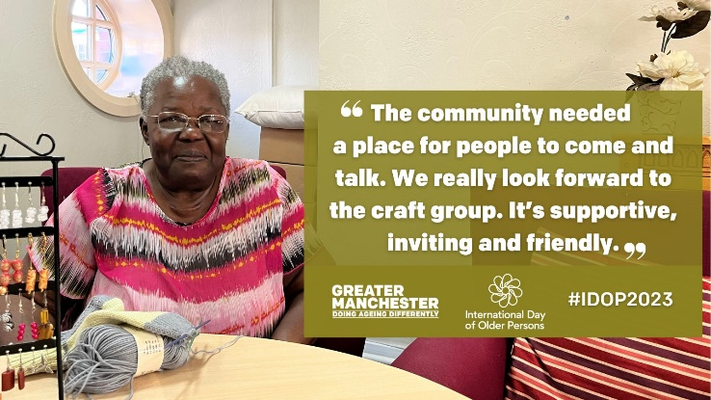  Alt text: A person in glasses sitting behind a table with a jewellery rack and a ball of wool on it. Graphic text reads, ‘”The community needed a place to come and talk. We really look forward to the craft group. It’s supportive, inviting and friendly.” | Many Hands is a craft group for older people in Ancoats that Elaine has been attending for many years.  Elaine describes the group as a support system for herself and many other local residents.  https://greatermanchester-ca.gov.uk/what-we-do/ageing/international-day-of-older-persons-2023/  #KnowOurPlace |  | 8 Oct PM
Stephen/Lorraine AIPP Smallbridge MP4 file  or  https://youtu.be/eIpeq1r2-AA | (Tweet 1)  “It’s great in Smallbridge, the people make the estate.”  Stephen and Lorraine volunteer at Smallbridge food pantry which helps more than 70 people a week and supports cooking sessions for local older residents next door.  #KnowOurPlace | (Comment/thread tweet)  The Ageing in Place Pathfinder programme is working together with people in mid and later life in Smallbridge and Kirkholt, Rochdale to ensure their voices are heard and valued.  Find out more greatermanchester-ca.gov.uk/what-we-do/ageing/the-ageing-in-place-pathfinder/ | 9 Oct PM
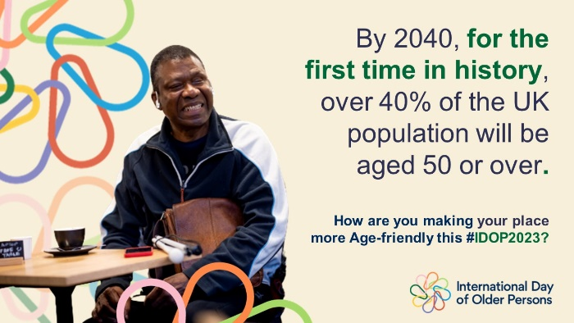  Alt text: A person sitting on a table smiling. Graphic text reads, ‘By 2040, for the first time in history, over 40% of the UK population will be aged 50 and over. How are you making your place more Age-friendly this #IDOP2023?’ | 📈 Our population is ageing rapidly and we all need to act to ensure places are accessible and welcoming to people of all ages.  In Greater Manchester, we want older people's voices to be heard and valued in the places they live.  👉 [insert press release website link]  #KnowOurPlace @Ageing_Better |  | 11 Oct AM
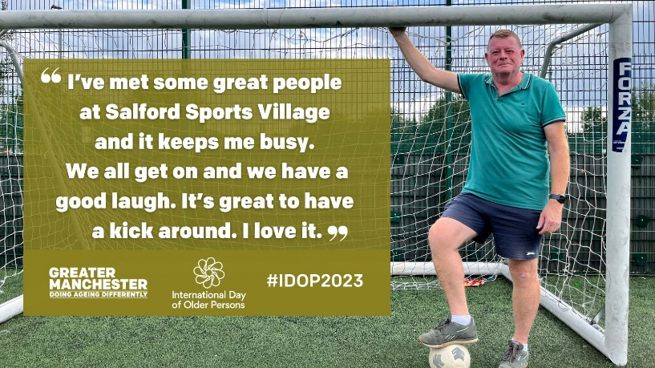  Alt text: A person standing in front of a football net with one foot on a football. Graphic text reads, ‘I’ve met some great people at Salford Sports Village and it keeps me busy. We all get on and we have a good laugh. It’s great to have a kick around. I love it.” | Joe lost his wife to dementia two years ago.  Foundation 92’s dementia walking football sessions in Salford provide support for people with and affected by dementia and Joe has been a regular for nearly five years.  https://greatermanchester-ca.gov.uk/what-we-do/ageing/international-day-of-older-persons-2023/  #KnowOurPlace |  | 11 Oct PM
Kath/Rita AIPP Moorside MP4 file  or  https://youtu.be/rESZHWoIz1Q | (Tweet 1)  Kath and Rita live in Moorside, Bury and volunteer at the local Clarence Park.  They both love having a green space on their doorstep and are incredibly grateful for the opportunity it provides them as they age.  #KnowOurPlace | (Comment/thread tweet)  The Ageing in Place Pathfinder is working with older people and a range of stakeholders in Moorside to improve local residents’ quality of life.  Find out more 👉 greatermanchester-ca.gov.uk/what-we-do/ageing/the-ageing-in-place-pathfinder/ | 13 Oct PM
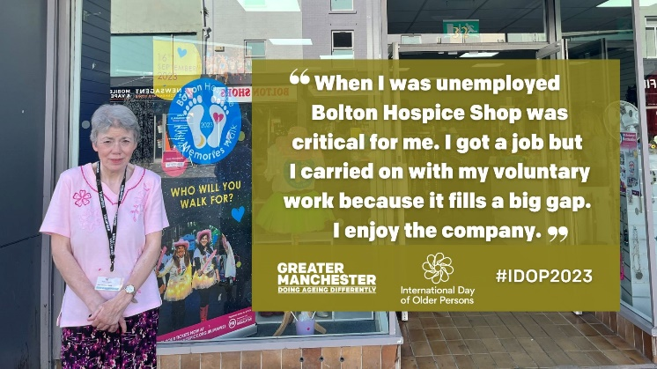  Alt text: A person wearing a lanyard standing outside of a shop. Graphic text reads, ‘”When I was unemployed Bolton Hospice Shop was critical for me. I got a job but I carried on with my voluntary work because it fills a big gap. I enjoy the company.” | Helen has been a volunteer at Bolton Hospice Shop for eight years now.  She has made great friendships with her colleagues and says the work “fills a big gap” and prevents loneliness.  https://greatermanchester-ca.gov.uk/what-we-do/ageing/international-day-of-older-persons-2023/  #KnowOurPlace |  | 17 Oct PM
Alt text: Person wearing shirt and rucksack smiling on a blue background. Graphic text reads, ‘More than 80% of people aged 65 and over want to stay where they are. This #IDOP2023, let’s celebrate how we’re making our place a batter place to age.’ | Research suggests as we age neighbourhood becomes more important to us.  In Greater Manchester, we’re putting place and the voice of lived experience at the heart of our age-friendly work.  Join the age-friendly movement www.greatermanchester-ca.gov.uk/what-we-do/ageing/keep-in-touch/  #KnowOurPlace @Ageing_Better |  | 25 Oct AM
June AIPP Pendleton MP4 file  or  https://youtu.be/GFT-KvDKraY | (Tweet 1)  “It’s opened up a whole new life.”  June has lived in Pendleton, Salford for 67 years and is thriving since joining local art and photography groups at the end of lockdown.  She really values being a part of the local community.  #KnowOurPlace | (Comment/thread tweet)  The Ageing in Place Pathfinder is working together with older residents in Pendleton and Charlestown, Salford to ensure their voices are heard and valued.  Find out more 👉greatermanchester-ca.gov.uk/what-we-do/ageing/the-ageing-in-place-pathfinder/ | 27 Oct AM
Geoff AIPP Brinnington MP4 file  or  https://youtu.be/6Zu3xXdIKPI | (Tweet 1)  “Brinnington is a good place to grow old. There are lots of activities and people get involved.”  Geoff is a resident of Brinnington, Stockport and runs a community art group with fellow over 50s to support people in the local area who are isolated.  #KnowOurPlace | (Comment/thread tweet)  Brinnington is one of the neighbourhoods supported by the Ageing in Place Pathfinder - a programme that works with local residents to find ways to improve people’s quality of life as they grow older.  Find out more 👉 greatermanchester-ca.gov.uk/what-we-do/ageing/the-ageing-in-place-pathfinder/ | 30 Oct AM
Facebook
Alt text: Green background with multicoloured International Day of Older Persons logo, white Greater Manchester Doing Ageing differently logo. Graphic text reads, ‘#IDOP2023’. | Today is International Day of Older Persons – an annual event to support older people and raise awareness about the challenges ageing populations face.  This year we are celebrating the importance of place and neighbourhood in ageing well and throughout October, we’ll be sharing the stories of older residents across Greater Manchester in places that support them in later life.  #KnowOurPlace #IDOP2023 |  | 1 Oct AM
Alt text: A person sitting in front of a lake on a park bench holding a dog. Graphic text reads, ‘”I really started community life here in Whalley Range. This is a very communal park and I love watching the wildlife.”’ | Freddi has been a regular at Alexandra Park ever since moving to Whalley Range 12 years ago.  A big part of the local age-friendly community, Freddi is passionate about green spaces and loves having a park where she can walk her dog and look at wildlife on her doorstep.  https://greatermanchester-ca.gov.uk/what-we-do/ageing/international-day-of-older-persons-2023/  #KnowOurPlace #IDOP2023 |  | 1 Oct PM
(Thumbnail hyperlink to PR) | In Greater Manchester, we’re putting place and the voice of lived experience at the heart of our age-friendly projects.  We want our city-region to be a place where older people feel valued and welcome.  Find out more 👉 [insert press release website link]  #KnowOurPlace |  | 2 Oct AM
Lynne AIPP Abbey Hey MP4 file  or  https://youtu.be/B2AXsIia0FI | 🗣 "The craft group is absolutely amazing."  Lynne has lived in Abbey Hey, Gorton for 15 years.  The local community centre is a big part of her social life and has helped her through Covid and with her digital skills.  The Ageing in Place Pathfinder programme is working with older people and a range of stakeholders in the neighbourhood of Abbey Hey to improve the quality of life for local residents.  Find out more greatermanchester-ca.gov.uk/what-we-do/ageing/the-ageing-in-place-pathfinder/  #KnowOurPlace |  | 2 Oct PM
Alt text: Person with a beard sitting on multicoloured steps holding a camera. Graphic text reads, ‘”It’s massively beneficial for me. It’s really nice to be involved in the community. It’s given me way more contacts and friends than I’ve had in my entire life.”’ | David is a volunteer photographer for @TalkingAboutMyGeneration – an older people’s-led news team who meet at Deansgate Mews.  Such volunteer work has been “massively beneficial” for David in his retirement and he is now “more engaged” with people than ever before.  https://greatermanchester-ca.gov.uk/what-we-do/ageing/international-day-of-older-persons-2023/  #KnowOurPlace |  | 3 Oct AM
Dave AIPP Worsley Mesnes MP4 file  or  https://youtu.be/ysL2QTlHZzM | 🗣 “You are always made to feel welcome and people feel comfortable.”  Dave has lived in Worsley Mesnes, Wigan with his wife for 52 years.  He loves the community and the wide range of amenities in the local area.  The Ageing in Place Pathfinder is working to ensure the voices of people in mid and later life are heard and valued in the places they live.  Find out what is being done in Worsley Mesnes and other neighbourhoods across the city-region to benefit older residents 👉 greatermanchester-ca.gov.uk/what-we-do/ageing/the-ageing-in-place-pathfinder/  #KnowOurPlace |  | 4 Oct PM
Alt text: Person wearing shirt and rucksack smiling on a blue background. Graphic text reads, ‘More than 80% of people aged 65 and over want to stay where they are. This #IDOP2023, let’s celebrate how we’re making our place a batter place to age.’ | Research suggests as we age neighbourhood becomes more important to us.  In Greater Manchester, we’re putting place and the voice of lived experience at the heart of our age-friendly work.  Join the age-friendly movement www.greatermanchester-ca.gov.uk/what-we-do/ageing/keep-in-touch/  #KnowOurPlace |  | 6 Oct AM
Pat AIPP Little Lever MP4 file  or  https://youtu.be/c4angGGVsVM | 👋 Pat runs a sign-language class in Little Lever, Bolton where she has lived for 52 years.  Pat looks forward to the class every week, as do the local residents who are supported by the class.  Little Lever is one of the neighbourhoods supported by the Ageing in Place Pathfinder - a programme that works with local residents to find ways to improve people’s quality of life as they grow older.  Find out more 👉 greatermanchester-ca.gov.uk/what-we-do/ageing/the-ageing-in-place-pathfinder/  #KnowOurPlace |  | 6 Oct PM
Alt text: A person in glasses sitting behind a table with a jewellery rack and a ball of wool on it. Graphic text reads, ‘”The community needed a place to come and talk. We really look forward to coming. It’s supportive, inviting and friendly.” | Many Hands is a craft group for older people in Ancoats that Elaine has been attending for many years.  Elaine describes the group as a support system for herself and many other local residents.  https://greatermanchester-ca.gov.uk/what-we-do/ageing/international-day-of-older-persons-2023/  #KnowOurPlace |  | 8 Oct PM
Stephen/Lorraine AIPP Smallbridge MP4 file  or  https://youtu.be/eIpeq1r2-AA | 🗣 “It’s great in Smallbridge, the people make the estate.”  Stephen and Lorraine volunteer at Smallbridge food pantry which helps more than 70 people a week and supports cooking sessions for local older residents next door.  The Ageing in Place Pathfinder programme is working together with people in mid and later life in Smallbridge and Kirkholt, Rochdale to ensure their voices are heard and valued.  Find out more 👉 greatermanchester-ca.gov.uk/what-we-do/ageing/the-ageing-in-place-pathfinder/  #KnowOurPlace |  | 9 Oct PM
Alt text: A person sitting on a table smiling. Graphic text reads, ‘By 2040, for the first time in history, over 40% of the UK population will be aged 50 and over. How are you making your place more Age-friendly this #IDOP2023?’ | 📈 Our population is ageing rapidly and we all need to act to ensure places are accessible and welcoming to people of all ages.  In Greater Manchester, we want older people's voices to be heard and valued in the places they live.  👉 [insert press release website link]  #KnowOurPlace |  | 11 Oct AM
Alt text: A person standing in front of a football net with one foot on a football. Graphic text reads, ‘I’ve met some great people at Salford Sports Village and it keeps me busy. We all get on and we have a good laugh. It’s great to have a kick around. I love it.” | Joe lost his wife to dementia two years ago.  Foundation 92’s dementia walking football sessions at Salford Sports Village provide support for people with and affected by dementia and Joe has been a regular for nearly five years, making some great friends along the way.  https://greatermanchester-ca.gov.uk/what-we-do/ageing/international-day-of-older-persons-2023/  #KnowOurPlace |  | 11 Oct PM
Kath/Rita AIPP Moorside MP4 file  or  https://youtu.be/rESZHWoIz1Q | 🌷 Kath and Rita live in Moorside, Bury and volunteer at the local Clarence Park.  They both love having a green space on their doorstep and are incredibly grateful for the opportunity it provides them as they age.  The Ageing in Place Pathfinder programme is working with people in mid and later life and a range of stakeholders in Moorside to improve local residents’ quality of life.  Find out more 👉 greatermanchester-ca.gov.uk/what-we-do/ageing/the-ageing-in-place-pathfinder/  #KnowOurPlace |  | 13 Oct PM
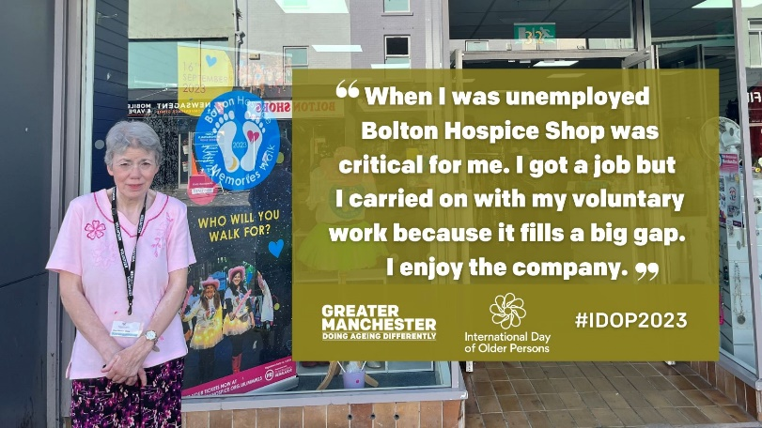  Alt text: A person wearing a lanyard standing outside of a shop. Graphic text reads, ‘”When I was unemployed it was critical for me. I got a job but I carried on with my voluntary work because it fills a big gap. I enjoy the company.” | Helen has been a volunteer at Bolton Hospice Shop for eight years now.  She has made great friendships with her colleagues and says the work “fills a big gap” and prevents loneliness.  https://greatermanchester-ca.gov.uk/what-we-do/ageing/international-day-of-older-persons-2023/  #KnowOurPlace |  | 17 Oct PM
Alt text: Person wearing shirt and rucksack smiling on a blue background. Graphic text reads, ‘More than 80% of people aged 65 and over want to stay where they are. This #IDOP2023, let’s celebrate how we’re making our place a batter place to age.’ | Research suggests as we age neighbourhood becomes more important to us.  In Greater Manchester, we’re putting place and the voice of lived experience at the heart of our age-friendly work.  Join the age-friendly movement www.greatermanchester-ca.gov.uk/what-we-do/ageing/keep-in-touch/  #KnowOurPlace |  | 25 Oct AM
June AIPP Pendleton MP4 file  or  https://youtu.be/GFT-KvDKraY | 🗣 “It’s opened up a whole new life.”  June has lived in Pendleton, Salford for 67 years and is thriving since joining local art and photography groups at the end of lockdown.  She really values being a part of the local community.  The Ageing in Place Pathfinder is working together with older residents in Pendleton and Charlestown, Salford to ensure their voices are heard and valued.  Find out more 👉 greatermanchester-ca.gov.uk/what-we-do/ageing/the-ageing-in-place-pathfinder/  #KnowOurPlace |  | 27 Oct AM
Geoff AIPP Brinnington MP4 file  or  https://youtu.be/6Zu3xXdIKPI | 🗣 “Brinnington is a good place to grow old. There’s lots of activities and people get involved.”  Geoff is a resident of Brinnington, Stockport and runs a community art group with fellow over 50s to support people in the local area who are isolated.  Brinnington is one of the neighbourhoods supported by the Ageing in Place Pathfinder – a programme that works with local residents to find ways to improve people’s quality of life as they grow older.  Find out more 👉 greatermanchester-ca.gov.uk/what-we-do/ageing/the-ageing-in-place-pathfinder/  #KnowOurPlace |  | 30 Oct AM
Instagram
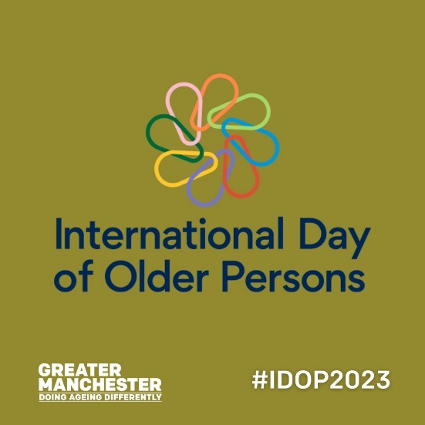  Alt text: Green background with multicoloured International Day of Older Persons logo, white Greater Manchester Doing Ageing differently logo. Graphic text reads, ‘#IDOP2023’. | Today is International Day of Older Persons – an annual event to support older people and raise awareness about the challenges ageing populations face.  This year we are celebrating the importance of place and neighbourhood in ageing well and throughout October, we’ll be sharing the stories of older residents across Greater Manchester in places that support them in later life.  #KnowOurPlace #IDOP2023 |  | 1 Oct AM
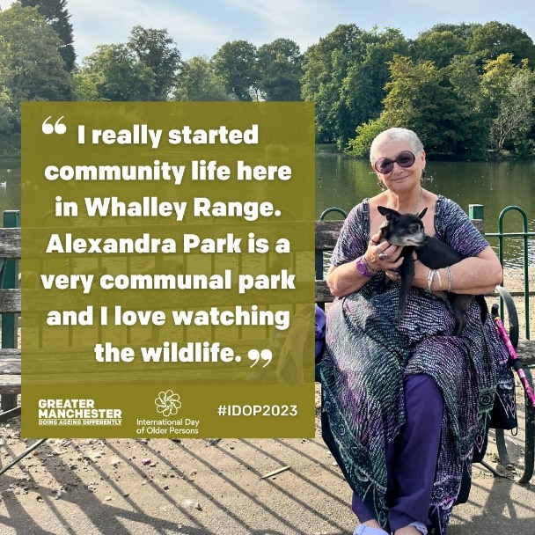  Alt text: A person sitting in front of a lake on a park bench holding a dog. Graphic text reads, ‘”I really started community life here in Whalley Range. This is a very communal park and I love watching the wildlife.”’ | Freddi has been a regular at Alexandra Park ever since moving to Whalley Range 12 years ago.  A big part of the local age-friendly community, Freddi is passionate about green spaces and loves having a park where she can walk her dog and look at wildlife on her doorstep.  #KnowOurPlace #IDOP2023 |  | 1 Oct PM
Lynne AIPP Abbey Hey MP4 file | ”The craft group is absolutely amazing.”  Lynne has lived in Abbey Hey, Gorton for 15 years.  The local community centre is a big part of her social life and has helped her through Covid and with her digital skills.  The Ageing in Place Pathfinder programme is working with people in mid and later life and a range of stakeholders in the neighbourhood of Abbey Hey to improve the quality of life for local residents.  To find out more search ‘Ageing in Place Pathfinder’ on the GMCA website.  #KnowOurPlace |  | 2 Oct PM
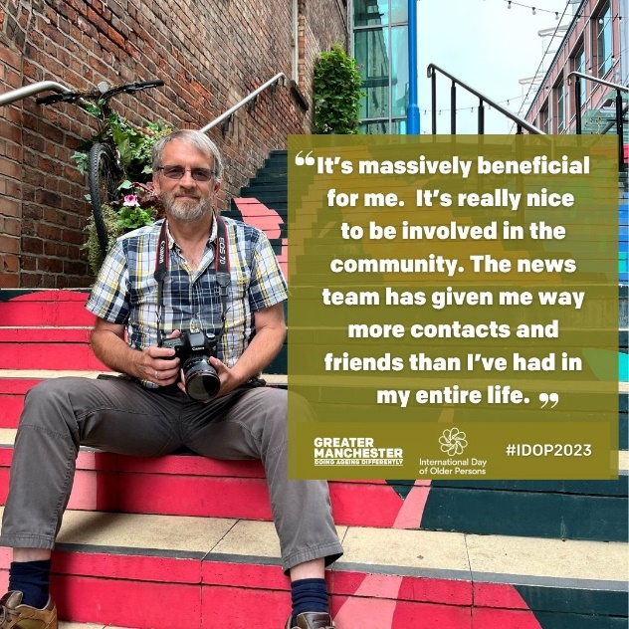  Alt text: Person with a beard sitting on multicoloured steps holding a camera. Graphic text reads, ‘”It’s massively beneficial for me. It’s really nice to be involved in the community. It’s given me way more contacts and friends than I’ve had in my entire life.”’ | David is a volunteer photographer for @mygengm – an older people’s-led news team who meet at Deansgate Mews.  Such volunteer work has been “massively beneficial” for David in his retirement and he is now “more engaged” with people than ever before.  To find out more about the importance of place and neighbourhood to ageing well, search ‘International Day of Older Persons’ on our website.  #KnowOurPlace #IDOP2023 |  | 3 Oct AM
Dave AIPP Worsley Mesnes MP4 file | 🗣 “You are always made to feel welcome and people feel comfortable.”  Dave has lived in Worsley Mesnes, Wigan with his wife for 52 years.  He loves the community and the wide range of amenities in the local area.  The Ageing in Place Pathfinder is working to ensure the voices of people in mid and later life are heard and valued in the places they live.  To find out more search ‘Ageing in Place Pathfinder’ on our website.  #KnowOurPlace |  | 4 Oct PM
Pat AIPP Little Lever MP4 file | 👋 Pat runs a sign-language class in Little Lever, Bolton where she has lived for 52 years.  Pat looks forward to the class every week, as do the local residents who are supported by the class.  Little Lever is one of the neighbourhoods supported by the Ageing in Place Pathfinder - a programme that works with local residents to find ways to improve people’s quality of life as they grow older.  To find out more search ‘Ageing in Place Pathfinder’ on the GMCA website.  #KnowOurPlace |  | 6 Oct PM
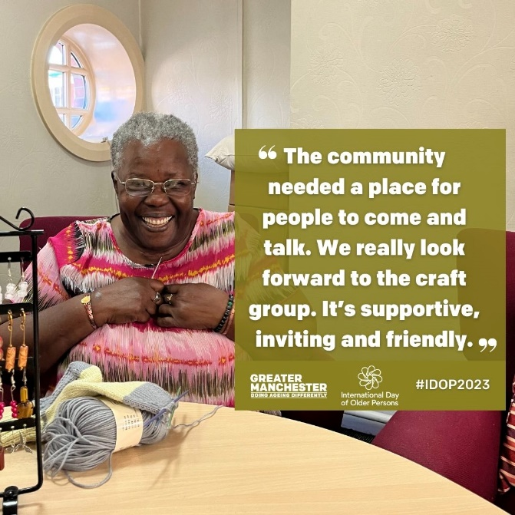  Alt text: A person in glasses sitting behind a table with a jewellery rack and a ball of wool on it. Graphic text reads, ‘”The community needed a place to come and talk. We really look forward to coming. It’s supportive, inviting and friendly.” | Many Hands is a craft group for older people in Ancoats that Elaine has been attending for many years.  Elaine describes the group as a support system for herself and many other local residents.  In Greater Manchester, we’re celebrating the importance of place and neighbourhood in mid to later life.  #KnowOurPlace |  | 8 Oct PM
Stephen/Lorraine AIPP Smallbridge MP4 file | 🗣 “It’s great in Smallbridge, the people make the estate.”  Stephen and Lorraine volunteer at Smallbridge food pantry which helps more than 70 people a week and supports cooking sessions for local older residents next door.  The Ageing in Place Pathfinder is working together with older residents in Smallbridge and Kirkholt, Rochdale to ensure their voices are heard and valued.  To find out more search ‘Ageing in Place Pathfinder’ on our website.  #KnowOurPlace |  | 9 Oct PM
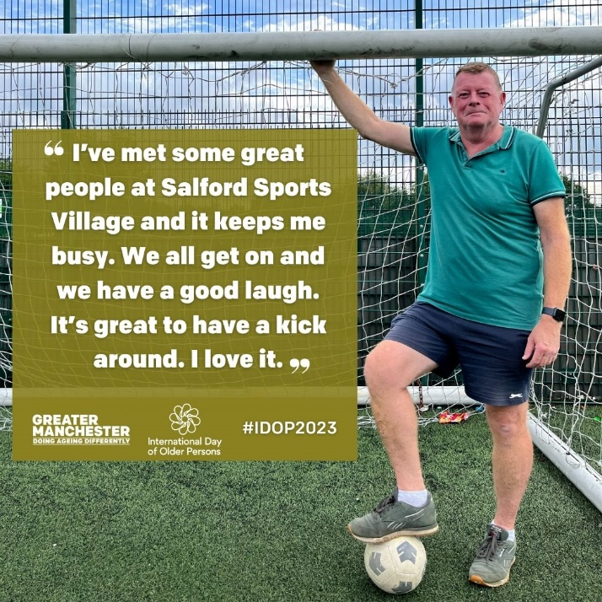  Alt text: A person standing in front of a football net with one foot on a football. Graphic text reads, ‘I’ve met some great people at Salford Sports Village and it keeps me busy. We all get on and we have a good laugh. It’s great to have a kick around. I love it.” | Joe lost his wife to dementia two years ago.  Foundation 92’s dementia walking football sessions at Salford Sports Village provide support for people with and affected by dementia and Joe has been a regular for nearly five years, making some great friends along the way.  To find out more about the importance of place and neighbourhood to ageing well, search ‘International Day of Older Persons’ on our website.  #KnowOurPlace |  | 11 Oct PM
Kath/Rita AIPP Moorside MP4 file | 🌷 Kath and Rita live in Moorside, Bury and volunteer at the local Clarence Park.  They both love having a green space on their doorstep and are incredibly grateful for the opportunity it provides them as they age.  The Ageing in Place Pathfinder programme is working with people in mid and later life and a range of stakeholders in Moorside to improve local residents’ quality of life.  To find out more search ‘Ageing in Place Pathfinder’ on our website.  #KnowOurPlace |  | 13 Oct PM
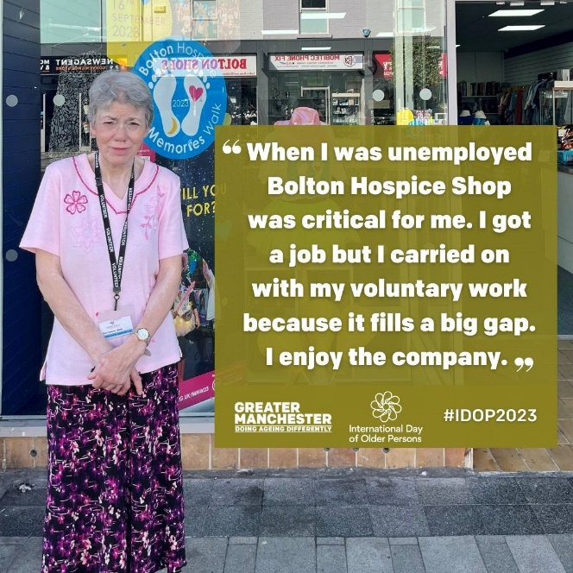  Alt text: A person wearing a lanyard standing outside of a shop. Graphic text reads, ‘”When I was unemployed it was critical for me. I got a job but I carried on with my voluntary work because it fills a big gap. I enjoy the company.” | Helen has been a volunteer at Bolton Hospice Shop for eight years now.  She has made great friendships with her colleagues and says the work “fills a big gap” and prevents loneliness.  To find out more about the importance of place and neighbourhood to ageing well, search ‘International Day of Older Persons’ on our website.  #KnowOurPlace |  | 17 Oct PM
June AIPP Pendleton MP4 file | 🗣 “It’s opened up a whole new life.”  June has lived in Pendleton, Salford for 67 years and is thriving since joining local art and photography groups at the end of lockdown.  She really values being a part of the local community.  The Ageing in Place Pathfinder is working together with older residents in Pendleton and Charlestown, Salford to ensure their voices are heard and valued.  To find out more search ‘Ageing in Place Pathfinder’ on the GMCA website.  #KnowOurPlace |  | 27 Oct AM
Geoff AIPP Brinnington MP4 file | 🗣 “Brinnington is a good place to grow old. There’s lots of activities and people get involved.”  Geoff is a resident of Brinnington, Stockport and runs a community art group with fellow over 50s to support people in the local area who are isolated.  Brinnington is one of the neighbourhoods supported by the Ageing in Place Pathfinder – a programme that works with local residents to find ways to improve people’s quality of life as they grow older.  To find out more search ‘Ageing in Place Pathfinder’ on the GMCA website.  #KnowOurPlace |  | 30 Oct AM
LinkedIn
Alt text: Person with a beard sitting on multicoloured steps holding a camera. Graphic text reads, ‘”It’s massively beneficial for me. It’s really nice to be involved in the community. It’s given me way more contacts and friends than I’ve had in my entire life.”’ | David is a volunteer photographer for @TalkingAboutMyGeneration – an older people’s-led news team who meet at Deansgate Mews.  Such volunteer work has been “massively beneficial” for David in his retirement and he is now “more engaged” with people than ever before.  https://greatermanchester-ca.gov.uk/what-we-do/ageing/international-day-of-older-persons-2023/  #KnowOurPlace |  | 3 Oct AM
Stephen/Lorraine AIPP Smallbridge MP4 file  or  https://youtu.be/eIpeq1r2-AA | 🗣 “It’s great in Smallbridge, the people make the estate.”  Stephen and Lorraine volunteer at Smallbridge food pantry which helps more than 70 people a week and supports cooking sessions for older local residents next door.  The Ageing in Place Pathfinder is working together with older residents in Smallbridge and Kirkholt, Rochdale to ensure their voices are heard and valued.  Find out more 👉 greatermanchester-ca.gov.uk/what-we-do/ageing/the-ageing-in-place-pathfinder/  #KnowOurPlace |  | 9 Oct PM
Kath/Rita AIPP Moorside MP4 file  or  https://youtu.be/rESZHWoIz1Q | 🌷 Kath and Rita live in Moorside, Bury and volunteer at the local Clarence Park.  They both love having a green space on their doorstep and are incredibly grateful for the opportunity it provides them as they age.  The Ageing in Place Pathfinder programme is working with people in mid and later life and a range of stakeholders in Moorside to improve local residents’ quality of life.  Find out more 👉 greatermanchester-ca.gov.uk/what-we-do/ageing/the-ageing-in-place-pathfinder/  #KnowOurPlace |  | 13 Oct PM
Alt text: A person wearing a lanyard standing outside of a shop. Graphic text reads, ‘”When I was unemployed it was critical for me. I got a job but I carried on with my voluntary work because it fills a big gap. I enjoy the company.” | Helen has been a volunteer at Bolton Hospice Shop for eight years now.  She has made great friendships with her colleagues and says the work “fills a big gap” and prevents loneliness.  https://greatermanchester-ca.gov.uk/what-we-do/ageing/international-day-of-older-persons-2023/  #KnowOurPlace |  | 17 Oct PM

If you have any queries relating to the content of difficulties accessing the assets, please contact dylan.childs@greatermanchester-ca.gov.uk

