Cost of living social media toolkit

Topic | Post | Graphic
Support for young families | Free childcare hours and benefits are available to parents of young children.  Even if you are working, you may entitled to support, including:  👶15 hours free childcare for 2yr olds  👶Universal credit support  Find out what you can claim👇  greatermanchester-ca.gov.uk/helpinghand  #HelpingHandGM | 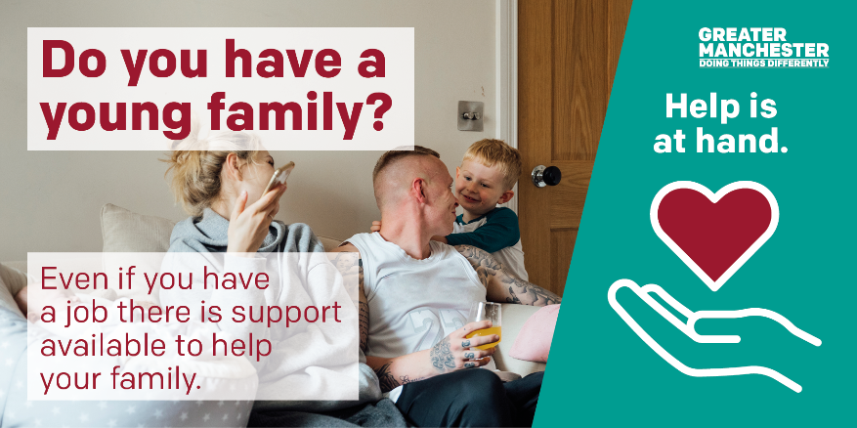  Alt text:  Do you have a young family? Even if you have a job there is support available to help your family.
General support | If you’re struggling to make ends meet, don’t struggle alone. ❤  There is support available for things like paying bills, accessing food and improving how you feel. 🏠  Help is at hand👇  greatermanchester-ca.gov.uk/helpinghand  #HelpingHandGM | 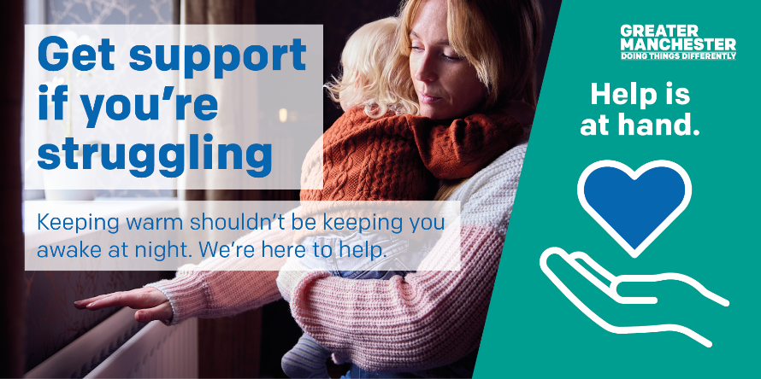  Alt text:  Get support if you’re struggling. Keeping warm shouldn’t be keeping you awake at night. We’re here to help.
General support | If you need support this winter, help is at hand.  From housing and food, jobs and skills, free help is available.  Help is at hand👇  greatermanchester-ca.gov.uk/helpinghand  #HelpingHandGM | Alt text:  Need a little support? A lot of us need a helping hand this winter. Reach out today.
Energy and bills | Need help with energy bills?  If you’re struggling to make payments, contact your provider who can support you. 🏠  Don’t struggle alone – help is at hand 👇  greatermanchester-ca.gov.uk/helpinghand  #HelpingHandGM | Alt text:  Struggling with your bills? Don’t struggle alone. Advice and support is available to help you.
Warm spaces | Warm spaces are open in your area this winter.  A warm space provides you with a comfortable place for a cuppa and a chat. Staff can help you find the information and advice you need this winter.  Find your local warm space  greatermanchester-ca.gov.uk/helpinghand  #HelpingHandGM | Alt text:  Warm spaces open near you. Find your local warm space for cuppas and catch ups.
Gambling | Gambling is not a way to make money.  If you need support this winter, there is financial help for you and your family.  Visit Helping Hand to find help in the right place.  greatermanchester-ca.gov.uk/helpinghand  Need support for gambling? Visit chapter-one.org  #HelpingHandGM | Alt text:  Need your money to go further? Gambling isnt the answer. Find help in the right place.
Ageing | Are older people in your life Winterwise?  📢Support is available to help them manage cost of living challenges and their wellbeing this winter.  In partnership with @IndependentAge we’re distributing Winterwise across GM.  👉 greatermanchester-ca.gov.uk/what-we-do/ageing/winterwise-guide/  ---  📢 Greater Manchester is supporting older people to stay warm, safe and well this winter.  More tips and advice are available from our Winterwise guide 👉 greatermanchester-ca.gov.uk/what-we-do/ageing/winterwise-guide/ | Alt text:  Support for all. There is lots of support for older people in your life.
Digital | We know a lack of digital access, affordability & skills can make you feel isolated 🙁  #GetOnlineGM can help everyone get online, get connected and build digital skills 👏  Visit greatermanchester-ca.gov.uk/GetOnlineGM  #HelpingHandGM | Alt text: Get online. Reduce isolation. We can help you get online, get connected and boost your online skills.
 | 806,500 GM residents face some form of digital exclusion. A lack of digital access, affordability & skills can make you feel isolated 🙁  #GetOnlineGM can help you, or someone you know get connected, build digital skills and get online! 👏  Visit greatermanchester-ca.gov.uk/GetOnlineGM  #HelpingHandGM | 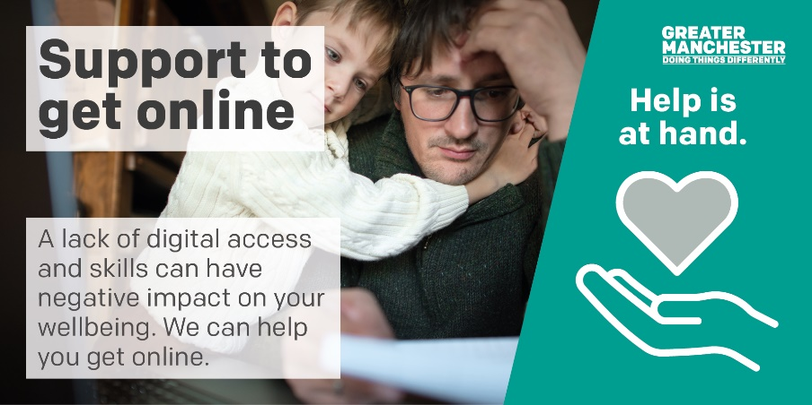  Alt text: Support to get online. A lack of digital access and skills can have negative impact on your wellbeing. We can help you get online.
Fire safety | There are some simple steps you can take to help you stay safe from fire.  Make sure you have a working smoke alarm on every floor of your home and a heat alarm in your kitchen, so you’re alerted quickly if there’s a fire.  #StayFireSafe  ---  We are all looking at ways to reduce our energy bills.  Make sure you #StayFireSafe and don’t put yourself at risk of fire in your home.  🚒 See @manchesterfire advice on keeping safe here: manchesterfire.gov.uk/your-safety/stay-fire-safe/ | 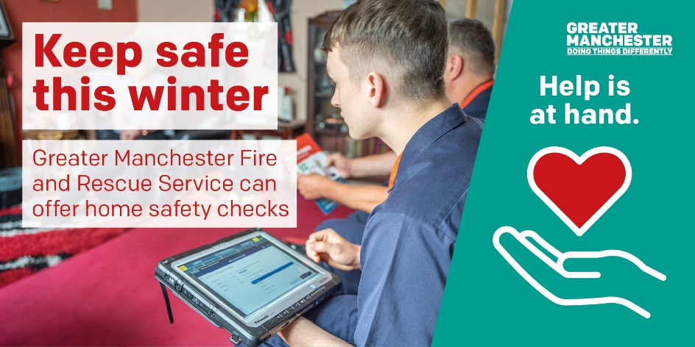  Alt text:  Keep safe this winter. Greater Manchester Fire and Rescue Service can offer home safety checks
Energy efficiency | Energy saving changes can help make your home warmer and reduce your energy bills, as well as helping make Greater Manchester a greener place to live 🏡💚  Find out what support you can get to make your home warmer: https://gmca.retrofitportal.org.uk/home  #HelpingHandGM | 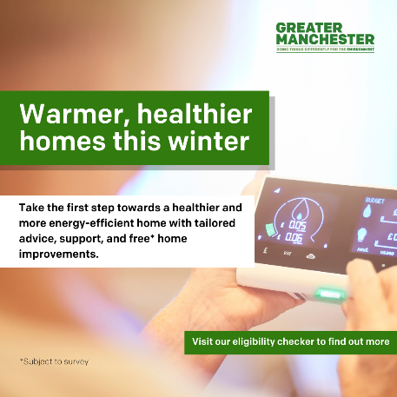  Alt text: Warmer, healthier homes this winter. Take the first step towards a healthier and more energy-efficient home with tailored advice, support, and free home improvements. Visit our eligibility check to find out more.
 | Your home - saving energy to take care of you, your wallet, and the planet 🌍  Greater Manchester Combined Authority is offering free, tailored advice to help residents improve their homes - see what free support you are eligible for here: https://gmca.retrofitportal.org.uk/home #HelpingHandGM | 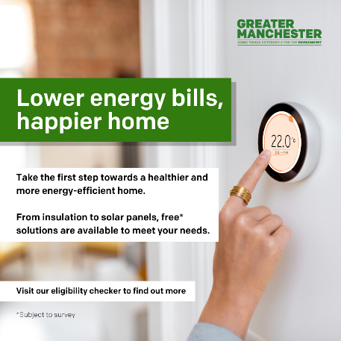  Alt text: Lower energy bills, happier home. Take the first step towards a healthier and more energy-efficient home. From insulation to solar panels, free solutions are available to meet your needs. Visit our eligibility check to find out more.
Breakthrough | Breakthrough UK provides accessible anonymous information and signposting for cost of living advice.  You can text 07860 022 876 to ask a question and will be directed to support in your area. Messages will be responded to by the next working day.  #HelpingHandGM | 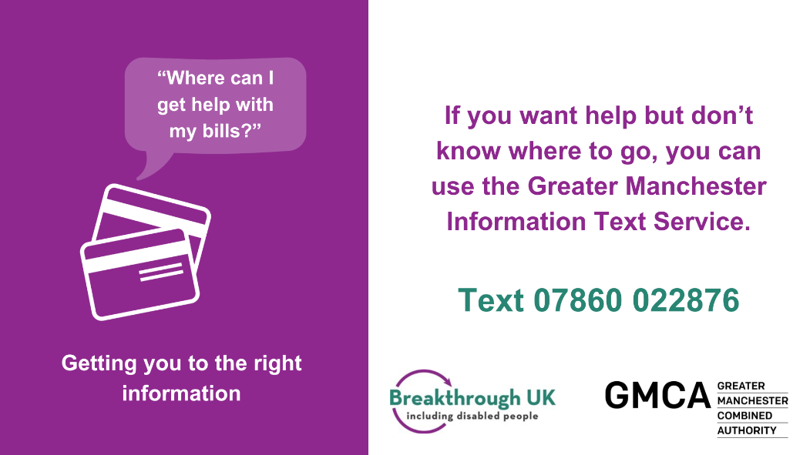  Alt text:  If you want help but don’t know where to go, you can use the Greater Manchester Information Text Service. Text 07860022876.

