Census 2021 Briefing

Car Availability
GMCA Research
January 2024

Dataset: Housing - Number of cars or vans
Datalink: The data used in this briefing can be found at https://www.ons.gov.uk/datasets/TS045/editions/2021/versions/4. It can also be found at https://www.nomisweb.co.uk/datasets/c2021ts045
Definition: The number of cars or vans owned or available for use by household members. Throughout this briefing, “number of cars” is used as shorthand for cars and vans. Where possible, the focus is on number of households with a car available. Where data was only available to compare with other groups in terms of number of residents instead (e.g. disability, age), residents is clearly stated.
Census day: The 2021 census was held in England and Wales on 21 March 2021. Census 2021 was undertaken during the Covid-19 pandemic so may not show normal population and household patterns due to temporary changes in living circumstances during the pandemic for some households.

Key points
- Almost three-quarters (73%) of Greater Manchester households now have a car available to them, up 4 percentage points since 2011. This continues a long-standing trend of increasing car availability across both the city-region and wider country.
- More than 1 in 4 Greater Manchester households do not have a car (27%, or 319,000 households, containing 575,000 residents). This is slightly higher than the 24% average across England.
- The proportion of households with two or more cars available has also increased to 30%, up from 27% in 2011. As a result, for the first time, more households in Greater Manchester now possess two or more cars than possess zero cars.
- Car availability varies significantly across the city-region. In Manchester, more than a third (39%) of households do not have a car, whereas in Trafford, this figure drops to just 19% of households. In some central Manchester LSOAs, more than 75% of households do not have a car.

Main Findings

Increasing car availability
From 1991 to 2021, there has been a steady increase in the number of Greater Manchester households with a car available to them. 73% of homes (860,000) now have at least one car, compared to 59% in 1991 (593,000).
Within this steady increase, the proportion of households with two or more cars available has risen quickest. 30% of households in Greater Manchester have two or more cars, up from 27% in 2011 and 19% in 1991. The number of households with a single car rose more steadily throughout this period, remaining relatively stable as a proportion of all households (43% by 2021, up from 41% in 1991).
This long-term trend of increasing car availability across Greater Manchester has placed increased pressure on the highway network. Since 1991, the number of households with a car in Greater Manchester has increased by 45% (against an 18% increase in total households), with 266,000 more households now having at least one car.
Number of cars available to households in Greater Manchester, 1991-2021

Source: OPCS, Census 1991, L21 - Nomis; ONS, Census 2001, KS017 - Nomis; ONS, Census 2011, KS404 - Nomis; ONS, Census 2021, TS045 - Nomis
Greater Manchester’s trend is similar to that seen in other major city-regions, such as the West Midlands, where two or more car households rose from 19% in 1991 to 31% in 2021, and across England, where two or more car households rose by a similar amount from a higher starting point, from 24% to 35% over the same 30 years. However, London was a clear outlier to this trend, with two or more car households remaining static at 18% in both 1991 and 2021. Likewise, the number of households without any car available also remained steady in London, unlike in Greater Manchester, the West Midlands and across England.

Households without cars
Across Greater Manchester, more than 1 in 4 households (27%, or 319,000 households) do not have a car. This is slightly higher than the England average of 24%. If we consider this in terms of residents, rather than households, 575,000 Greater Manchester residents are living in a household which does not have a car available (20% of residents). 110,000 of these residents are under 16 years old, which is equivalent to 19% of all under-16-year-olds in the city-region.

Differences within Greater Manchester
Number of cars or vans available to households in Greater Manchester, 2021

Source: ONS, Census 2021, TS045 - Nomis
As might be expected, there is significant variation within the city-region. In Manchester, over a third (39%) of households do not have a car, whereas in Trafford, this figure is just 19%. The differences are even starker at LSOA-level, with more than 75% of households in several central Manchester neighbourhoods not having a car, compared to less than 5% of households in areas of Stockport, Bury, Trafford, Wigan, Salford and Rochdale.
There is also significant variation in households with two or more cars within Greater Manchester, with 37% of Trafford and Stockport households having two or more cars, compared to just 24% in Salford and only 18% in Manchester. In parts of Trafford, 72% of homes within an LSOA have two or more cars, compared to just 2% in some Manchester LSOAs.
Percentage of households without a car in Greater Manchester by LSOA, 2021
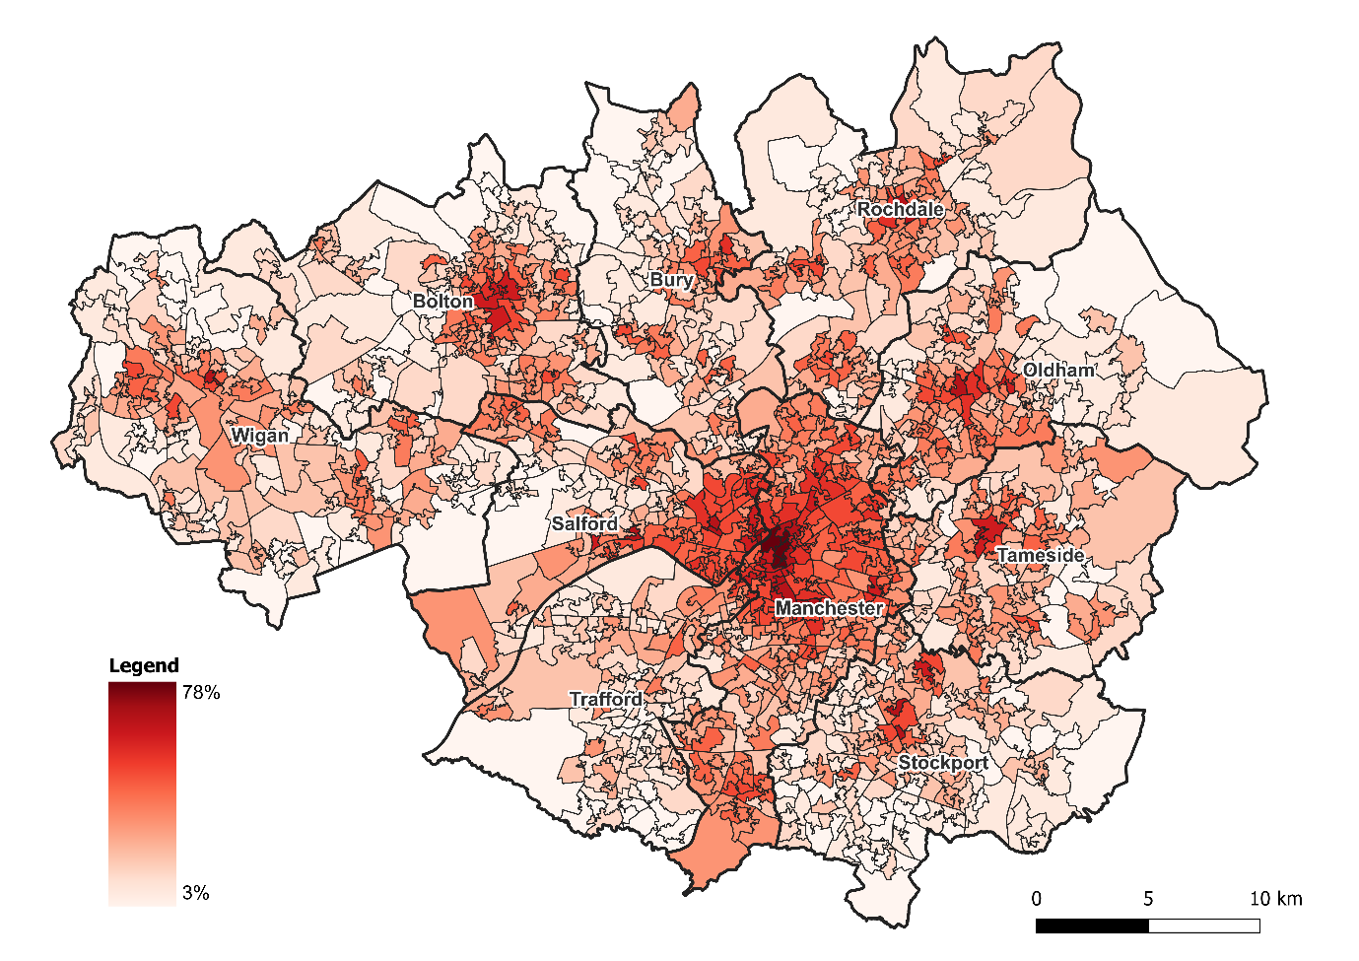
Percentage of households with two or more cars in Greater Manchester by LSOA, 2021
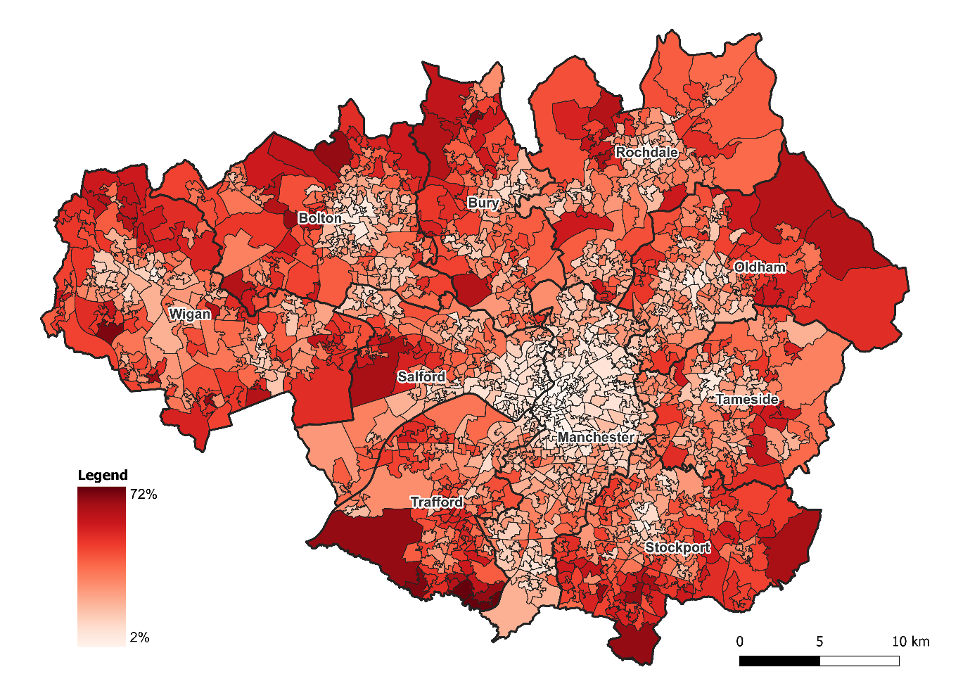
Source: ONS, Census 2021, Custom dataset - Car or van availability

Which groups are more likely to have a car?
- Households living in flats are considerably less likely to have a car, with more than half not having a car available (55%). In contrast, just 10% of detached households go without a car. Detached households are also much more likely than other accommodation types to have two or more cars (56%, compared to 7% in flats, 24% in terraces and 37% in semi-detached homes).
- Residents who reported a disability (those who assessed their day-to-day activities as limited by long-term physical or mental health conditions or illnesses) are much less likely to live in a household with access to a car. 34% of disabled residents do not live in a household with a car available (170,000 residents), compared to 17% of residents who did not report a disability.
- Residents identified as social grade AB were much more likely to live in a household with at least one car (93%) than residents identified as DE (62%).
- Households containing dependent children are much more likely to have at least one car, at 82%, compared to just 69% of households without dependent children.
- Middle-aged residents (35-64 years old) are most likely to live in a household with a car (84%), with under-16s close behind (81%). Residents aged 65+ are least likely (73%), followed by younger adults, aged 16 to 34 (77%).
- There is a significant divide between ethnic groups in likelihood to have a car. While Asian residents are most likely to live in a household with a car (85%, followed by 80% of White residents), just 68% of Black residents live in a household which has a car available.

Reflections
Household car availability has been increasing in Greater Manchester since 1991, reflecting a similar trend across the whole of England.
Car availability is traditionally associated with increased affluence, so this trend could be interpreted as a sign of rising prosperity within the city region. However, Greater Manchester is home to some of the most deprived areas in the country, and we know that many people here have historically had little option but to spend money on car-keeping to facilitate essential journeys.
Greater Manchester has set out a vision for 50% (currently around 60%) of the city-region’s journeys to be made by walking, cycling and public transport by 2040. This vision will support economic growth in Greater Manchester without increasing overall motor-vehicle traffic. The 1991 to 2021 trend of increasing car availability represents a challenge to achieving this target.
To support this change, Greater Manchester is now delivering the Bee Network - an integrated transport network which brings together walking, wheeling & cycling, bus, tram and trains as one consolidated network, with high quality services and affordable fares. This is an important step in making the use of sustainable modes more attractive, but with car availability already high, other policies may be required for the Bee Network to achieve its full potential.
The car will continue to play an important role in supporting economic growth and opening up opportunities for people to improve their quality of life. However, many of the negative impacts of transport, such as congestion, high emissions, noise and road traffic casualties, are a consequence of our over-reliance on cars, and the planning decisions that made car use the most convenient, or only choice for some journeys.
An over-reliance on cars also has significant health impacts. They contribute to poor air quality and facilitate unhealthy, sedentary lifestyles. Whilst the growing number of electric vehicles in Greater Manchester have a smaller carbon impact than fossil-fuelled alternatives, they share the majority of these negative impacts.
Car-keeping can also be expensive: the combined costs of insurance, fuel, maintenance and leasing can form a substantial proportion of household budgets. Public transport and active travel can offer an affordable – or free – alternative.
There are a significant minority of Greater Manchester households and residents who do not have a car available to them. In some neighbourhoods, often in central Manchester or Salford, those without a car even make up a majority of households. The sizable proportion of disabled residents who do not have a car available to them means considering accessibility while designing the public realm is crucial (whether public transport, active travel infrastructure, or private taxis).

