Census 2021 Briefing Social Class (NS-SEC)
GMCA Research
June 2024
Dataset: NS-SEC (National Statistics Socio-economic Classification). The technical manual for NS-SEC can be found here
Datalink: The data used in this briefing can be found here
Definitions: NS-SEC is a system used by statisticians to categorise the status of people inside and outside the labour market. It classifies people by the nature of employment relations (how they sell their labour) and conditions of work. For example, jobs described as ‘routine’ have little need for employee discretion and judgement and have the most basic forms of labour contract. Jobs described as ‘higher managerial, administrative and professional’ have a service relationship with the employer and involve planning and supervision of others on behalf of the employer.
Census day: The 2021 census was held in England and Wales on 21 March 2021. Census 2021 was undertaken during the Covid-19 pandemic so may not show normal population and household patterns due to temporary changes in living circumstances during the pandemic for some households.

Key points
- This briefing explores the class structure of Greater Manchester by analysing the labour market. It is a companion to another briefing on class (‘social grade’).
- Greater Manchester had a lower proportion of residents in managerial and professional types of work compared with England in 2021 (11.3% vs 13.2% - although differences are larger among individual districts).
- Meanwhile, it has a higher proportion in ‘routine occupations’ – relatively repetitive, low status work (13.1% vs 12% in England).
- The class structure of Greater Manchester shows some evidence of ‘polarization’ – growth at the ‘top’ and ‘bottom’ and decline in the ‘middle’ of the occupational spectrum.
- The class structure of the conurbation can also be seen in the spatial concentration of roles – for instance a higher proportion of residents with routine occupations in areas such as Wigan; and residents with managerial and professional jobs in Trafford and Stockport.

Introduction
Britain is often said to be a class-based society. But class is famously difficult to define. Wealth, education, culture and taste all play a part. GMCA census briefings cover two aspects of class. One briefing covers ‘social grade’ – often used by marketing firms to target products at different types of consumer. This briefing concentrates on class positions in the labour market.

The kind of work people do is fundamental to understanding class. Labour market situation determines income, economic security and the prospects for economic advancement. The NS-SEC – or National Statistics Socio-Economic Classification - is a system for categorizing occupations.

The main idea behind the NS-SEC is that it aims to reflect the real employment situations of people, and the type of labour contract they have, rather than how they see themselves, their skill levels, or their pay. Key distinctions are whether they are an employer, self-employed or employee; whether they supervise other workers; and the number of employees at a workplace. The NS-SEC focuses on employment relationships.

Although information on unemployment and the student population is also available from the NS-SEC, it is perhaps most useful for understanding differences among working people. People in what are referred to as ‘routine jobs’ (definition in the appendix) may not be the very worst off in society, but their autonomy in their jobs will be curtailed. And they are likely to undertake relatively repetitive, arduous work.

Findings
The chart below compares residents living in Greater Manchester to those elsewhere in England in 2021. Greater Manchester has fewer residents in ‘higher’ and ‘lower’ level managerial, administrative and professional roles than the English average. In addition, it has fewer people who are in self-employment. However, it has more of its population in ‘routine jobs’, more who are long-term unemployed or who have never worked, and a higher proportion of full-time students.

NS-SEC categories, Greater Manchester and England, 2021
Source: Census 2021

District variations
Differences are greater among districts. For example, Trafford has a much higher proportion of its residents in higher managerial, administrative and professional roles than the English average (19% vs. 13.2%). Yet in several districts such roles account for well below 10% of residents.

Meanwhile, among residents in ‘routine jobs’, proportions are notably higher in Wigan, Tameside, Rochdale and Oldham. These findings are set out in the next two charts.

Residents in ‘Higher managerial, administrative and higher professional occupations’, 2021
Source: Census, 2021

Residents in ‘routine jobs’, 2021
Source: Census 2021

These differences can be seen better at ‘lower super output area’ (LSOA) level – small geographical units. Routine jobs are concentrated in Wigan and generally to the north and east of the city centre (although there are pockets elsewhere, such as in the Wythenshawe area of Manchester to the south). Meanwhile, regarding higher level managerial, administrative and professional occupations, these tend to be a little less concentrated, but are generally more prevalent towards the south of the city centre, especially in Trafford and Stockport (although again there are pockets elsewhere).

NS-SEC occupations by LSOA: % in ‘routine’ jobs (map 1)
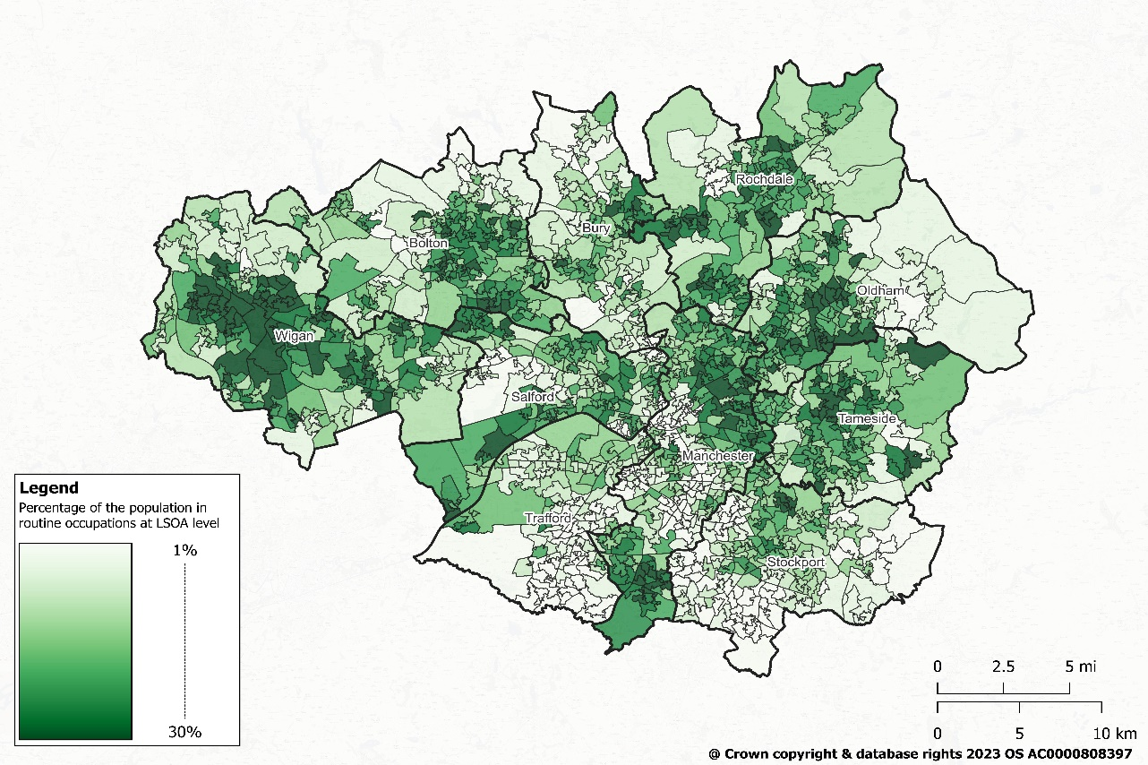

NS-SEC occupations by LSOA: % in ‘higher managerial, admistrative and professional’ occupations (map 2).
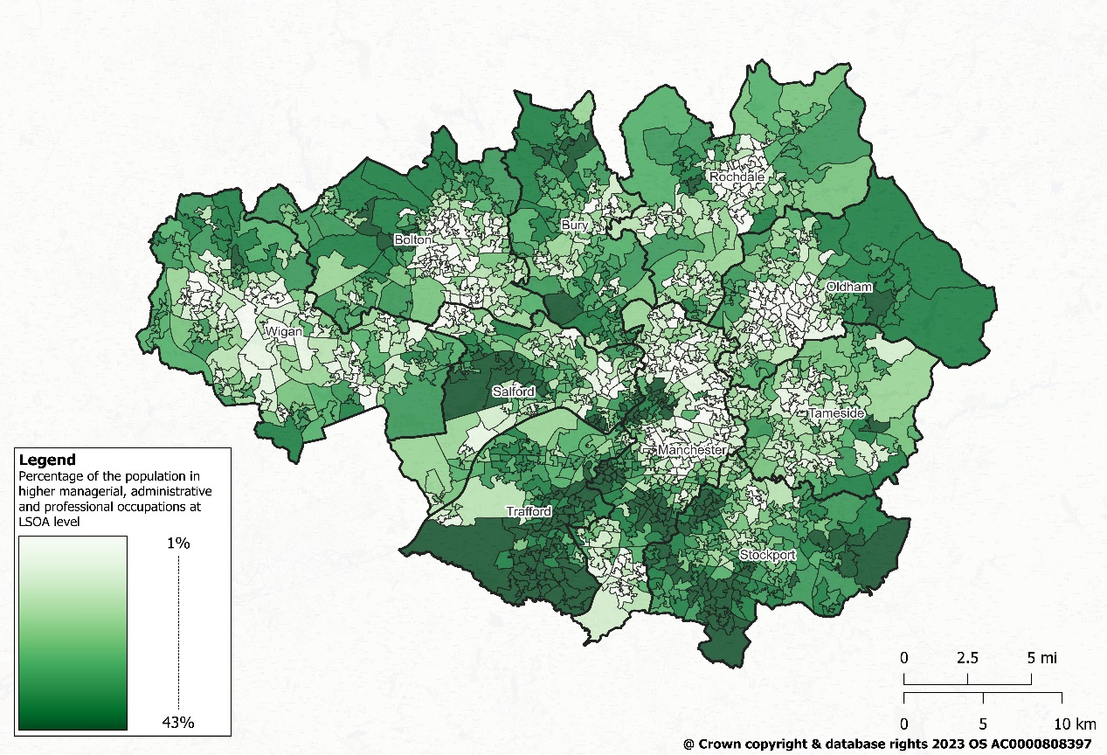
Source: Census 2021

Change 2011-2021
Which labour market groups have risen and which have declined? Comparisons are possible with the 2011 census a decade earlier, but the information is more difficult to reconcile with census years prior to 2011. The groups which have declined in Greater Manchester over the decade betweeen 2011 and 2021 include:
- Semi-routine occupations (by 3.5 percentage points or ppts). The ‘semi-routine’ category has a slightly better labour contract and a little more discretion than a ‘routine’ job. The group has fallen most in Salford.
- Lower supervisory and technical occupations (by 1.5ppts). This group has some responsibility to supervise other workers; some operate through service rather than labour contracts, which can enable more autonomy. Oldham (2.2ppts) and Tameside (2.1ppts) have seen the largest falls.
- Intermediate occupations: (by 1.4ppts). These workers, often in sales and service type roles, mix both elements of a service contract and a labour contract. They have fallen most in Trafford between census years (by 2.5 ppts).
The key groups that have increased in Greater Manchester are:
- Higher managerial, admistrative and professional occupations (by 2.5 ppts) – most dramatically in Trafford (by 4.6 ppts).
- Small employers and own account workers (by 0.9 ppts). Growth in this group has been most pronounced in Manchester (1.6 ppts).
- Routine occupations (by 0.7 ppts). These have increased most in Bolton (by 1.3ppts), but Tameside (1.1ppts) and Manchester (1 ppt) are close.
The chart below reflects these patterns of change.
Change in NS-SEC categories, 2011-2021
Source: Census 2021

Reflections
Overall, the information about class contained in the NS-SEC can be interpreted as consistent with ‘polarization’ in society.

There is clear growth at the ‘top’ of the labour market. Managers and people in professional work have increased strongly over the decade between censuses. This growth is evident everywhere. It is most apparent, however, in places where these kinds of jobs were already relatively concentrated (for example, in Trafford).

However, there is also growth at the ‘bottom’ (albeit less strong). The numbers of people in ‘routine’ jobs – think of working in bars, warehouses, shops etc – is increasing. These workers have least power and control over their working situation.

Meanwhile, ‘middling’ sorts of jobs have declined. These jobs include those in intermediate, in supervisory and technical, and in semi-routine positions. The ‘semi-routine’ has declined while ‘routine’ occupations have expanded.

The underlying explanations for the inequalities in wealth and power in society that tend to generate substantial public attention arguably relate to these changes in labour market situation. Mutations in the subtle nature of ‘class’ are both reflected in, but also driven by, residents’ labour market positions.

Appendix: NS-SEC Definitions of occupational groups

NS-SEC grouping | Example Occupations
L1, L2 and L3 Higher managerial, administrative and professional occupations | Directors of major organisation, medical practitioner, higher education teaching professional, senior civil servant, clergy, accountant, solicitor, statistician
L4, L5 and L6 Lower managerial, administrative and professional occupations | Nurse, midwife, journalist, editor, musician, teacher, paramedic, investment analyst, customer service manager, housing manager, youth worker
L7 Intermediate occupations | Medical secretary, travel agent, ambulance staff, police officer (sergeant and below), nursery nurse, debt collector, medical and dental technician
L8 and L9 Small employers and own account workers | Taxi driver, roofer, hotel manager, farmer, product designer, driving instructor, window cleaner
L10 and L11 Lower supervisory and technical occupations | Baker, electrician, gardener, train driver, road construction operative, senior care worker, cleaning manager, quarry worker, car mechanic
L12 Semi-routine occupations | Scaffolder, traffic warden, dental nurse, housekeeper, farmworker, fitness instructor, cook, care worker, caretaker, retail cashier, metalworker
L13 Routine occupations | Cleaner, waiter, labourer, butcher, fishmonger, print worker, decorator, glazier, woodworker, florist, hairdresser, textile process operative, miner
L14.1 and L14.2 Never worked and long-term unemployed | -
L15 Full-time students | -

