Social Media Pack for Public Consultations on Joint Supplementary Planning Documents (SPDs)
This pack contains the social media graphics and suggested text for the public consultations on the Holcroft Moss Planning Obligations SPD and South Pennine Moors SPD. These documents support the delivery of the Places for Everyone (PfE) Plan, which having been adopted by the nine authorities, came into force on 21st March 2024. The SPDs provide developers with clear advice and guidance in relation to proposed developments and will be a valuable tool to be used by the local planning authorities in the determination of relevant planning applications and the protection of two European protected habitat areas .

More information can be found - Joint Supplementary Planning Documents - Greater Manchester Combined Authority (greatermanchester-ca.gov.uk)

Objective
Key Goal: To ensure that developers are aware of the obligations required of them to meet the relevant PfE policies.

The consultation period will run from Friday 1st November to Thursday 12th December 2024 (6 week period) and will primarily be managed through www.gmconsult.org

Suggested Newsletter text
The Greater Manchester Combined Authority (GMCA), in partnership with local planning authorities, is coordinating the production of two joint Supplementary Planning Documents (SPDs). The joint SPDs will help to guide planning applications for new homes and business. Making sure that the delivery of the Places for Everyone Plan does not have a negative impact on some of the most important habitat sites in and around Greater Manchester
The joint SPDs cover two European protected habitat areas, the South Pennine Moors, in Rochdale, Oldham and Tameside, and Holcroft Moss, in Warrington. Near to the border of Greater Manchester, including, Salford, Wigan and Trafford. To help shape these important documents the GMCA needs your input
Share your views here: www.gmconsult.org
The consultation will run for 6 weeks from Friday 1st November to Thursday 12th December 2024. More information is available here: Joint Supplementary Planning Documents - Greater Manchester Combined Authority (greatermanchester-ca.gov.uk)

Graphic Downloads

Joint graphics | https://we.tl/t-xuOZsfBRCJ
Holcroft Moss graphics | https://we.tl/t-SLUg0hiniF
South Pennine Moors | https://we.tl/t-u9vWAyMGTL

X (Formerly Twitter)
Joint Launch Post (thread)
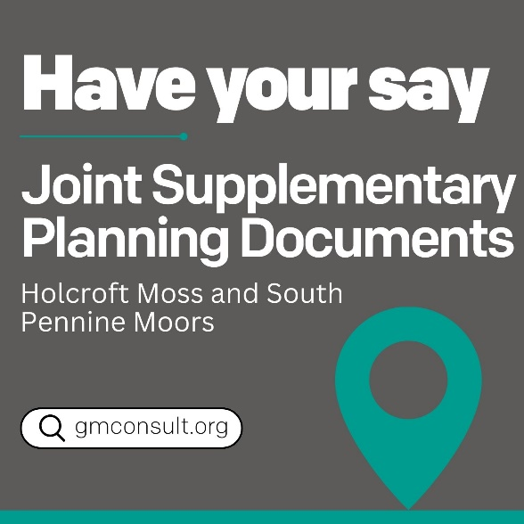  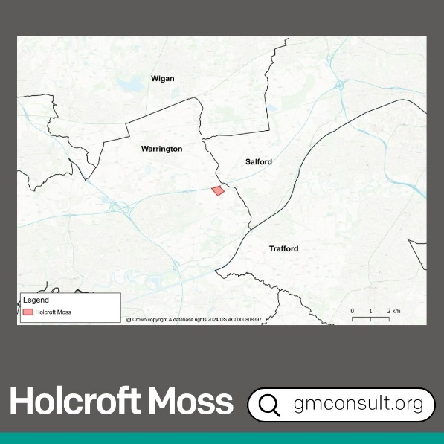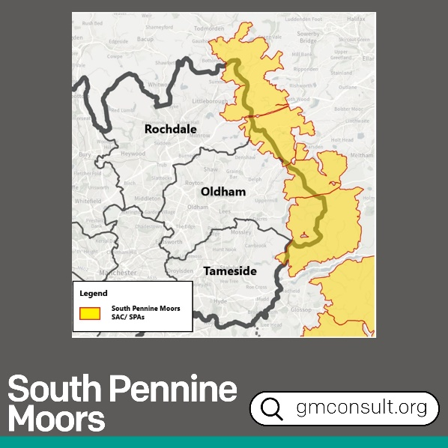 | 🌳 As part of delivering jobs, new homes, and sustainable growth in our Places for Everyone Plan, we have committed to protecting important natural habitats.  The Joint Supplementary Planning Documents (SPDs) are a key part of this commitment.
📍They will guide developments from having adverse impacts on two key areas: Holcroft Moss and the South Pennine Moors

🗣️We want to hear your views to help shape the content of these documents: www.gmconsult.org
 | Find out more here [link to PR]
South Pennine Moors
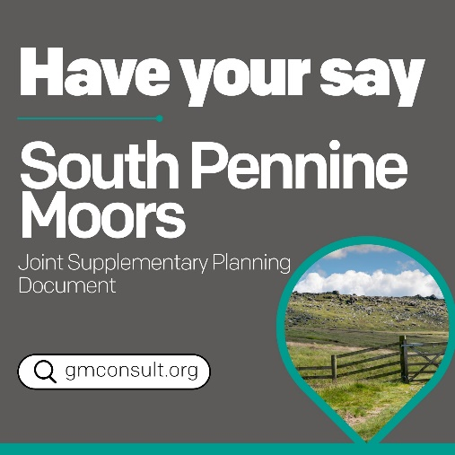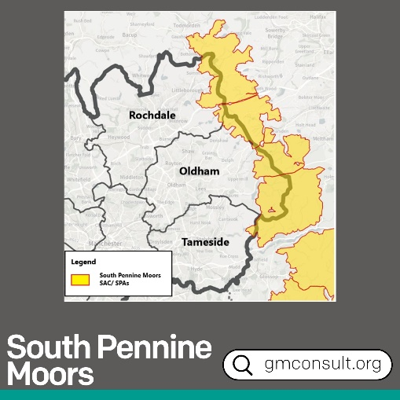 | 🐦 The South Pennine Moors is an important natural habitat for a wide range of bird species.  We want to ensure that new homes and businesses in Oldham, Rochdale and Tameside, close to the area, have safeguards in place to protect these habitats.
🗣️ The Joint Supplementary Planning Document is a key part of this, and we want your input to help shape it.

www.gmconsult.org/pfe/south-pennine-moors

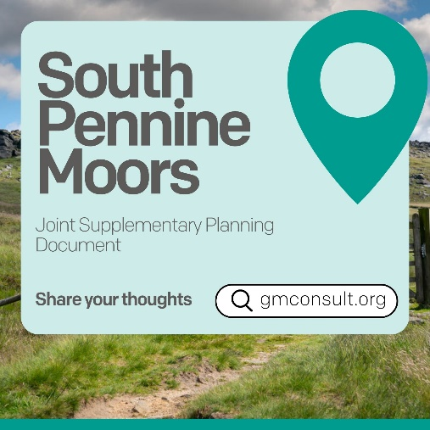 | 🦉 Did you know parts of Oldham, Rochdale and Tameside are important bird habitats for Merlins, Golden Plovers and short-eared Owls?  We want to ensure that new homes and businesses in these areas have safeguards in place to avoid harm to these species
🗣️ The Joint Supplementary Planning Document is a key part of this, and we want your input to help shape it.

www.gmconsult.org/pfe/south-pennine-moors

Holcroft Moss
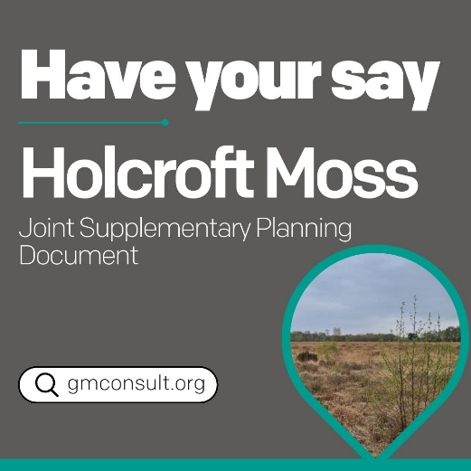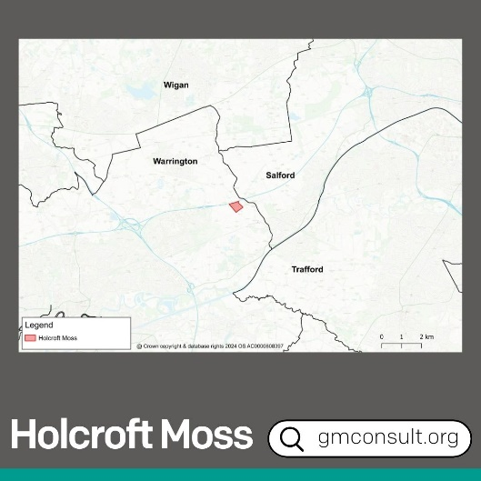 | 📍Close to Greater Manchester, in Warrington, is Holcroft Moss. It is an important peat bog habitat which has developed over thousands of years.  We want to ensure that new homes and businesses have safeguards in place to avoid harm to this site.
🗣️ The Joint Supplementary Planning Document is a key part of delivering this, and we want your input to help shape it.

www.gmconsult.org/pfe/holcroft-moss
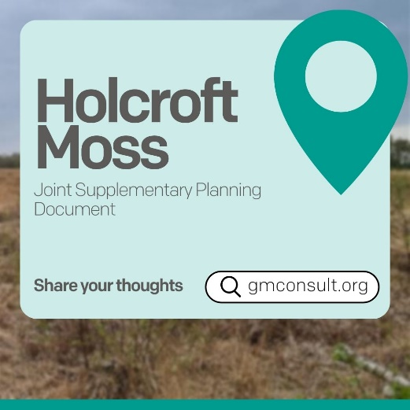 | 📍Did you know Holcroft Moss is an important peat bog habitat, developed over thousands of years?  The Places for Everyone Plan has a policy to ensure that new homes and businesses mitigate their impact on this site.
🗣️ The Joint Supplementary Planning Document is a key part of delivering this, and we want your input to help shape it.

www.gmconsult.org/pfe/holcroft-moss
Facebook/LinkedIn

Joint Launch Post
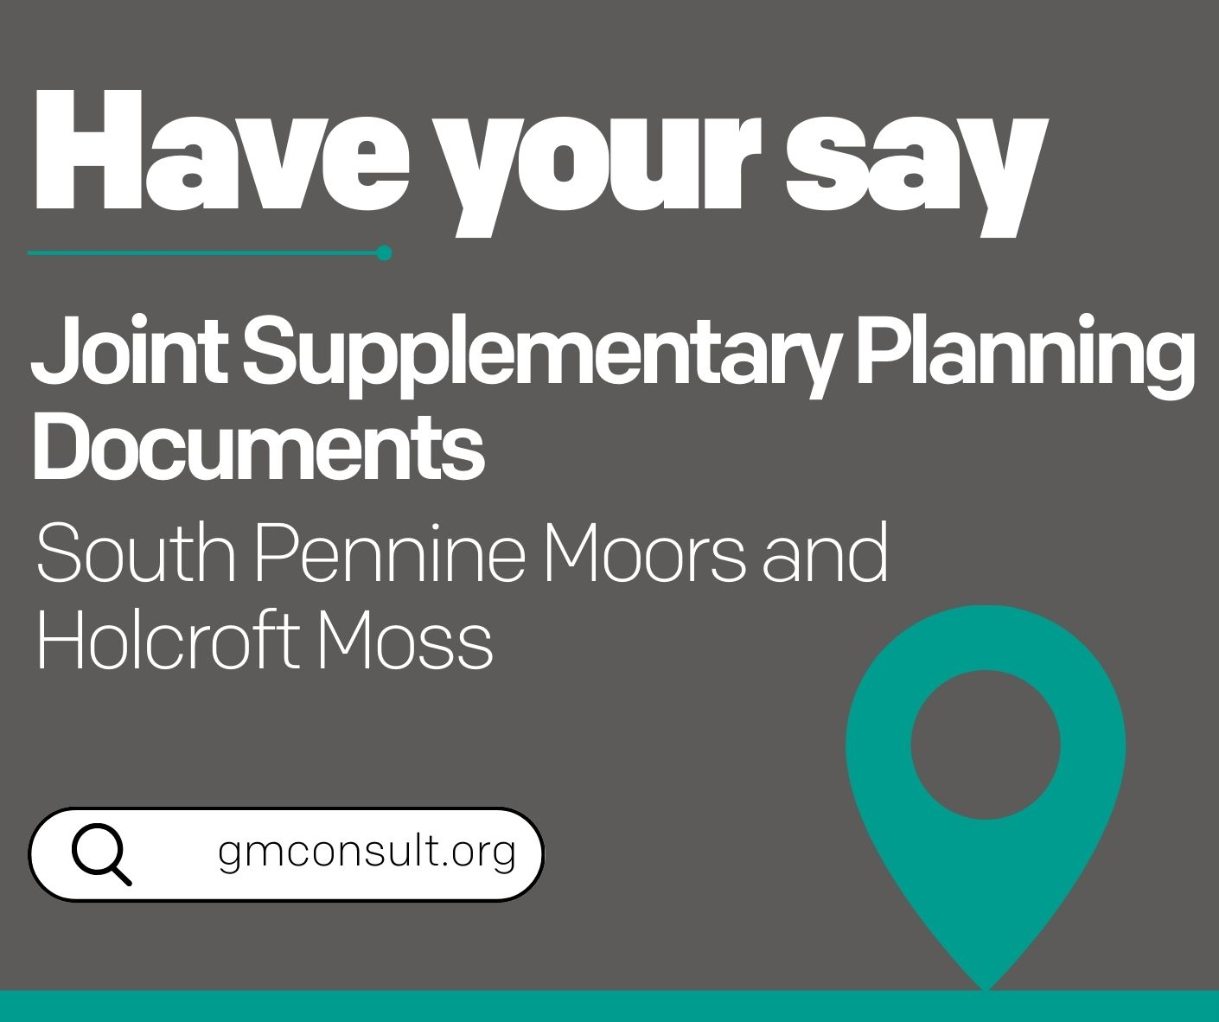 | 🌳 As part of delivering jobs, new homes, and sustainable growth in our Places for Everyone Plan, we have committed to protecting important natural habitats.  The Joint Supplementary Planning Documents (SPDs) are a key part of delivering on this commitment.  They will guide developments from having adverse impacts on two key areas: Holcroft Moss and the South Pennine Moors  🗣️We want to hear your views to help shape the content of these documents: www.gmconsult.org  Find out more here [link to PR]

South Pennine Moors
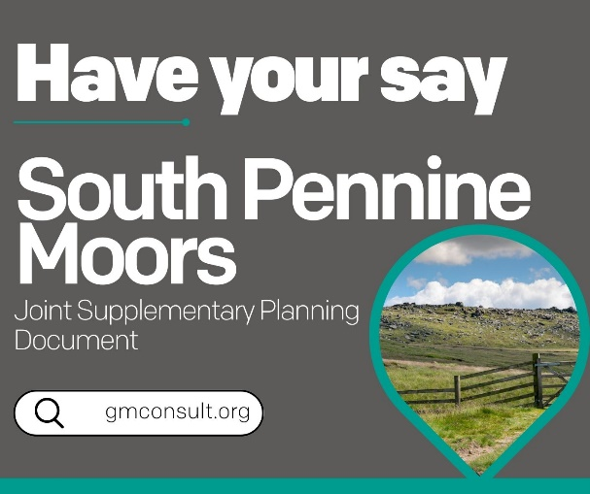 | 🐦 The South Pennine Moors is an important natural habitat for a wide range of bird species.  We want to ensure that new homes and businesses in Oldham, Rochdale and Tameside, close to the area, have safeguards in place to protect these habitats.  🗣️ The Joint Supplementary Planning Document is a key part of this, and we want your input to help shape it.  www.gmconsult.org/pfe/south-pennine-moors
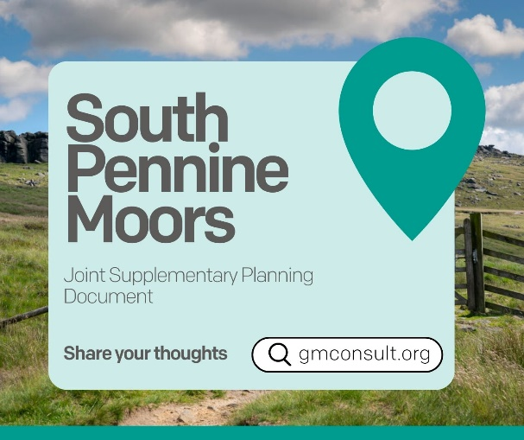 | 🦉 Did you know parts of Oldham, Rochdale and Tameside are important bird habitats for Merlins, Golden Plovers and short-eared Owls?  We want to ensure that new homes and businesses in these areas have safeguards in place to avoid harm to these species  🗣️ The Joint Supplementary Planning Document is a key part of this, and we want your input to help shape it.  www.gmconsult.org/pfe/south-pennine-moors

Holcroft Moss
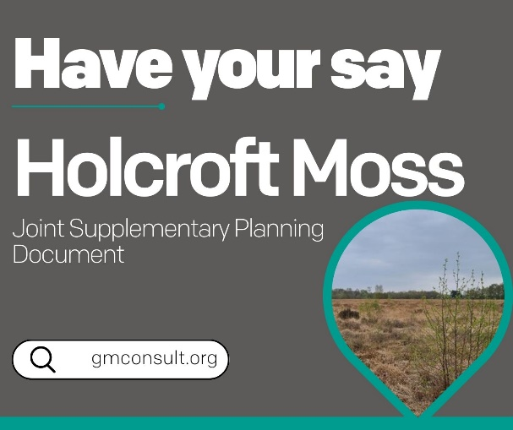 | 📍Close to Greater Manchester, in Warrington, is Holcroft Moss. It is an important peat bog habitat which has developed over thousands of years.  We want to ensure that new homes and businesses have safeguards in place to avoid harm to this site.  🗣️ The Joint Supplementary Planning Document is a key part of delivering this, and we want your input to help shape it.  www.gmconsult.org/pfe/holcroft-moss
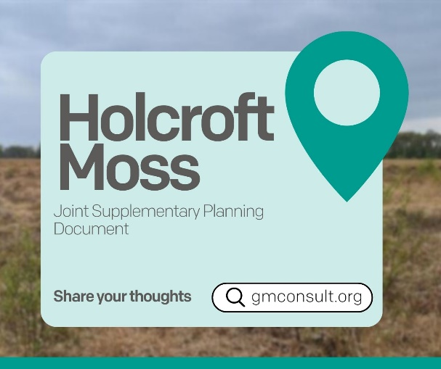 | 📍Did you know Holcroft Moss is an important peat bog habitat, developed over thousands of years?  The Places for Everyone Plan has a policy to ensure that new homes and businesses mitigate their impact on this site.  🗣️ The Joint Supplementary Planning Document is a key part of delivering this, and we want your input to help shape it.  www.gmconsult.org/pfe/holcroft-moss

Instagram

Joint Launch Post
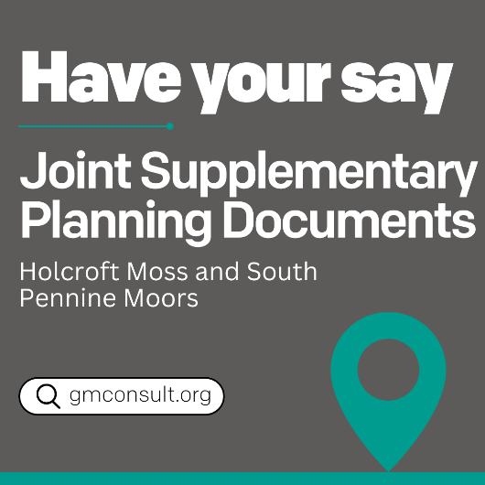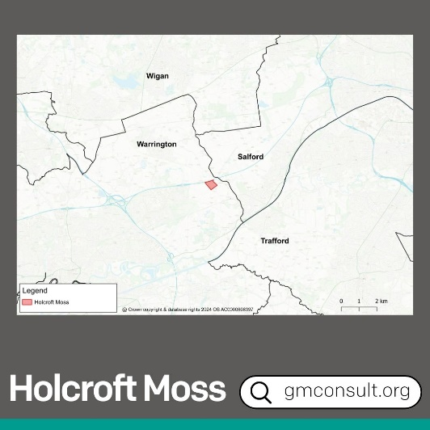  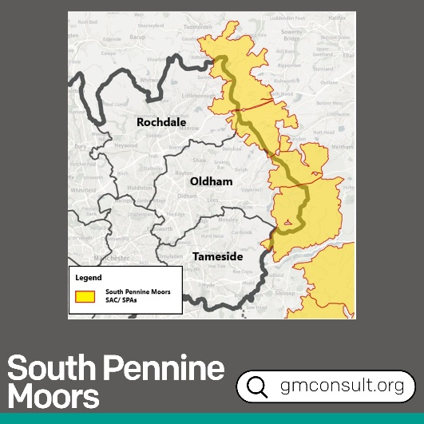 | 🌳 As part of delivering jobs, new homes, and sustainable growth in our Places for Everyone Plan, we have committed to protecting important natural habitats.  The Joint Supplementary Planning Documents (SPDs) are a key part of delivering on this commitment. They will guide developments from having adverse impacts on two key areas.  🗣️We want to hear your views to help shape the content of these documents. Visit gmconsult.org

South Pennine Moors
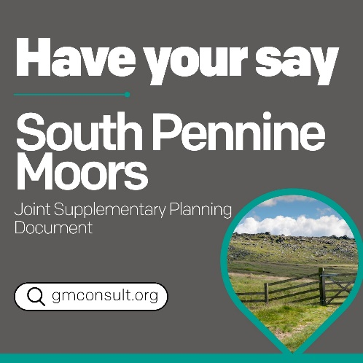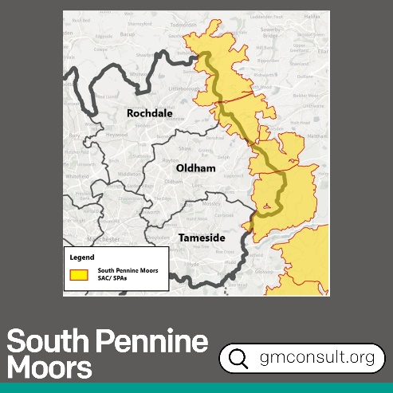 | 🐦 The South Pennine Moors is an important natural habitat for a wide range of bird species.  We want to ensure that new homes and businesses in Oldham, Rochdale and Tameside, close to the area, have safeguards in place to protect these habitats.  🗣️ The Joint Supplementary Planning Document is a key part of this, and we want your input to help shape it.  Visit gmconsult.org
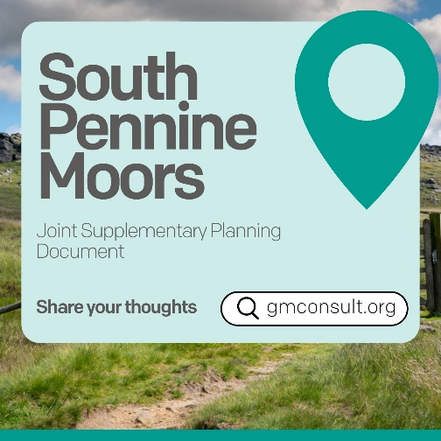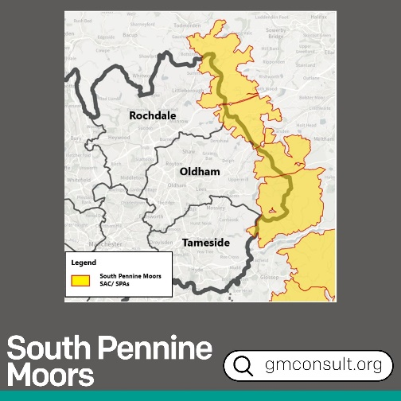 | 🦉 Did you know parts of Oldham, Rochdale and Tameside are important bird habitats for Merlins, Golden Plovers and short-eared Owls?  We want to ensure that new homes and businesses in these areas have safeguards in place to avoid harm to these species  🗣️ The Joint Supplementary Planning Document is a key part of this, and we want your input to help shape it.  Visit gmconsult.org

Holcroft Moss
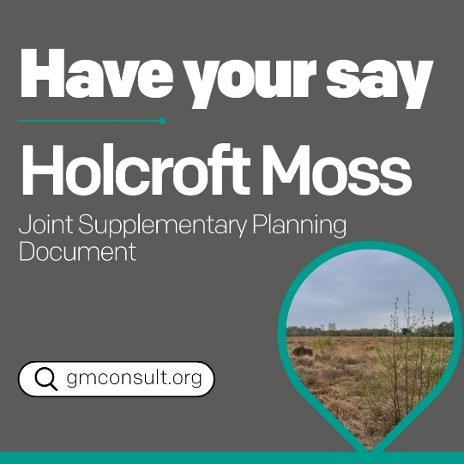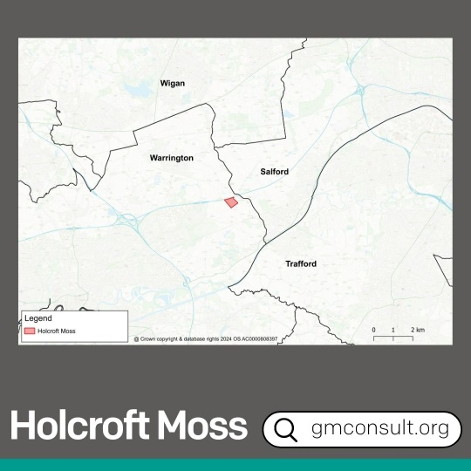 | 📍Close to Greater Manchester, in Warrington, is Holcroft Moss. It is an important peat bog habitat which has developed over thousands of years.  We want to ensure that new homes and businesses have safeguards in place to avoid harm to this site.  🗣️ The Joint Supplementary Planning Document is a key part of delivering this, and we want your input to help shape it.  Visit gmconsult.org
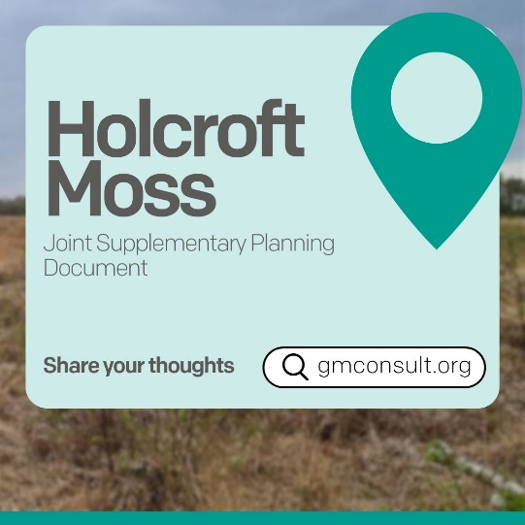 | 📍Did you know Holcroft Moss is an important peat bog habitat, developed over thousands of years?  The Places for Everyone Plan has a policy to ensure that new homes and businesses mitigate their impact on this site.  🗣️ The Joint Supplementary Planning Document is a key part of delivering this, and we want your input to help shape it.  Visit gmconsult.org

